"Would you like to walk together on <The Scientist's Path>?!" Held the 2nd sign unveiling ceremony

– The second sign unveiling ceremony was held in front of the Gwangju Institute of Science and Technology on the morning of the 15th

– ‘Science City’ Gwangju Landmark… Create a 7km promenade within the high-tech complex proposed by GIST

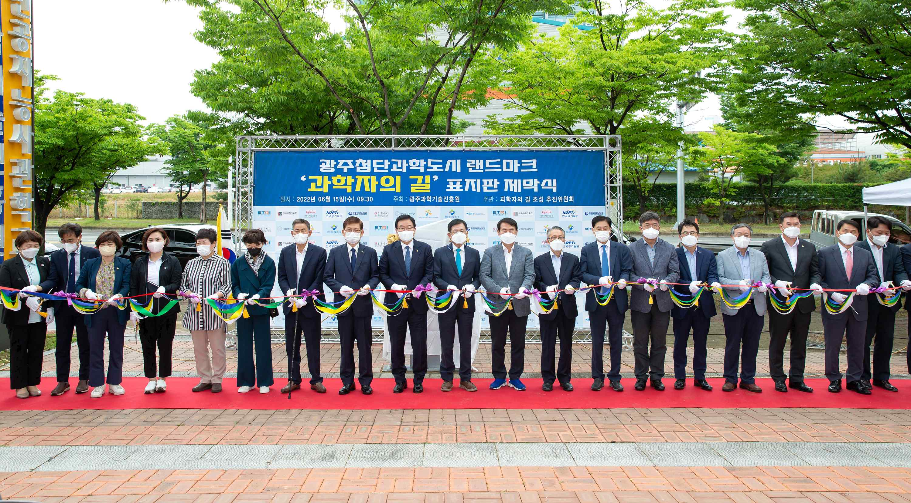
▲ The unveiling ceremony of a sign on the path for scientists to create a landmark for the Gwangju Advanced Science City was held at the Gwangju Institute of Science and Technology the 15th with the main attendees cutting the commemorative ribbon (4th from the right: Vice President of Public Affairs Young-jip Kim)

The second sign unveiling ceremony of <The Scientist's Path>, proposed by GIST (Gwangju Institute of Science and Technology, President Kiseon Kim) to create a landmark for the Gwangju Advanced Science City, was held on the morning of June 15 at the Gwangju Science and Technology Promotion Center.

The unveiling ceremony was hosted by the Gwangju Institute of Science and Technology, Gwangju Institute of Science and Technology and Gwangju Techno Park and was jointly hosted by the 'Scientist's Path Creation Promotion Committee' in which 11 science and technology-related institutions located in the Gwangju Advanced Science Industrial Complex, including the Korea Institute of Optical Technology, participated.

<The Scientist's Path> is a trail created by GIST and other industry-academic research institutes within the high-tech science industrial complex to create a Gwangju high-tech science landmark to help citizens feel science as if it were a daily life and use it as a place for leisure activities.

Earlier, on January 17, the 'Scientist Path Promotion Committee' installed the first signpost for the first course of the 'Scientist's Path’' in front of the main gate of GIST, and a second sign was installed through this event.

The first course of the trail is [GIST (Gwangju Institute of Science and Technology) → Gwangju National Science Museum → Korea Industrial Complex Corporation → Gwangju Techno Park → Korea Institute of Optical Technology → Gwangju Institute of Science and Technology → Gwangju Citizen’s Forest → Gwangju Advanced Science and Technology Industrial Complex → Korea Electronics Technology Researcher Gwangju Regional Headquarters → Korea Institute of Industrial Technology’s Southwest Headquarters → Korea Electronics and Telecommunications Research Institute Honam Center → Gwangju Institute of Design Promotion → Ssanam Park → GIST (Gwangju Institute of Science and Technology)].

The Promotion Committee plans to expand <The Scientist's Path> by sequentially developing additional paths.

The unveiling and cutting ceremony of <The Scientist's Path> sign event started with a welcoming speech by Seong-soo Park, chairman of the Path of Scientists and Gwangju Superintendent of Education Jeong-seon Lee, congratulatory remakrs from Buk-gu Mayor Moon In, a congratulatory address, and a progress report by GIST Vice President of Public Affairs Young-jip Kim.

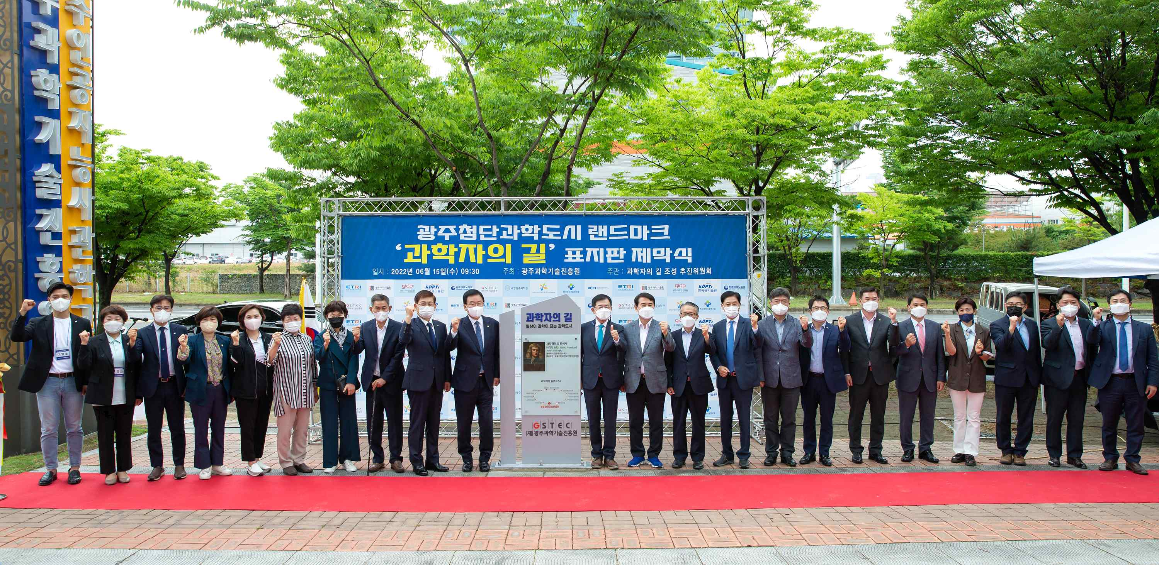
▲ Commemorative photo at the Gwangju Science and Technology Promotion Center on the 15th of the unveiling sign ceremony of <The Scientist's Path> to create the landmark of Gwangju Advanced Science City (Main participants: Park Seong-soo, president of Gwangju Economic and Employment Promotion Agency (promotional chairperson), GIST Vice President of Public Affairs Young-jip Kim, Shin Yong-jin, president of Korea Institute of Optical Technology, Kim Seon-min, director of Gwangju Technopark, Song Jin-hee, president of Gwangju Institute of Design Promotion, Hwang Sang-hyun, head of Korea Industrial Complex Corporation, Lee Gil-haeng, Korea Electronics and Telecommunications Research Institute Honam Branch Director, Lee Sang-beop, Korea Electronics Technology Research Institute Director, Jeong Chae-hwan, Korea Institute of Industrial Technology, Jinhyuk Yoo, Gwangju R&D Special Zone Director, Yoon Seok-koo, Gwangju Institute of Science and Technology Promotion, Seo Yong-gyu)

GIST Vice President of Public Affairs Young-jip Kim said, "In consultation with participating organizations, many students and citizens are contemplating ways to utilize <The Scientist's Path>. In August, we plan to establish a master plan for <The Scientist's Path> that will install additional information boards for each major branch, such as installing a tertiary sign in front of the Korea Institute of Optical Technology."

