Discussing ways to cooperate with Slovakia in the fields of robotics and artificial intelligence

– A delegation from the Slovak Institute of Technology and others visited the GIST Institute of Integrated Technology on the 9th

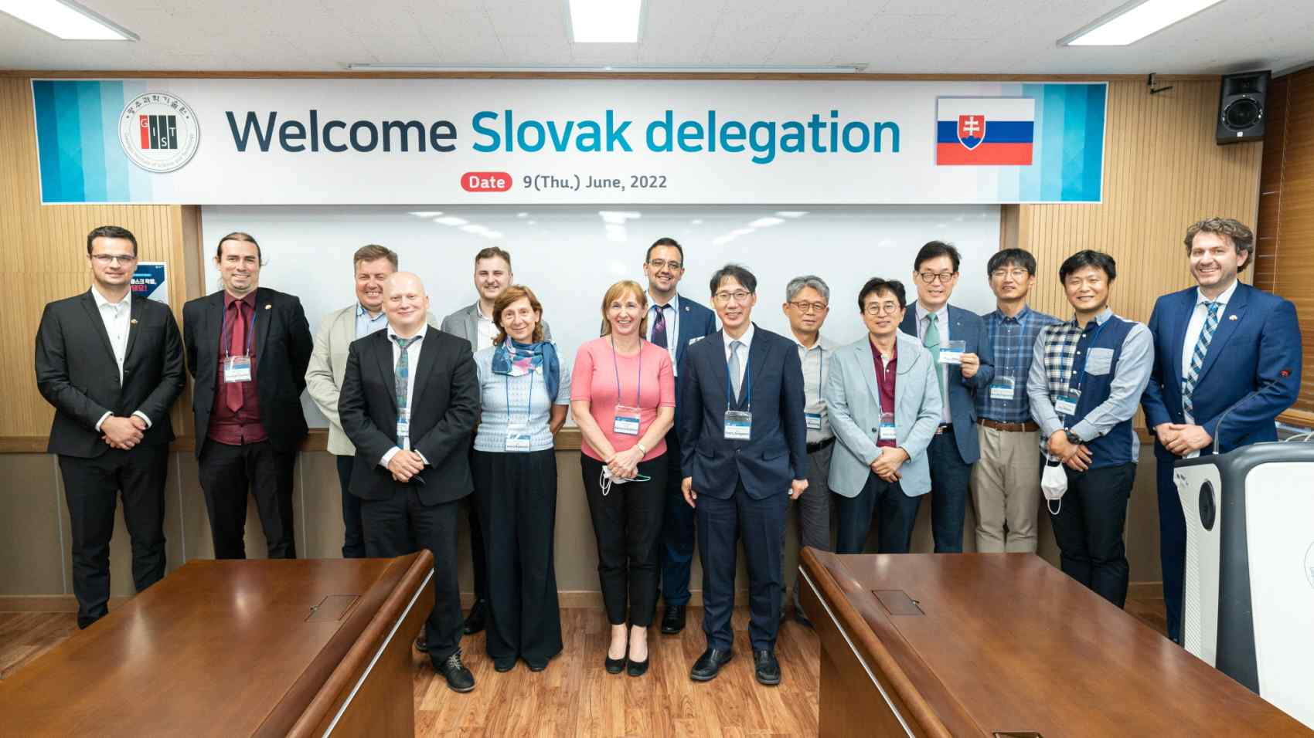
▲ GIST professors in the fields of robotics and artificial intelligence and a delegation from Slovakia are taking a commemorative photo in the seminar room of GIST Dasan Building.

A delegation from Slovakia, composed of researchers and businessmen, visited the Institute of Integrated Technology at GIST (Gwangju Institute of Science and Technology, President Kiseon Kim) on Thursday, June 9th for exchange and cooperation in the field of "Robot Engineering and Artificial Intelligence (AI)."

A delegation of 12 people, including two from the embassy, six professors and four business representatives from Slovak University of Technology in Bratislava (STUBA), Technical University of Košice (TUKE), Slovak Institute of Informatics of the Slovak discussed research areas of each institution with professors from the Institute of Integrated Technology, School of Mechanical Engineering, and Artificial Intelligence Graduate School.

GIST Institute of Integrated Technology Professors Jung Won Yoon, Je Ha Ryu, Kim Moon-sang, and Mun Sang Kim, who are conducting research in the field of robots and artificial intelligence, and School of Mechanical Engineering Professors Kyi Hwan Park and Pilwon Hur, and Artificial Intelligence Graduate School Professor UeHwan Kim participated at GIST.

The delegation from Slovakia plans to visit GIST again in the second half of this year to sign a business agreement for mutual exchange and promote human resource exchange and joint research among researchers and students.

GIST Professor Jung Won Yoon said, "Based on the achievements of exchanges with Slovakia, we expect that exchanges with European countries will expand in the future."

