GIST's 'number of thesis citations per faculty' ranked 1st in Korea and 6th in the world

– Announcement of QS World University Rankings for 2023... Ranked 1st in Korea for 'research competency' and remained top 10 in the world

– Evaluation as an objective indicator of research performance and influence, "Creating the best research immersion environment"

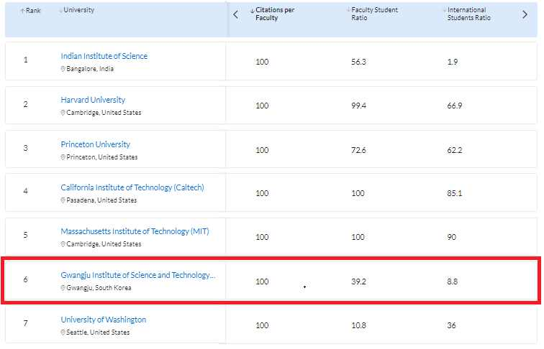
▲ Ranking of thesis citations per faculty (GIST 1st in Korea, 6th in the world)

In the 'QS World University Rankings 2023' announced on the morning of June 9 (Korean time) by QS (Quacquarelli Symonds), a global university evaluation institution in the UK, GIST (Gwangju Institute of Science and Technology, President Kiseon Kim) was ranked first in Korea (6th in the world) in the 'Citations per Faculty' category.

As a result of this year's results, GIST was ranked first in Korea for 15 consecutive years since 2008 in this category. It has been recognized for its world-class research capabilities, such as staying in the top 10 in the world by ranking 2nd to 6th, which is the highest among universities in the world.

'The number of thesis citations per faculty' is an indicator of how many thesis citations by the researchers at the university were cited by other researchers. It is a category that can evaluate both the quantity and the quality of university research capacity.

In this year's 'number of thesis citations per faculty' category, papers published by the university between 2016 and 2020 (5 years) were ranked based on the 'number of citations' cited between 2016 and 2021 (six years) divided by 'total number of faculty.' GIST papers published by 200 researchers were cited 53,000 times during the period.

In particular, this evaluation item differs from items such as 'academic reputation' or 'graduate reputation' where the subjectivity of the survey respondents greatly influences the results. It is considered as the most reliable evaluation category in that it shows the average research performance of universities and their 'objective' impact on other research in the field.

GIST's research capabilities have been evaluated as world-class for more than 10 years, with 'internationalization' and 'convergence' as its operating philosophy from the early days of its establishment (1993). This is thanks to the creation of an optimal environment for researchers to immerse themselves in research. By breaking down the barriers between research fields and disciplines, convergence research centered on research groups made up of researchers from various fields is encouraged.

In addition, GIST provides a residential environment suitable for research to all faculty and students so that they can stay on campus and focus on research without worrying about housing. Various incentives and reward systems are in place for researchers who create excellent results.

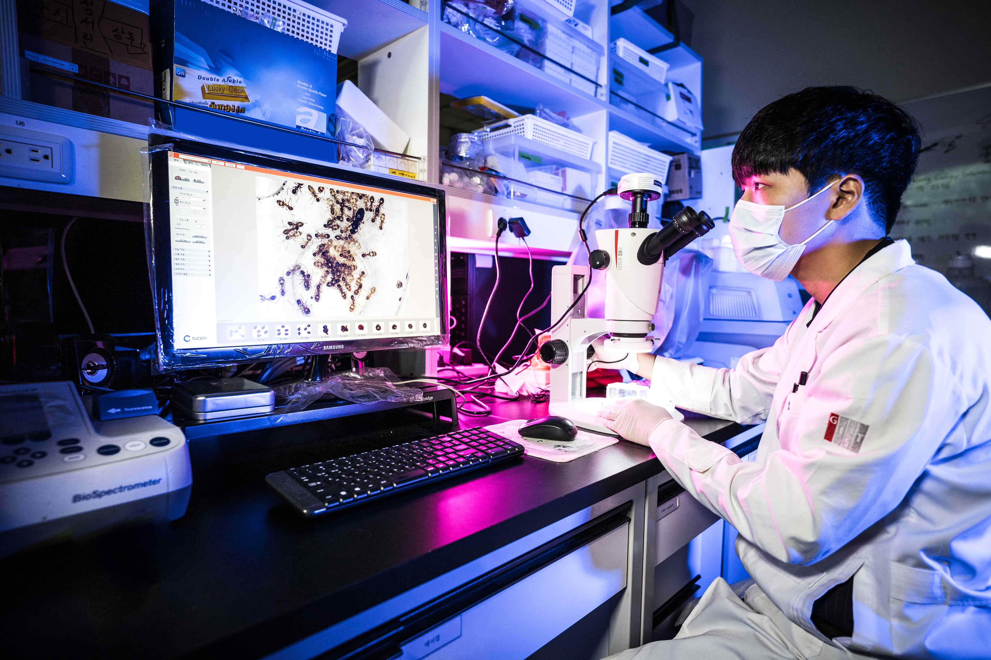
▲ A GIST student is doing research on plants and insects in the evolutionary ecology laboratory. GIST was ranked 1st in Korea (6th in the world) in this year's QS World University Rankings for 'Citations per Faculty'. GIST has been recognized for its world-class research capabilities by maintaining the first place in Korea and the top 10 in the world for 15 consecutive years since 2008 in this category.

In this year’s 'number of thesis citations per faculty' category, not only GIST but also most research-oriented science and technology specialized universities received excellent evaluations among domestic universities. It showed that national strategy and intensive support for R&D in science and technology and nurturing future specialists are very important for improving research competitiveness of universities and securing research and technology initiatives.

As for domestic universities, UNIST (Ulsan Institute of Science and Technology) was ranked 11th in the world after GIST, and POSTECH and Korea Advanced Institute of Science and Technology (KAIST) ranked 26th and 27th in the world. The Indian Institute of Science ranked first in the world, and Harvard University, Princeton University, Caltech, and MIT in the US ranked 2nd to 5th.

President Kiseon Kim said, "The result of this evaluation proves once again that GIST's research capabilities are the best in the world through the unremitting efforts of the members who respect the institution's operating philosophy. In the future, we will do our best to improve GIST's research competitiveness by strengthening the AI foundation, such as promoting the GIST-MIT international cooperation project and the AI data center (HPC) construction project. As a national model, we will do our best as a pivotal institution that not only researches but also leads regional innovation for personnel training and job creation for the core role of building an AI-centric city."

QS announces the world university rankings every June, and this year the '2023 QS World University Rankings' results were announced on June 9, 2022.



