The inspiring 'reading group' story of engineering students in the Ph.D. course, <Gong Gam Dok Seo> published

– Five seniors and juniors from the GIST undergraduate program read books together for 5 years despite busy lab life

– Various themes such as the firstborn son, capitalism, film, love...
With stories about reading groups and books

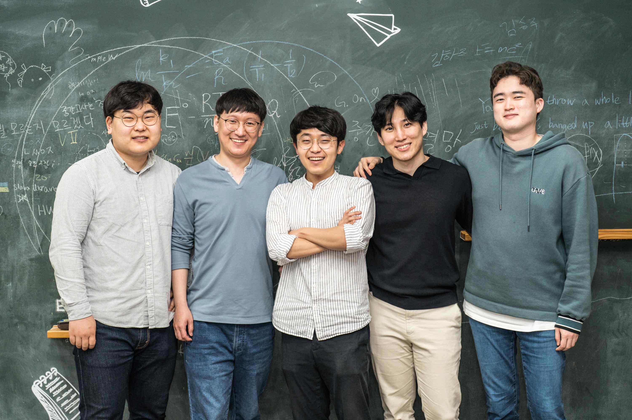
▲ (Authors from left) Chang-mook Kang, Min-sang Cho, Wang-seok Oh, Hoon Song, Jeong-wook Shin

I was able to forget for a moment the disappointment I felt after ruining an elaborate experiment for a few days while I was talking at a reading group. It was fun because it was light, but it was also useful because it was serious. We agreed to capture the true image of our meeting.
- <Gong Gam Dok Seo>, p.6

GIST (Gwangju Institute of Science and Technology) students who attended both the undergraduate and graduate programs at GIST published a book to share their thoughts on society, life, and reading after creating their own 'reading group.'

GIST's publishing house, GIST PRESS, recently published <Gong Gam Dok Seo - The story of the inspiring reading group of engineering college and graduate students>, a book written by five talented people in science and engineering who worked together in the doctoral program at GIST. It contains the story of a reading group that was held for over 5 years from 2015 to 2020.

The authors are among the seniors and juniors who entered the GIST undergraduate program in 2010 and entered the GIST graduate school with different majors. Dr. Wang-seok Oh (graduated from the School of Materials Science and Engineering in 2021, currently a postdoctoral researcher) said, "I like the friction feeling of flipping a paper book rather than the smoothness of an e-book." Dr. Min-sang Cho (graduated from the Department of Physics and Photon Science in 2022, currently a postdoctoral researcher at Lawrence Livermore National Laboratory, USA) said, "During college, I was fascinated with the subjects of consciousness and unconsciousness, good and evil, and justice." Physicist student Hoon Song (Ph.D. student in the Department of Physics and Photon Science) loves movies to the extent that "every Wednesday is a movie day." Chang-mook Kang (Ph.D. student in the Department of Chemistry) said, "While doing research on chemistry, I often remember the novel I read the day before. Jeong-wook Shin (Ph.D. student in the Department of Physics and Photon Science) was "reborn as a convergence specialist who took a philosophy class from a science high school student locked in math and science."

At first glance, life seemed like a squirrel spinning a wheel, but inside us there was that warmth that we felt when we were in college. It was not our only problem with each research subject. We discussed the meaning of true love, discovered a new perspective on films, and thought together about the meaning of university in this era and the fundamentals of modern society that make people powerless. It was there that we spent such a passionate graduate school life together.
- <Gong Gam Dok Seo>, p.168

The GIST undergraduate program, where the authors graduated, claims to be the first liberal arts college in Korea, and introduces an innovative educational model called 'liberal arts education for scientists and engineers' at a university specializing in science and technology. A new paradigm of domestic university education has been proposed.

In <Gong Gam Dok Seo>, the process and trial and error that the authors made to habituate reading for a long time and to keep meeting while taking the doctoral course in science and engineering after the humanities convergence science and technology education experienced in the undergraduate course was trial and error. Through reading, they were constantly interested in and thinking about social issues.

The authors said, "We want to share the meaning and value of the reading group with GIST juniors and, furthermore, Korean science and engineering undergraduate and graduate students." The background of starting the reading group through chapters 1 to 3 of the book and introduces how the reading group evolved.

In particular, in chapter 3 of the book <Gong Gam Dok Seo>, the actual presentations written by each member are presented as examples and each other's thoughts on each presentation are included without adding or subtracting, making it feel as if you are sitting at a reading meeting. It has been made available for reference by readers.

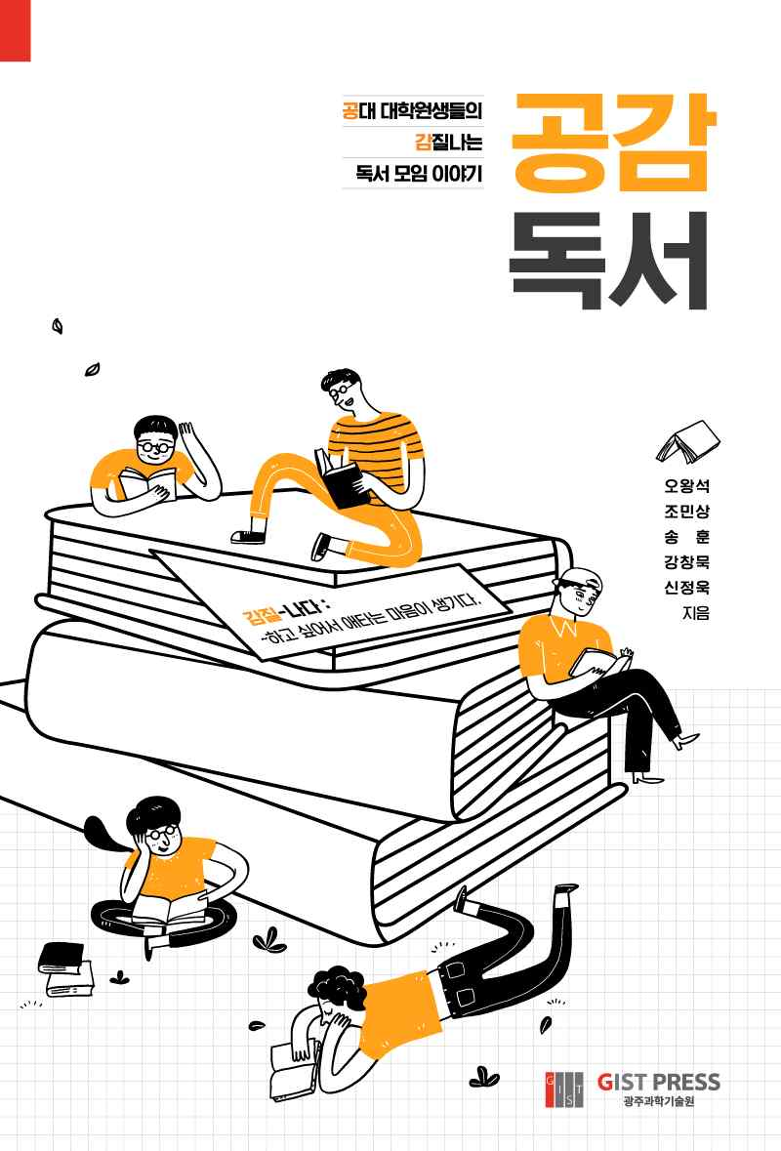
▲ [Book Cover] GIST PRESS has published <Gong Gam Dok Seo> by collecting the stories of graduate students from the first and second years of the GIST undergraduate program.

The authors' thoughts on 13 books in various fields such as philosophy, art, and literature are summarized. In addition, Chapter 5 of the book, <Rewriting the traces of the reading group>, contains the stories of the books the authors read by developing the existing presentations: Eldest son <eldest son>, Joseph Stiglitz's <The price of inequality>, Jung-kwon Jin's <Imagine of Jin Joong-kwon>, Paula Stefan' <How economics drives science>, and Albert Camus's <The Stranger>.

...During the time we spent together, we also grew in many ways. As we gained more experience and knowledge, we were able to ask questions we could not have thought of before. Rather than putting our thoughts and experiences ahead, we realized the importance of stopping for a moment and listening to others.
- <Gong Gam Dok Seo>, p.88

The authors said, "The roots of our reading group are the liberal arts lectures we took in college and the time we spent with great professors. Even though reading groups were burdensome due to busy life in the lab, we felt full of new knowledge and learned the joy of discovering things that we couldn't see alone by reading and sharing stories."

The authors said, "We hope that <Gong Gam Dok Seo> will become a stepping stone for juniors and colleagues who have been hesitant to participate in a reading group or are just starting meetings."



