GIST donates books to science dreamers in the community

– Social Contribution Group & GIST Development Foundation donated 500 books to 3 elementary schools in Jeollanam-do agricultural and fishing villages

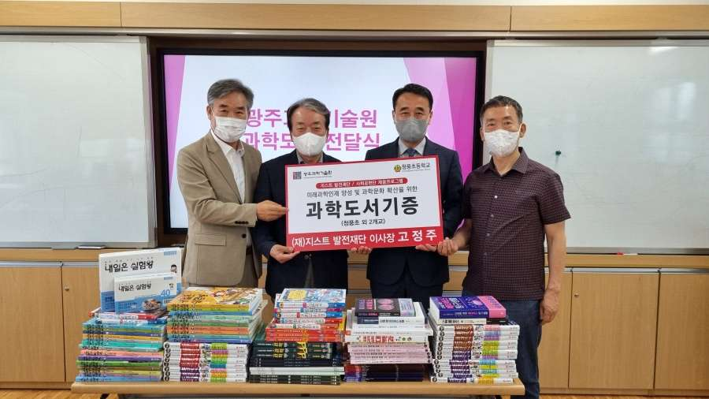
▲ GIST Social Contribution Group 'PIUM' and GIST Development Foundation are holding a science book delivery ceremony at Cheongpung Elementary School in Hwasun. (From left) GIST Development Foundation Director Hae-myung Kim, Chairman Jung-ju Ko, Hwasun Cheongpung Elementary School Principal Soo-yeol Yang, GIST Development Foundation Director Hwa-seok Park

GIST (Gwangju Institute of Science and Technology, President Kiseon Kim) Social Contribution Group 'PIUM' and GIST Development Foundation (Chairman Jung-ju Ko) are working together to foster future science and technology specialists and are spreading science culture at an elementary school in rural and fishing villages in Jeollanam-do by donating scientific books.

GIST Social Contribution Group has donated science books to local children's centers and elementary schools in underprivileged areas every year since 2003. Since 2017, it has been conducting a donation project together with the GIST Development Foundation.

This year, science books worth six million won were delivered to three elementary schools in Jeollanam-do, including Hwasun Cheongpung Elementary School, Damyang Nam-myeon Elementary School, and Jangseong Samseo Elementary School. The book delivery ceremony was held at Cheongpung Elementary School in Hwasun on the 3rd (Friday) with the participation GIST Development Foundation Chairman Jung-ju Ko, Hae-myung Kim, and Hwa-seok Park.

GIST Development Foundation Chairman Jung-ju Ko said, "We hope that reading will help students to acquire various knowledge, develop a rich imagination, and grow. Going forward, we will continue to take the lead in supporting the education of children and adolescents in underprivileged areas."

Cheongpung Elementary School Principal Soo-yeol Yang said, "Thank you for giving the students a great gift from GIST and the Development Foundation. Through the books donated this time, we will encourage reading activities in various ways so that children can develop their dreams of science."

Since its establishment in 2016, the GIST Development Foundation has been supporting local science and technology student development and educational activities with GIST's social contribution group 'PIUM' with books and goods to support underprivileged areas. GIST is actively supporting social contribution activities such as water purifier supply projects for developing countries that lack water.

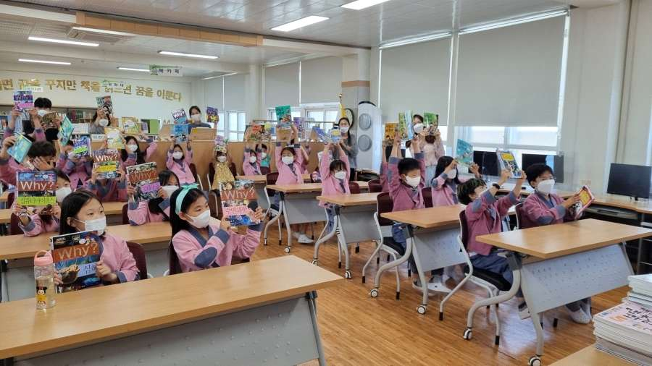
▲ Students of Hwasun Cheongpung Elementary School rejoice with their science books



