GIST GIST Academy hosts the May Breakfast Forum

– GIST Professor Hisam Kim invited to lecture on the topic of 'a divided society and the future of trust'

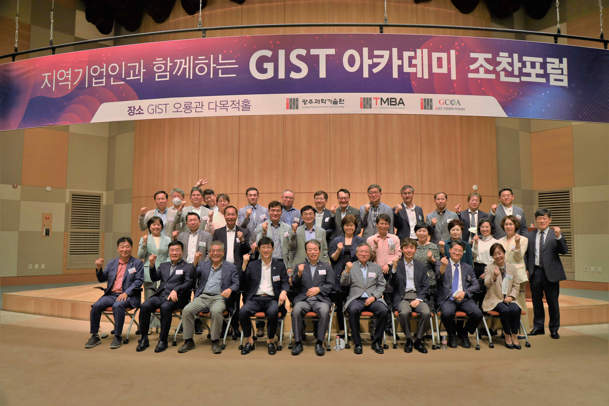
▲ Commemorative photo of GIST's May Breakfast Forum in Oryong Hall

GIST (Gwangju Institute of Science and Technology, President Kiseon Kim) Academy held its May breakfast forum under the theme of 'a divided society and the future of trust' at Oryong Hall on May 30 with about 40 representative business people from Gwangju and Jeollanam-do.

GIST College Division of Liberal Arts and Sciences Professor Hisam Kim, who was the speaker of the forum, drew a lot of attention from the attendees by suggesting the low tolerance index and interpersonal trust index of Korean society and emphasizing civic participation, which is essential for peaceful collective decision-making.

Professor Hisam Kim explained that the area that has retreated from the quality of life for Koreans is the 'family and community area.' He cited the dissolution of the local kinship group, the creation of a nuclear family, and the disappearance of opportunities for exchange with neighbors as factors for the decline of regional trust.

Professor Kim also categorizes social trust into three stages: △ local trust, △ institutional trust, and △ distributed trust. He explained that it is still necessary to consider the role of regional trust and institutional trust along with distributed trust when considering the future of trust and seeking solutions in our society.

The GIST Academy operates the Techno Management Business Academy (opened in 2010) and the Climate Change Academy (opened in 2016) as non-degree programs. The 'GIST Academy Breakfast Forum' is held on the last Monday of every month, inviting experts from various fields as lecturers for alumni and local business executives.

The GIST Academy provides business environment and global management strategies through lectures from the best experts in each field and fosters a sense of culture, supports the formation of a wide human network, and contributes to the revitalization of the local economy and industry-university cooperation.



