Senior-Friendly Comprehensive Experience Center Reopens in June

– Closed due to COVID-19... Expected to energize senior-friendly industry and AI convergence empirical research

– 'Popular Experience Center' located in Nam-gu, Gwangju... "Preparing content to expand the base of the senior-friendly industry"

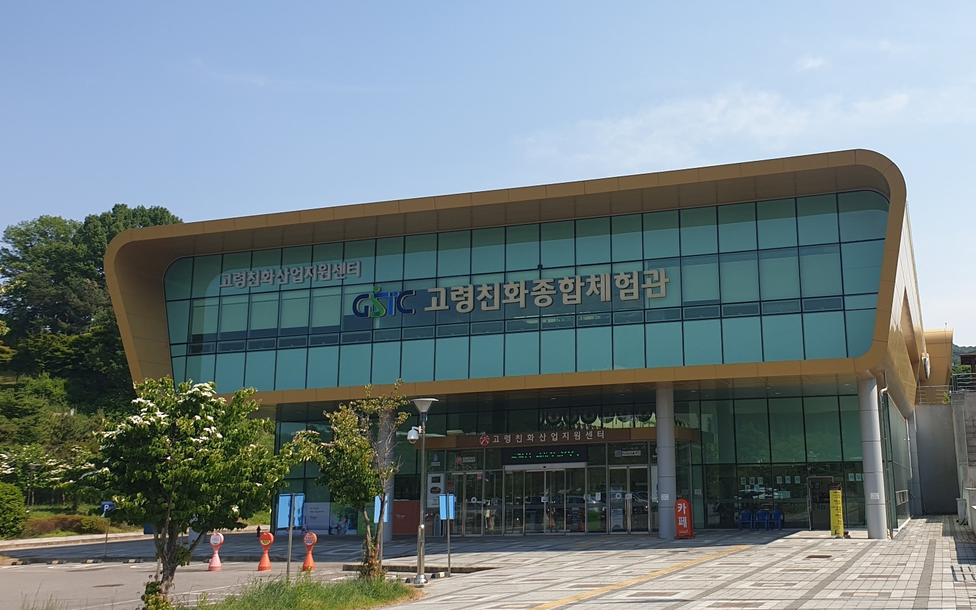▲ View of the Senior-Friendly Comprehensive Experience Center

The 'Senior-Friendly Comprehensive Experience Center' (hereinafter referred to as the Experience Center) operated by the Gwangju Senior-Friendly Industry Support Center (Centre Director Chang-Myung Oh, Professor of Biomedical Engineering at GIST) ended its temporary closure due to the COVID-19 outbreak and reopened on Thursday, June 2nd.

Located at 37 Deoknam-gil, Nam-gu, Gwangju (156 Haengam-dong), the Senior-Friendly Experience Center is an experience space of about 470 pyeong for fostering an senior-friendly industry.

The facility was visited by an average of 200 visitors a day, including welfare facility workers, but has been closed since September 2020.

The senior-friendly industry support center will reorganize some facilities in line with the re-opening of the experience center, and a new research facility based on △ Living Lab was created along with space for research on various senior-friendly content, such as △ healthcare △ entertainment △ planned exhibition zone to create demand for senior-friendly products and support for the industry.

In particular, by converting to a big data utilization system centered on verification space and usability evaluation of artificial intelligence (AI), Internet of Things (IoT) home appliances, healthcare, etc., it collects, analyzes, and shares health care data for the elderly based on the Living Lab.

The hours of operation of the experience center are from 9:30 a.m. to 5 p.m. on weekdays (Monday to Friday), which are the same as before the temporary closure, and is closed on weekends and legal holidays.
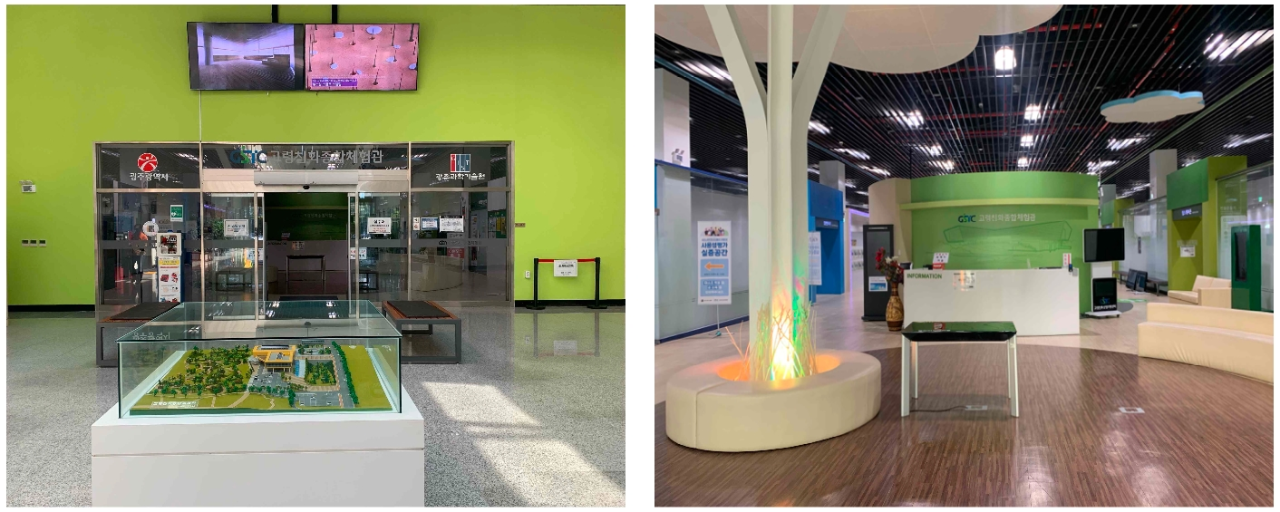
▲ Experience Center entrance ▲ View of Comprehensive Experience

Director Chang-Myung Oh said, "As the Senior-Friendly Comprehensive Experience Center is reopening with difficulty, we have prepared contents so that many citizens can understand the senior-friendly industry and expand its base. We will do our best to create a foundation for the senior-friendly convergence industry that reflects the technology trend of the industry and to create results as a leading center for the 4th Industrial Revolution."

The Gwangju Senior-Friendly Industry Support Center, which opened in May 2013, has been carrying out its projects with support from the Gwangju Metropolitan City and the Ministry of Trade, Industry and Energy to revitalize the Gwangju area, which is attracting attention as a new growth engine. GIST is currently operating the 4th stage project exclusively through the Gwangju Metropolitan City commission and consignment project contest in 2021.

As a hub for technology commercialization and the creation of a senior-friendly convergence industrial base that reflects the 4th Industrial Revolution technology trend, together with Gwangju Metropolitan City, it is △ nurturing an senior-friendly leading company △ supporting 4th Industrial Revolution convergence type R&D △ technology commercialization R&BD (commercialization-linked technology development) to strengthen the senior-friendly industry ecosystem and to build a profit-generating model through the establishment of a platform.



