'Pengsoo Daeppang' Myung-joong Kim, former EBS president, invited for GIST Special Lecture

– 5.26 (Thursday) Introducing the success story of Pengsoo under the theme of crisis management and new challenges

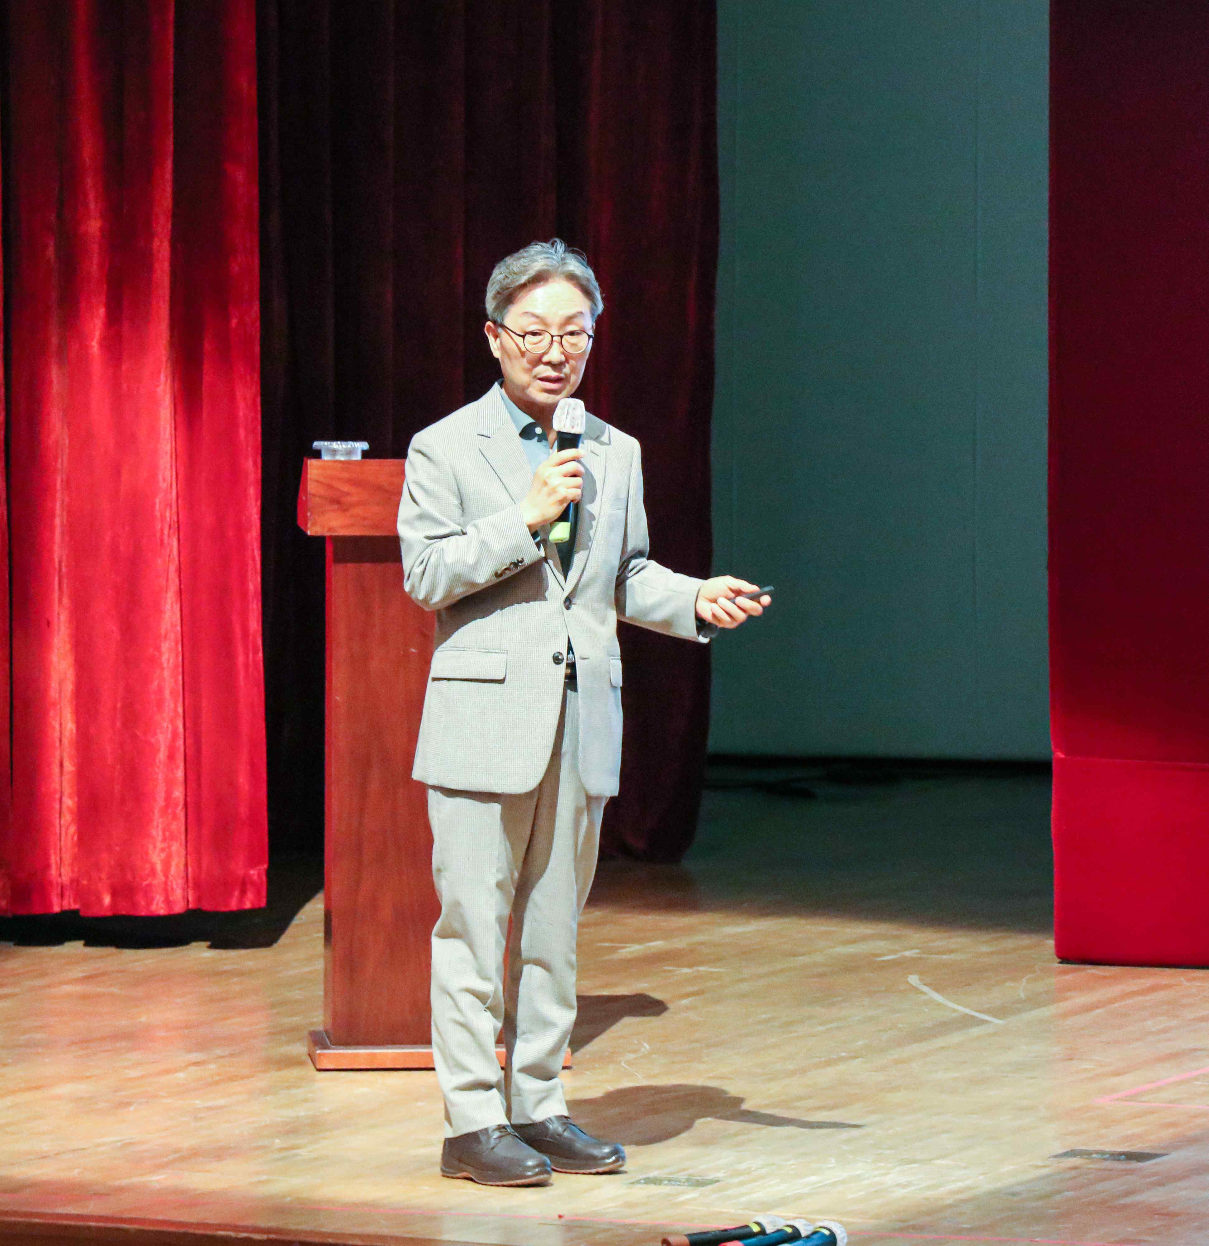
▲ Former EBS president Myung-joong Kim, famous for 'Pengsoo Daeppang,' is giving a special lecture on the topic of 'crisis management and new challenges' at the CT Art Hall on the 1st floor of the GIST Administration Building on the 26th (Thursday).

Former EBS president Myung-joong Kim, who is called the 'Daeppang' of the penguin character 'Pengsoo' developed by EBS, gave a special lecture at GIST (Gwangju Institute of Science and Technology, President Kiseon Kim) to members and local residents on the afternoon of May 26 (Thursday).

'Pengsoo' is the mascot character of <Giant Peng TV>, an educational entertainment program for children on EBS. It started airing during the tenure of former president Kim and gained unprecedented popularity. With the explosive increase in the number of YouTube channel subscribers, Pengsoo has so far been active as the top-grossing character of EBS.

In this special lecture, which was held as part of GIST's 'Social Contribution Academy,' former president Kim, under the theme of 'crisis management and new challenges', overcame the crisis caused by COVID-19. It received a great response by explaining the story of overcoming the situation and taking on a new challenge and the process of making the popular EBS icon 'Pengsoo' character successful through character business support.

Former president Kim, who is also famous for 'Pengsoo Daeppang,' explained new challenges he took to overcome the crisis during his tenure, such as such as <Great Class, GREAT MINDS> and <Giant Peng TV>. He emphasized the importance of bold challenges without fear of failure.

In addition, at the end of the lecture, Pengsoo made a surprise appearance through a video, and a message of support was delivered to former president Kim and GIST members.

GIST President Kiseon Kim said, "I was impressed by the passion and effort of former CEO Kim, who was not afraid of failure and continued to take on challenges. Going forward, we will frequently invite various social contribution experts who can spend a beneficial time not only with our members but also local residents."

Meanwhile, to provide opportunities for sustainable value creation and fulfill its social responsibilities, GIST is conducting various social contribution activities such as △ science school △ visiting science camp △ book donations △ lectures at the social contribution academy.



