"For a start-up that dreams of being on the world stage, GIST will help you!"

– Selected as 'Global Corporate Collaboration Program' by the Ministry of SMEs and Startups in ‘22, and secured a total project cost of 8.5 billion won

– Cooperation with global companies such as Siemens... Supports up to 300 million won in commercialization funds per company

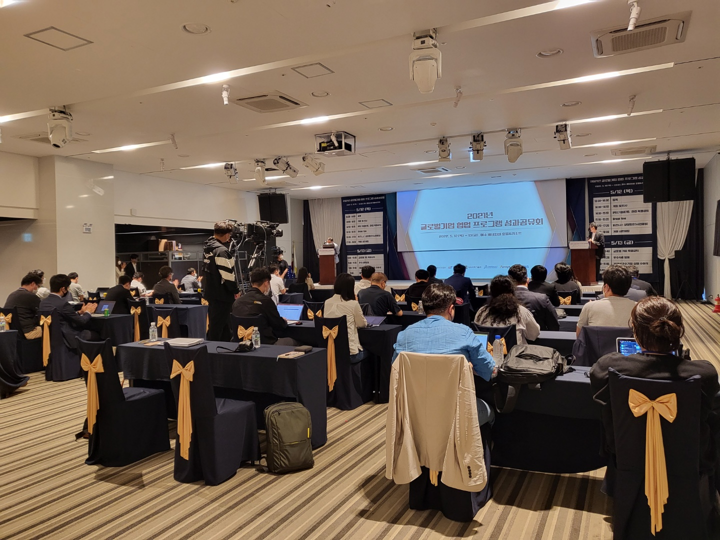▲ GIST Business Support Center held the '2021 Global Corporate Collaboration Program Performance Sharing Meeting' at the Venice Hotel & Resort in Yeosu in May 2022 to share the business performance of 60 participating companies with global companies (Dassault Systèmes, Siemens, ANSYS).

GIST (Gwangju Institute of Science and Technology, President Kiseon Kim) was selected as the 2022 Global Corporate Collaboration Program by the Ministry of SMEs and Startups to support start-ups in advanced manufacturing, automation, health, and diagnosis in cooperation with global companies.

GIST Business Support Center (Director Sung-geun Ki) plans to receive about 8.5 billion won in total project costs from the Ministry of SMEs and Startups to support 60 start-ups in advanced manufacturing, automation, and health and diagnosis from May to December of this year.

For this program, GIST plans to form a dedicated organization to support start-ups and operate various global acceleration programs to help companies grow globally, including organizing investment organizations and securing investment funds.

Dassault Systems, a French-based design software developer, Ansys, a U.S. engineering simulation software company, and SIEMENS, a global electrical and electronics company, operate global specialized programs such as corporate customized investment programs, global tech up, and global biz up. G-tech Mall*, a technology shopping mall of the Science and Technology Application Research Group, an organization dedicated to technology commercialization and start-ups of GIST, plans to operate various support programs such as technology transfer, matching researchers, and solving difficulties.

* G-tech Mall: https://gtm.gist.ac.kr/

Start-up companies wishing to participate in the "Global Corporate Collaboration Program" can be supported through the K-startup website of the Korea Startup Promotion Agency. When selected, up to 300 million won (13.5 billion won on average) in commercialization funds can be provided and services necessary for the growth of start-up companies such as education, consulting, and networking can be provided.

The GIST Business Support Center has been conducting the project as the organizer of the start-up leap package project for seven consecutive years since 2016. In 2021, 60 companies were selected and the Business Support Center's active investment promotion activities attracted KRW 49 billion of new investment and achieved sales of KRW 61 billion.

In particular, compared to other hosting organizations, it has been highly praised by the target companies by helping the company's sustainable growth through a more thorough follow-up management program. Even after the completion of the project, the company provides necessary support for corporate growth, such as providing guidance on various government projects.

In the case of Green Bio, the company selected for 2021, it was selected as a 'baby unicorn' company in the '2021 K-Unicorn Project' of the Ministry of SMEs and Startups through GIST's follow-up management program. It also won the Excellence Award in the 1st K-Camp Final Round hosted by the Korea Securities Depository.

Thanks to active technical cooperation and support with GIST, Green Bio is promoting projects such as the construction of a 3 trillion won factory with the Malaysian government, and it is growing into a global company that mass-produces eco-friendly materials and products.

GIST Business Support Center Director Sung-geun Ki said, "The Corporate Support Center discovers, accelerates, and attracts investment through global corporate collaboration programs.

We will not spare any systematic support to help start-ups grow into global innovative companies, including support for overseas market advancement.



