GIST – Wonkwang University Hospital signed an MoU for cooperation in the medical field such as joint research

– Establishing cooperative relationships for development in the medical field such as joint research and human resource exchange

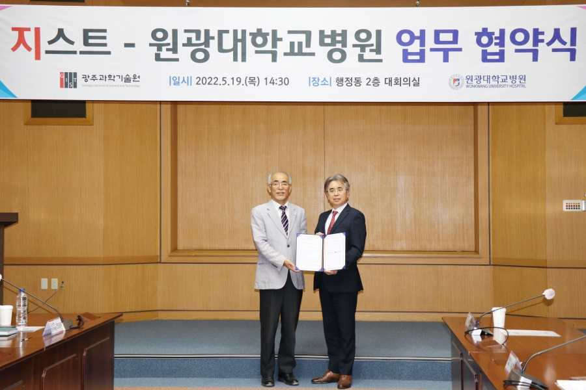
▲ Commemorative photo of GIST and Wonkwang University Hospital signing a business agreement for joint cooperation in the medical field (From left) GIST President Kiseon Kim, Wonkwang University Hospital Director Il-young Seo

GIST (Gwangju Institute of Science and Technology, President Kiseon Kim) and Wonkwang University Hospital (Director Il-young Seo) signed a business agreement (MoU) to conduct joint research in the medical field and to exchange technology and personnel.

The signing ceremony between the two organizations was held on the afternoon of May 19 and included GIST President Kiseon Kim, Vice President for R&D Raekil Park, Vice President for Public Affairs Young-jip Kim, Research Director Chang-Duk Jun, Department of Biomedical Science and Engineering Chair Jae Gwan Kim, Wonkwang University President Maeng-soo Park, Wonkwang University Hospital Director Il-young Seo, Medical Services Director Seon-ho Ahn, Institute of Medical Life President Gun-seok Seo, and Information Management Office Director Do-shim Park. The event was held in the GIST Administration Building with the presence of key officials including Jang Seung-ho, a professional assistant at the Biomedical Research Institute.

Using this agreement as an opportunity, the two institutions will ▲ plan new projects and carry out joint research ▲ cooperate in research and clinical trials and share data ▲ host academic events such as seminars, workshops, and short-term training ▲ exchange technology and professional research personnel ▲ promote joint use of research facilities and equipment.

In particular, the 'Future Innovation Committee (tentative name)' will be formed to come up with concrete and practical future cooperation plans as well as comprehensive cooperation such as university education innovation, future research paradigm, and revitalization of international joint research.

GIST President Kiseon Kim said, "I am very happy and reassured to conclude a business agreement with Wonkwang University Hospital, which has abundant research experience in the medical field and excellent medical staff. This is expected to be very helpful not only for joint research and human resource exchange in the medical field but also for the operation and revitalization of the GIST Clinic (tentative name), which is currently planned to be established at GIST."

Wonkwang University Hospital Director Il-young Seo said, "Through mutual cooperation with GIST, which is playing a pivotal role in nurturing future scientific specialists, research and development, and revitalization of high-tech industrial bases, the two institutions will strive for mutual growth in the future."



