Alumni start-up company 'No. 1 listed on KOSDAQ' BIO-FD&C Co., Ltd., donated 100 million won to Development Fund

– School of Life Sciences Co-CEOs Dai Hyun Jung and Sang Hyun Mo, "Please use it to help juniors achieve their dreams"

– Founded a bio venture company in 2005 after graduation... Successfully listed on the KOSDAQ in February of this year

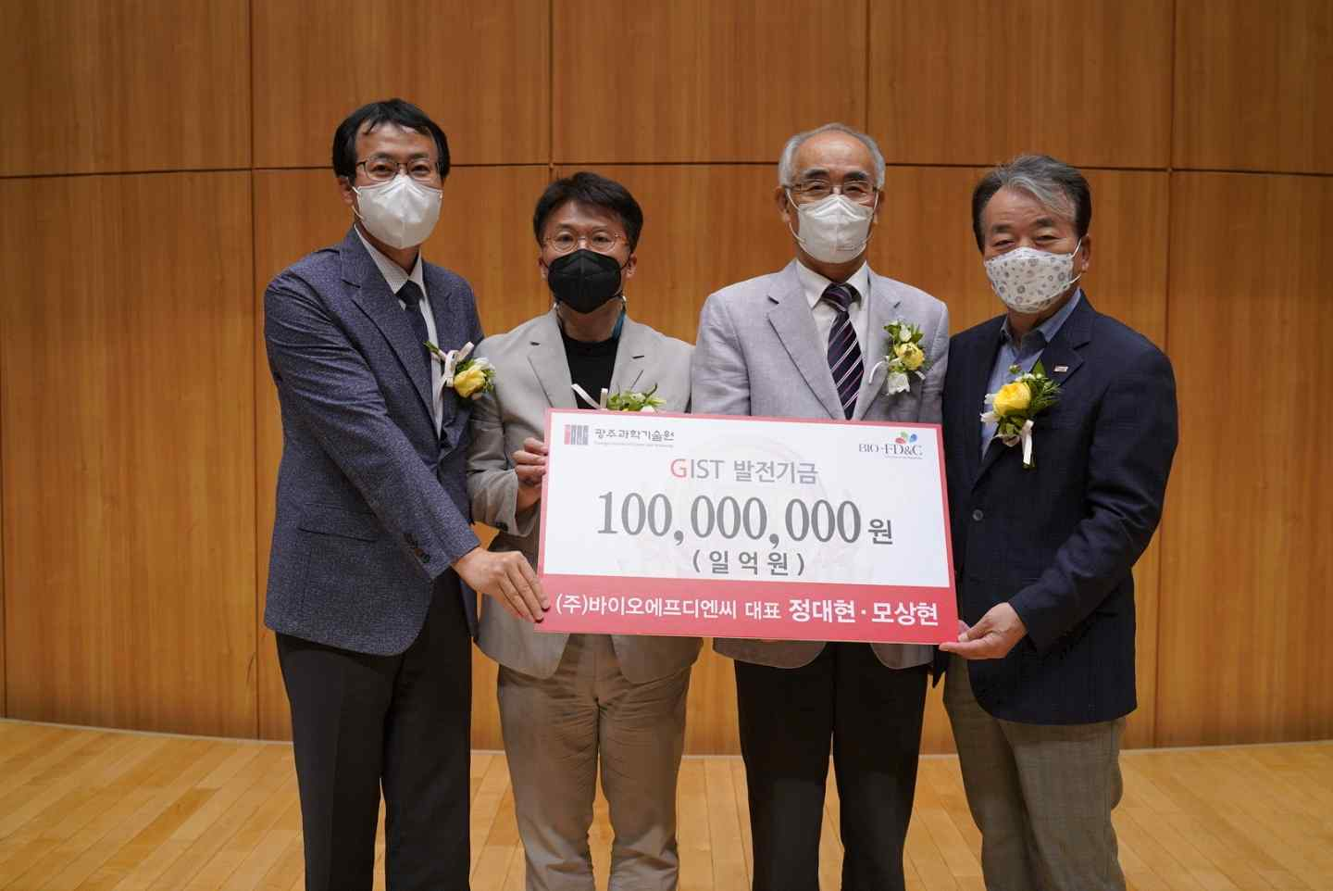
▲ Commemorative photo of alumni start-up company BIO-FD&C Co., Ltd., donating 100 million won to the GIST Development Fund on May 19 for juniors. (From left) BIO-FD&C Co., Ltd., Dai Hyun Jung and Sang Hyun Mo, GIST President Kiseon Kim, Development Fund Chairman Jeong-joo Koh

"Students who are interested in starting a business in their field of study need to focus on the process or process of developing the technology they are researching. The difference between taking classes with those worries and not taking them is bigger than you think," said CEO Dai Hyun Jung.

There is an entrepreneur who donated a large amount of development funds to his alma mater for his juniors after the dream of starting a business that he had in graduate school blossomed by being listed on the KOSDAQ market.

Dai Hyun Jung (51), an alumnus, who received a doctorate from the School of Life Sciences at GIST (Gwangju Institute of Science and Technology) in 2004 and started a venture company the following year and alumnus Sang Hyun Mo (48) who received a master's degree in 2003 donated 100 million won to the GIST Development Fund on May 19 for their juniors.

The plant cell platform-based bio venture company BIO-FD&C Co., Ltd., founded by the two of them, was listed on the KOSDAQ in February this year based on their past achievements. BIO-FD&C is the first company founded by GIST graduates to be listed on the KOSDAQ.

The two alumnus, who listed BIO-FD&C on the KOSDAQ after 17 years of starting their business, began their studies with the hope to start a business from their graduate school days. They agreed that "the solid research experience in the graduate course helped a lot in research and development of new bio materials and platform technology from a practical point of view after founding."

CEO Dai Hyun Jung said, "The biggest reward and charm of start-ups is that not only does the technology and the results of it return to me completely, but it also leads to the happiness and welfare of the members who believe in the vision of companies."

BIO-FD&C Co., Ltd.m is a bio-venture company that commercialized plant cell line design and plant cell culture and production technology, and it has developed bio-materials and plant cell platform technologies since its start-up.

Since its successful listing on the KOSDAQ market on February 21 of this year, it has established itself as a leading company in the plant cell field by declaring a commercialization plan using plant cell platform technology and entering the CDMO (consignment development and production) business.

Currently, the head office is located in Songdo, Incheon, and the Plant Cell Research Center and Gwangju Jeonnam branch are located in Hwasun-gun, Jeollanam-do, along with the 1st and 2nd factories as well as the Pharmaceutical Nanomaterials Research Center. Through steady R&D since its inception, it has held over 100 domestic and international patents and 60 international papers.

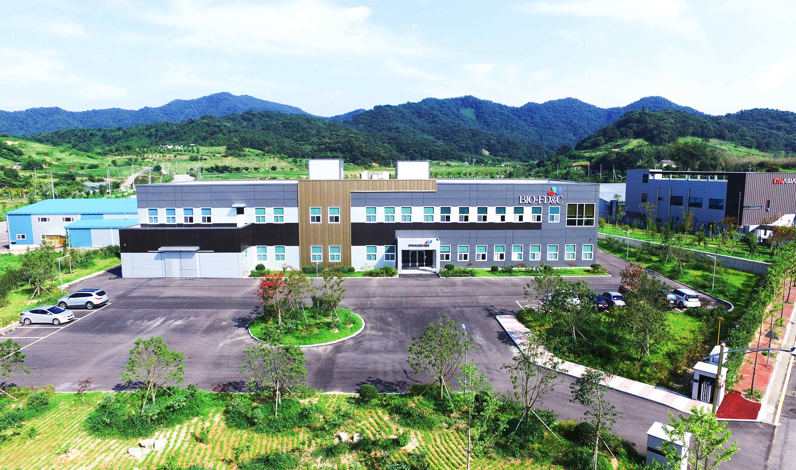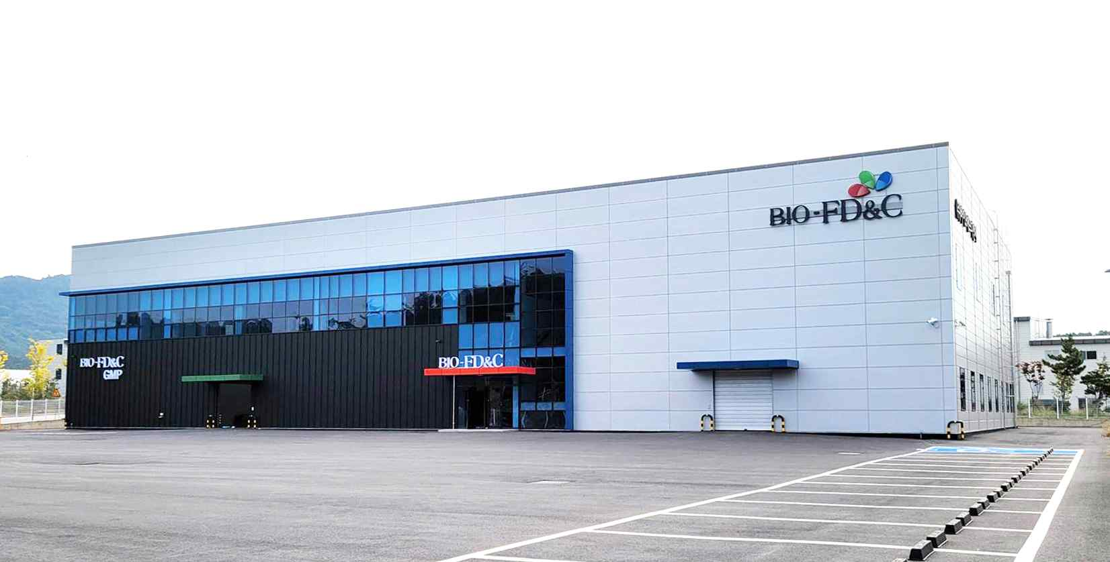
▲ BIO-FD&C Co., Ltd. (BIO-FD&C) Plant 1 and Plant 2 in Hwasun, Jeollanam-do

In addition to the two representatives, several alumni who graduated from GIST are working as researchers and other executives and employees. It has established a lasting bond and cooperative relationship with its alma mater, such as conducting joint research with the GIST School of Life Sciences.

CEO Dai Hyun Jung said, "We decided to donate development funds to support R&D and to promote a virtuous cycle of expanding technology start-ups to our alma mater, which has been striving to foster excellent scientific and technological specialists and collaborations with industry. I am happy to be able to make a small contribution to help realize the dreams of juniors who study hard."

CEO Sang Hyun Mo said, "I am happy that a meaningful event has been prepared for juniors who dream of starting a business. BIO-FD&C Co., Ltd. will solidify its ESG management by faithfully fulfilling its corporate social responsibilities, including this donation."

* ESG: An acronym for Environment, Social, and Governance. It contains the philosophy that sustainable business can be conducted by considering eco-friendliness, socially responsible management, and governance improvement in corporate activities.

The development fund donation ceremony was held at 4 pm on the 19th at GIST Oryong Hall with about 100 people from GIST and BIO-FD&C, including President Kiseon Kim and co-representatives Dai Hyun Jung and Sang Hyun Mo. After the donation ceremony, there was an unveiling ceremony for the 'Dai Hyun Jung and Sang Hyun Mo Classroom.'

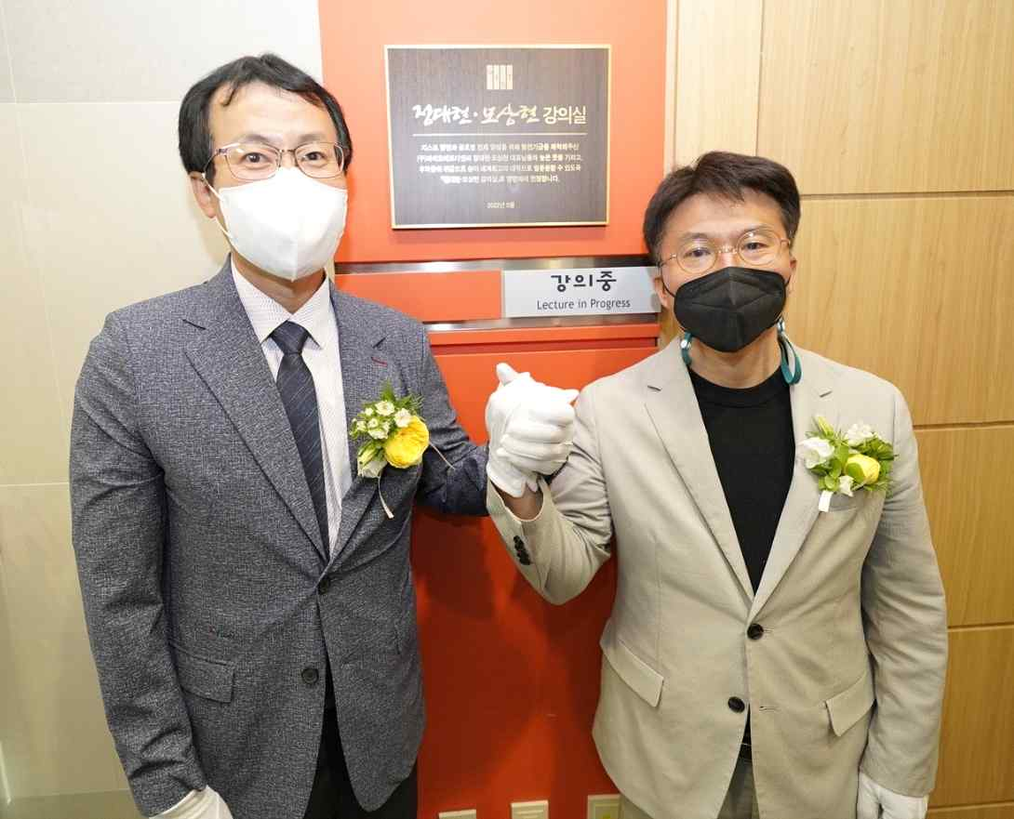
▲ Unveiling ceremony of the Dai Hyun Jung and Sang Hyun Mo Classroom (from left) Co-CEOs Dai Hyun Jung and Sang Hyun Mo

GIST President said, "I would like to express my gratitude to the two alumni who will continue the success story of alumni entrepreneurship.

Following the passion and challenging spirit of the two entrepreneurs, we will spare no effort to support GIST students so that they can jump into more challenging and creative student start-ups."



