"Research on intractable pain using AI big data" Joint Research Center of the Institute of Science and Technology, business agreement with T3Q

– Agreement signed on 17th with T3Q,
a company specializing in AI big data

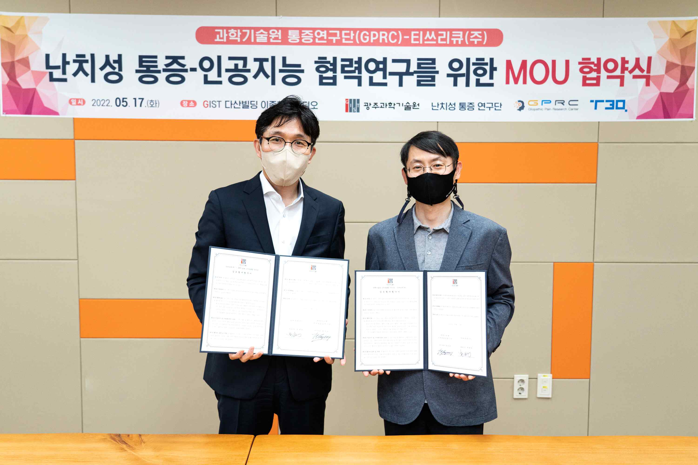
▲ On the 17th at GIST Dasan Building, the Institute of Science and Technology Joint Intractable Pain Research Center and T3Q are taking a commemorative photo after holding an MoU agreement for joint research on intractable pain and artificial intelligence. (From left) T3Q Co., Ltd., CEO Byeong-Hoon Park, Institute of Science and Technology Joint Intractable Pain Research Center Director Euiheon Chung (GIST Department of Biomedical Science and Engineering Professor)

The Institute of Science and Technology Joint Intractable Pain Research Center (Director Euiheon Chung and GIST Department of Biomedical Science and Engineering Professor) will collaborate with an artificial intelligence (AI) big data company to conduct research on intractable pain using AI.

On the 17th (Tuesday), Institute of Science and Technology Joint Intractable Pain Research Center signed a business agreement with T3Q (CEO Byeong-Hoon Park), a company specializing in artificial intelligence big data, to collect big data related to diagnosis and treatment of intractable pain and to collaborate on artificial intelligence research.

With this agreement, the two sides plan to create an AI big data cloud environment for clinical and preclinical data in the intractable pain field and promote research cooperation using big data-based AI technologies.

The signing ceremony was held on May 17 in the Department of Biomedical Science and Engineering's 'Jonghyun Lee Studio' with the participation of researchers from the Institute of Science and Technology Joint Intractable Pain Research Center and Park Byeong-hoon, CEO of T3Q.

The Institute of Science and Technology Joint Intractable Pain Research Center was launched in 2019 for joint research at four science and technology research institutes with the aim of developing pain diagnosis and treatment markets based on objective diagnosis and precision neurological control through the identification of the neurological mechanism of intractable chronic pain.

GIST (Gwangju Institute of Science and Engineering, President Kiseon Kim) KAIST, DGIST, UNIST, POSTECH, Chonnam National University Hospital, Yangsan Pusan National University Hospital, Yonsei University Shinchon Severance Hospital, Neurofit Co., Ltd., Visnob Co., Ltd., Patent Firm Well, etc. universities, hospitals, and companies are collaborating to conduct joint research.

T3Q is an artificial intelligence big data company that creates an artificial intelligence ecosystem through a marketplace based on a big data integration platform. Main products include ▲ artificial intelligence / big data integrated real-time intelligence platform (T3Q.ai/T3Q.ai Cloud) ▲ H/W and S/W integrated edge artificial intelligence platform (T3Q A-Box) ▲ simulation solution (T3Q AI Service) Package) ▲ an integrated monitoring solution (T3Q E2E Package) that supports real-time intelligence.

Research Director Euiheon Chung said, "Through industry-academic cooperation with T3Q Co., Ltd., we will make efforts to combine advanced neuroscience and AI technology to achieve good results such as clinical application of intractable chronic pain and creation of a living lab for pain treatment."



