Leehyo Bioscience Co., Ltd., CEO Hyo-cheol Lee donated 50 million won to GIST

– A distribution company in the field of biotechnology established in ‘95... "Use this for biotechnology R&D, nurturing specialists"

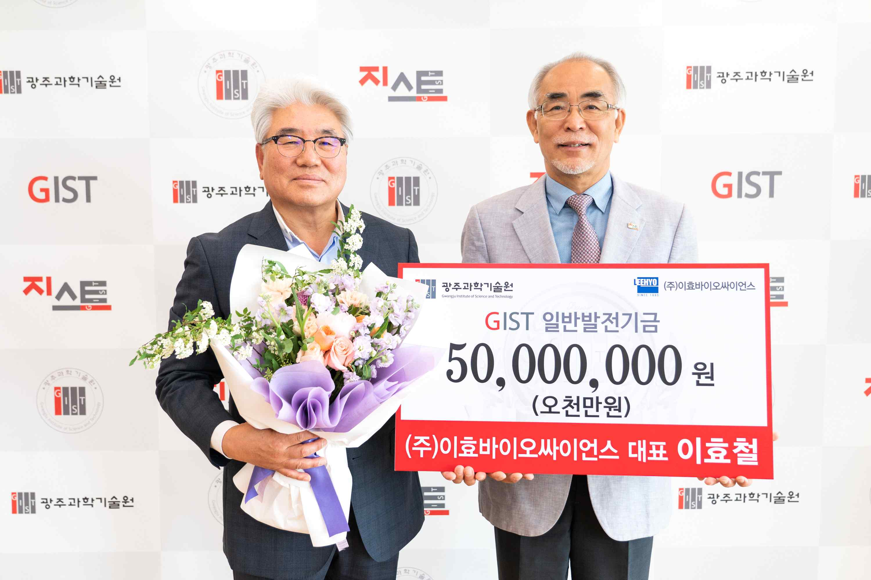
▲ Commemorative photo of Leehyo Bioscience Co., Ltd., CEO Hyo-cheol Lee donating
50 million won to GIST. (From left) CEO Hyo-cheol Lee, President Kiseon Kim

GIST (Gwangju Institute of Science and Technology, President Kiseon Kim) received a donation of 50 million won from Leehyo Bioscience Co., Ltd., CEO Hyo-cheol Lee to develop national science and technology and foster global leaders.

The donation ceremony was held at 10:00 am on the 12th (Thursday) in the GIST President's Office in the presence of officials, including President Kiseon Kim and Research Director Chang-Duk Jun.

CEO Hyo-cheol Lee is a manager who has continued to expand his businesses. After establishing Leehyo Bioscience Co., Ltd., a biotechnology-related distribution company in 1995, he established Daol Bio (2014) and LB Traders Co., Ltd. (2017) one after another.

Leehyo Bioscience Co., Ltd., is handling foreign brands in various application fields such as DNA/RNA/Protein, antibody, and biochemistry. It is growing into a specialized distribution company attracting attention in the global biotechnology field by signing Korean agency contracts with more than 90 overseas companies.

CEO Hyo-cheol Lee said, "Leehyo Bioscience, like GIST, has grown along with the development of domestic science and technology. I hope that GIST will actively support talented people in the biotechnology field and help create excellent research results."

President Kiseon Kim said, "I would like to thank CEO Hyo-cheol Lee, who donated to the GIST Development Fund, and I will provide more interest and support for research and development in the biotechnology field and fostering specialists."



