GIST Techno Management Business Academy alum Moon-han Choi donated KRW 10 million to the Development Fund

– Giram Engineering Co., Ltd., CEO and alum of the 9th GTMBA... "Train outstanding specialists and contribute to regional development"

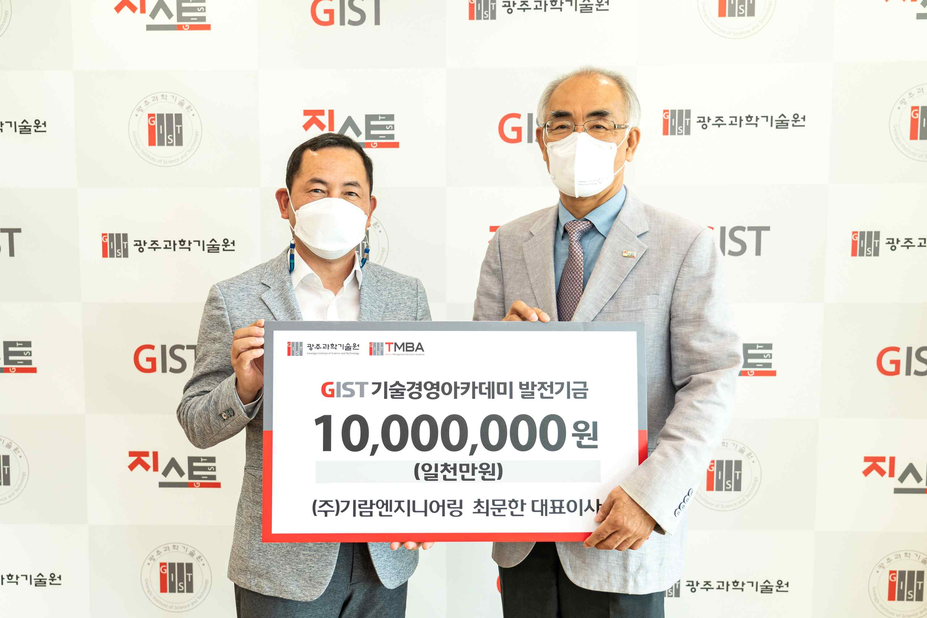
▲ Commemorative photo of Giram Engineering Co., Ltd., CEO Moon-han Choi and alum of the 9th GTMBA donates to the GIST Development Fund. (From left) CEO Moon-han Choi and President Kiseon Kim

GIST (Gwangju Institute of Science and Technology, President Kiseon Kim) Techno Management Business Academy (GTMBA) alum and Giram Engineering Co., Ltd., CEO Moon-han Choi donated 10 million won to GIST.

CEO Moon-han Choi said, "I hope that GIST will foster talented specialists and develop them together with the community and help them lead the future of Gwangju and Jeollanam."

President Kiseon Kim said, "We are thankful for your contribution to the development of GIST despite these difficult times, and we will use it preciously to foster talented specialist and enhance the academic curriculum."

The Development Fund donation ceremony was held on May 11 (Wednesday) at 11:00 am at the GIST President's Office and was attended by GIST President Kim Ki-sun, Vice President for Public Affairs, Research Director Chang-Duk Jun, and others. The donated funds will be used to develop the GIST Techno Management Business Academy.

GIST is currently operating two non-degree programs, starting with the 'Techno Management Business Academy' in 2010 and the 'Climate Change Academy' in 2016, and is contributing to the vitalization of the local economy and industry-university cooperation by providing the best lectures from experts in Korea and as a place to form wider human networks.



