R&D of super-strong laser defense weapon to block enemy's 'small drone' attack

– Advanced optical technology, research on ultra-strong laser plasma application technology

– Instantaneous damage to small drones and missile sensors

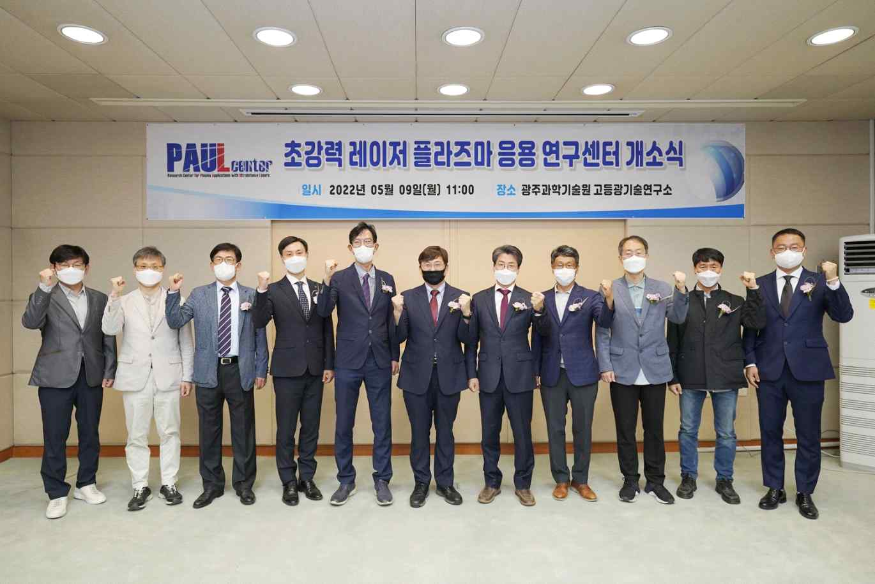
▲ GIST Advanced Photonics Research Center held an opening ceremony of the ultra-strong laser plasma application research center on the 9th (Monday), and major participants take a commemorative photo. (From left) Senior Researcher Jin Woo Yoon, Deputy Director Chul Sik Kee, three officials from related agencies, Center Director Hyung Taek Kim, Research Director Chang-Duk Jun, Director Yeung Lak Lee, Senior Researcher Jae Hee Sung, Senior Researcher Ki Hong Pae, Senior Researcher Hyuk Yoon

GIST (Gwangju Institute of Science and Technology, President Kiseon Kim) is conducting research on cutting-edge defense technology that uses a super-powerful laser* to disable electronic equipment of the enemy army, such as small drones and unmanned robots.

* super-powerful laser: A pulsed laser having a very high instantaneous power of more than (1012 watts, 1 trillion watts) for an instantaneous time in the femtosecond (10-15 seconds, 1 trillionth of a second) region, which can instantaneously ionize all objects to form a plasma state.

If the existing laser weapons cause damage by accumulating heat on an object by irradiating a laser with a narrow beam diameter on an object for a long time, then using a super-strong laser can instantly damage all objects, making it possible to develop a defense weapon that can quickly strike the core of an enemy weapon.

GIST's researchers, including Advanced Photonics Research Center (Director Yeung Lak Lee) Senior Researcher Hyung Taek Kim were selected for the Future National Defense Technology R&D project through the 2021 Defense Acquisition Program Administration to carry out the task of 'developing an ultra-high-strength laser and laser plasma technology for disabling electronic equipment' for the next five years.

To this end on the 9th (Monday) at the Advanced Photonics Research Center, the opening ceremony of the 'Super Power Laser Plasma Application Research Center (PAUL center)' was held in the presence of officials, including Advanced Photonics Research Center Director Yeung Lak Lee and GIST Research Institute Director Chang-Duk Jun. The research and development of ultra-strong laser plasma application technology, which is attracting attention as a key element of future smart defense technology, has started in earnest.

The research team plans to conduct research and development so that the super-powerful femtosecond laser plasma defense weapon technology, which has remained so far at the basic scientific proof-of-principle level, can be developed to a level that can be applied to actual warfare.

When a super-powerful femtosecond laser is propagated in air, ionization and nonlinear focusing occur simultaneously, generating filamentous plasma with a size of several hundred micrometers. Like optical fibers, it can propagate over a kilometer (km) while focusing (thinning the diameter of the beam) super-strong laser pulses.

If this is applied, it is possible to develop a technology that damages small drones and missile sensors in the laser path without a precise focusing device.

In addition, by rapidly scanning the direction of the super-powerful femtosecond laser, a filament plasma shield structure can be formed in the air, making it possible to develop a defense weapon that damages the core of an offensive weapon that passes within the shield area.

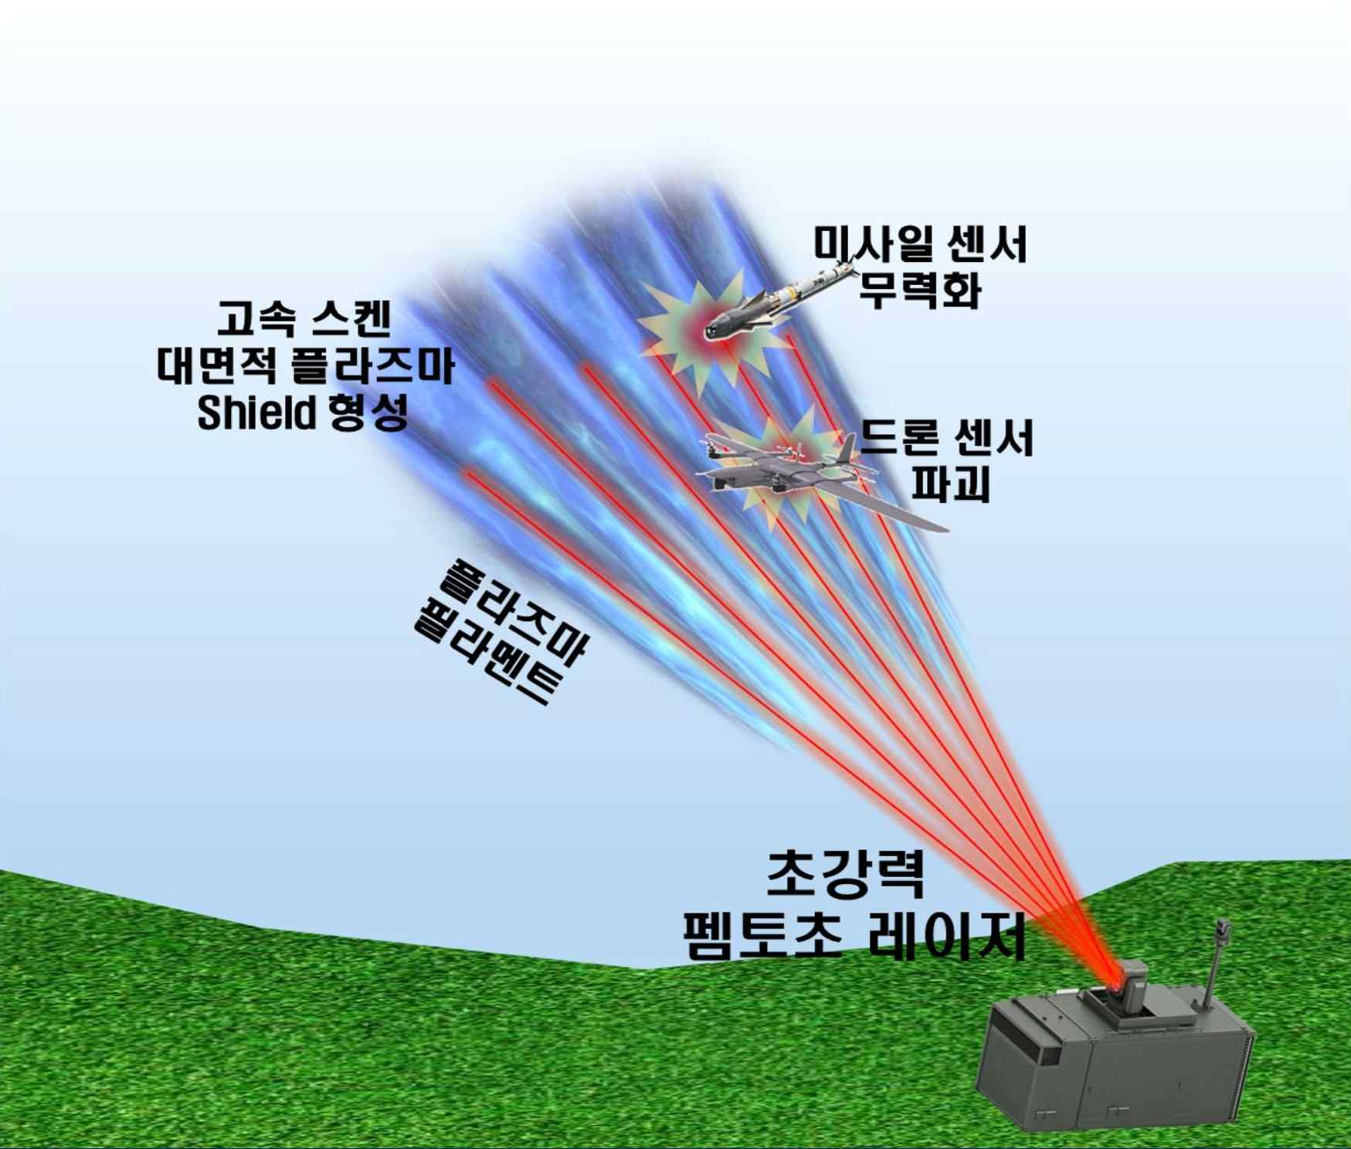
▲ Conceptual diagram of the development of plasma shield defense weapons using ultra-strong femtosecond laser filament plasma: A two-dimensional plasma shield structure is formed by scanning the filamentation plasma generated using an ultra-strong femtosecond laser. Damage to the sensor part of missiles and drones passing through the plasma shield with the laser field and electromagnetic field in the filament plasma.

In addition, when a super-powerful femtosecond laser is focused in the air and irradiated with heavy metals, high-magnetic field plasma and radiation are generated, which can instantly generate high-intensity EMP*.

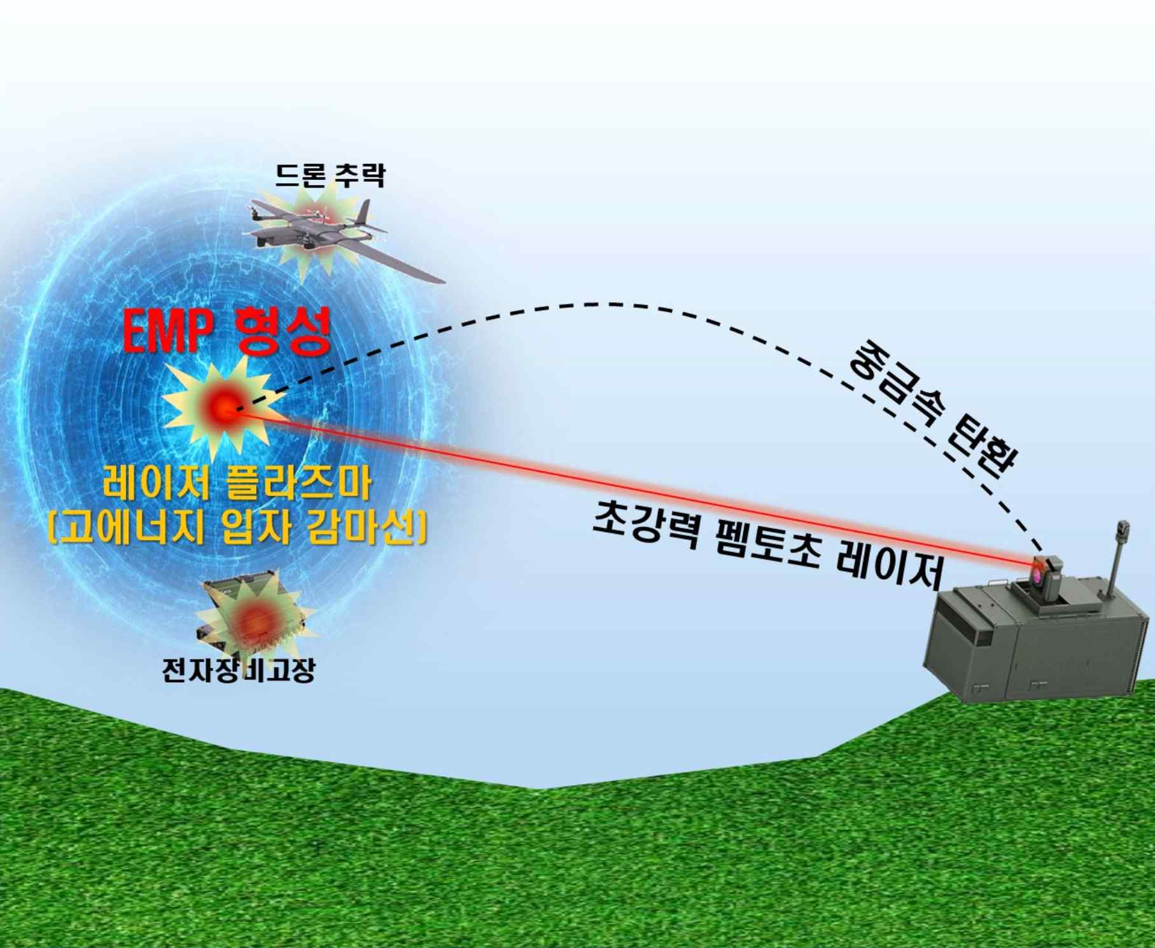
* EMP (electro-magnetic pulse): High-intensity electromagnetic pulse that can paralyze communication equipment, computers, computer networks, and military equipment by inducing overcurrent in electronic circuits.

The research team is developing a new technology that simplifies and stabilizes the complex structure and vacuum chamber of the existing ultra-powerful femtosecond laser for basic research, and they plan to develop a high-density high-magnetic-field plasma generation technology by focusing it in the atmosphere.

The technology to be developed is expected to be applied to various fields such as laser radiation cancer treatment, ultra-precise medical imaging, remote hazardous material detection, remote air quality measurement, ultra-precise non-destructive testing, and real-time precision material analysis.

GIST Advanced Photonics Research Center is an ultra-short light quantum beam project (2003~2012) for the establishment of a petawatt (1,000 trillion watt) laser facility. Through the 'Center for Relativistic Laser Science' (2012~present) project of the Institute for Basic Science (IBS), which studies relativistic plasma phenomena using super-power lasers, excellent research results have been achieved in the development and application of super-power lasers. Based on the research results of basic science, various applied research, such as national defense, medical care, stability, and precision measurement, are being conducted.

Advanced Photonics Research Center Chief Research Hyung Taek Kim said, "Recently, concerns over smart attacks such as small drone network attacks, portable missile attacks, and unmanned robot attacks are growing, so it is urgent to develop new defense weapons. Using super-strong femtosecond laser plasma, it is possible to incapacitate a large number of small arms at high speed, so it is expected that it will be able to effectively respond to the enemy's smart attack threat."

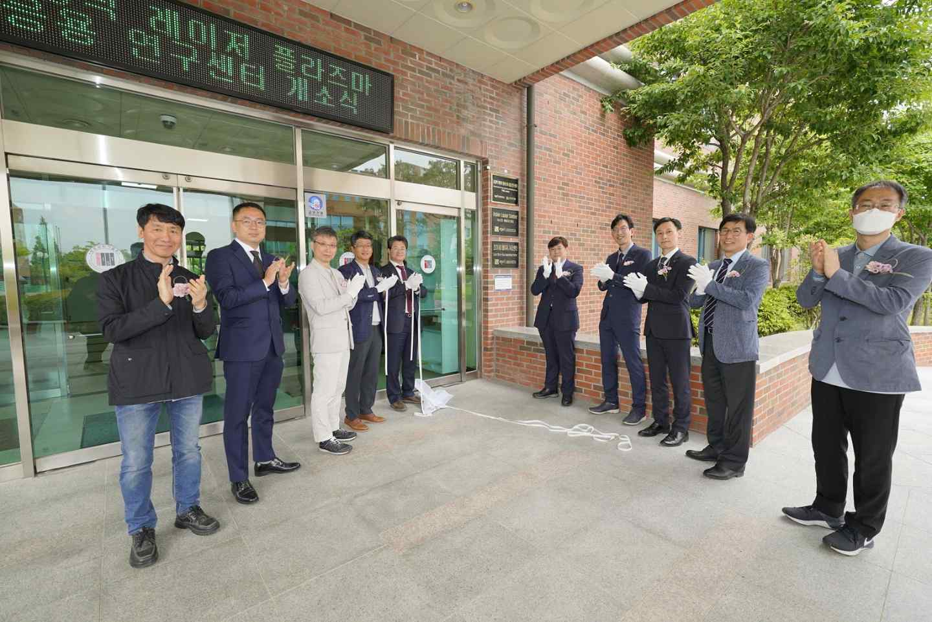
▲ The GIST Advanced Photonics Research Center held an opening ceremony for the Ultra-Powerful Laser Plasma Application Research Center on the 9th (Mondat), and major participants take a commemorative photo. (From left) Senior Researcher Ki Hong Pae, Senior Researcher Hyuk Yoon, Deputy Director Chul Sik Kee, Director Yeung Lak Lee, Research Director Chang-Duk Jun, Center Director Hyung Taek Kim, three officials from related agencies, Senior Researcher Jae Hee Sung



