GIST invites former EBS President
Myung-joong Kim to a meeting

– Efforts to expand the role of GIST in the
region and spread consensus on its vision

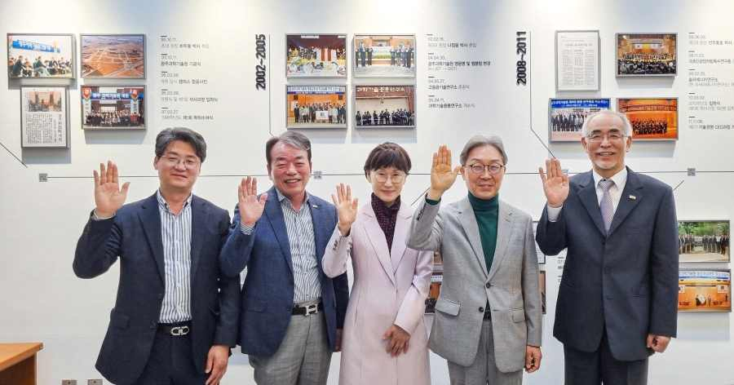
▲ Former EBS President Myung-joong Kim visits GIST and discusses the role and vision of GIST in the region and takes a commemorative photo with relevant officials including President Kiseon Kim. (From left) GIST Research Institute Director Chang-Duk Jun (concurrently serving as Dean of International and Public Affairs), GIST Power Generation Foundation Chair Jung-joo Koh, Gwangju Institute of Design Promotion Director Jin-hee Song, Former EBS President Myung-joong Kim, GIST President Kiseon Kim

GIST (Gwangju Institute of Science and Technology, President Kiseon Kim) invited former EBS President Myung-joong Kim to a meeting on the 3rd about expanding the role of GIST in the region and spreading consensus on its vision.

Former EBS President Kim Myung-joong (served from 2019.3 ~ 2022.3) contributed the most to EBS's great popularity by sympathizing and communicating with the public through the Pengsu character, which was created by EBS itself and gained national popularity during his tenure.

At the meeting, President Kiseon Kim, GIST Research Institute Director Chang-Duk Jun (concurrently serving as Dean of International and Public Affairs), GIST Power Generation Foundation Chair Jung-joo Koh, Gwangju Institute of Design Promotion Director Jin-hee Song, and former EBS President Myung-joong Kim discussed regional development plans and strengthening GIST's growth and capabilities.

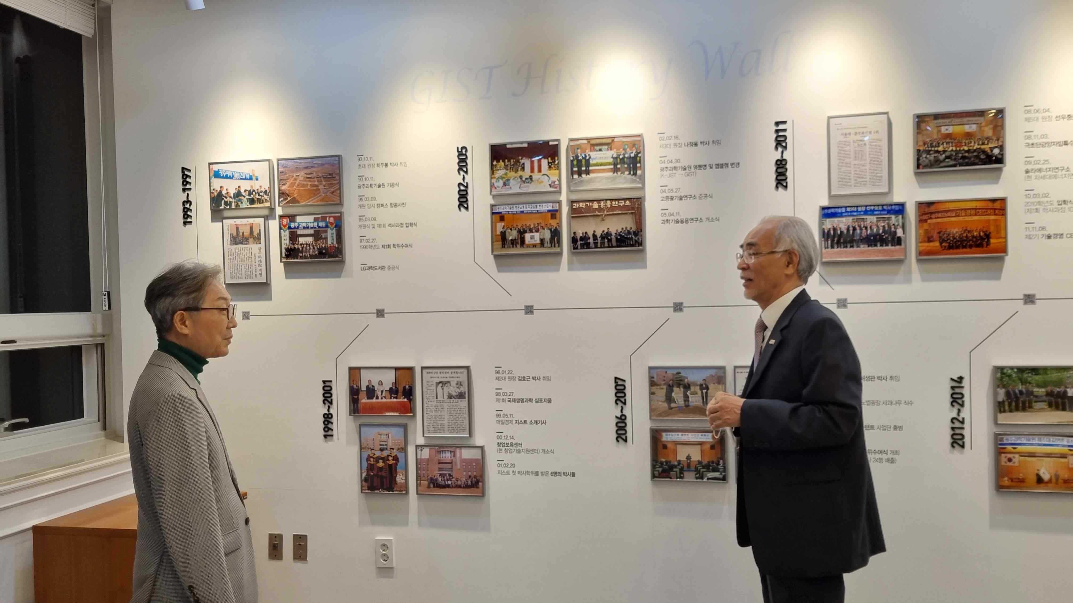
▲ (From left) Former EBS President Myung-joong Kim and GIST President Kiseon Kim



