GIST's Gliopathic Pain Research Center and Neurogrin Co., Ltd., sign a business agreement to develop the field of intractable chronic pain

– Expected cooperation to diagnosis intractable chronic
pain and to develop non-pharmaceutical treatments

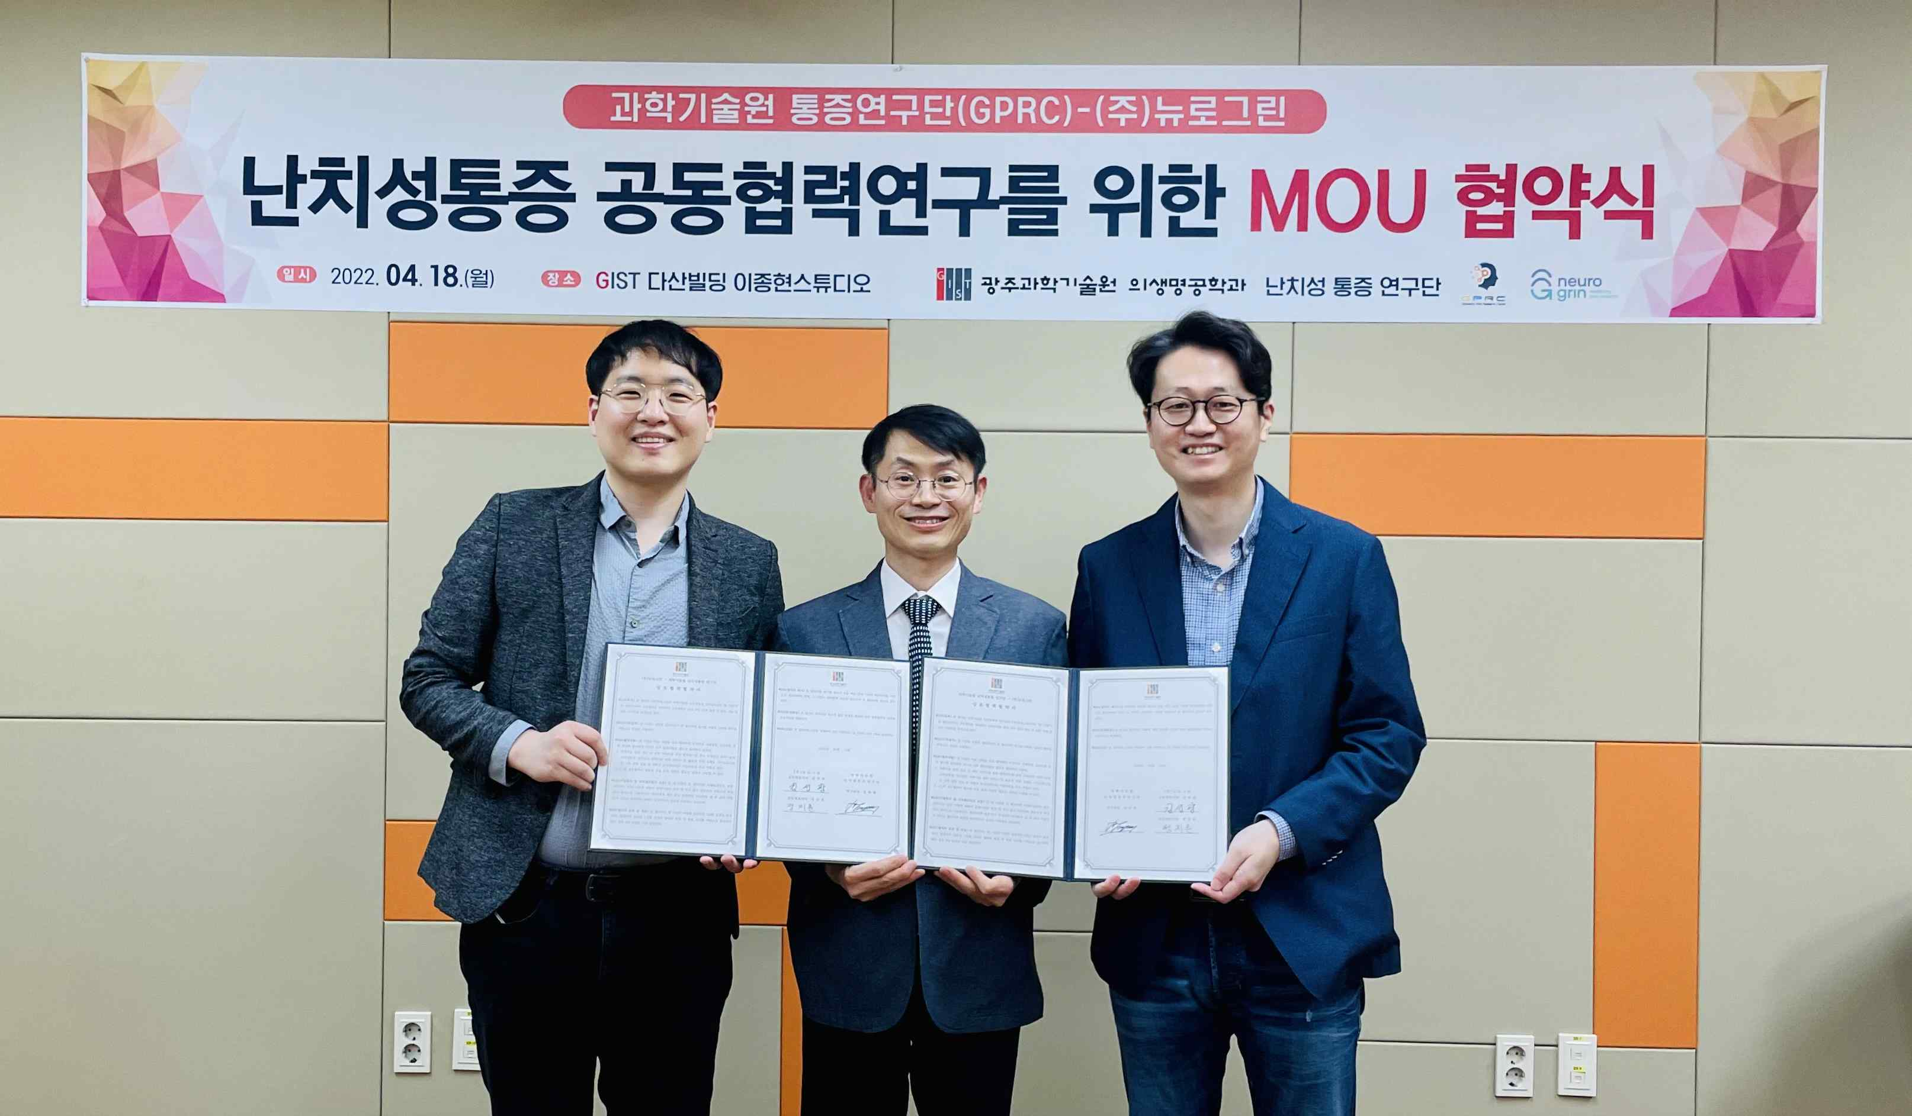
▲ GIST's Gliopathic Pain Research Center (Director Euiheon Chung, professor in the Department of Biomedical Science and Engineering) signed an MoU on the 18th with Neurogrin Co., Ltd. (Co-CEOs Seon-kwang Kim and Ji-hun Jung). (From left) Neurogrin Co., Ltd. CEO Ji-hun Jung, Gliopathic Pain Research Center Director Euiheon Chung, and Neurogrin Co., Ltd. CEO Seon-kwang Kim

The biopharmaceutical start-up Neurogrin Co., Ltd. (Co-CEOs Seon-kwang Kim and Ji-hun Jung) and GIST's Gliopathic Pain Research Center (Director Euiheon Chung, professor in the Department of Biomedical Science and Engineering), which consists of researchers from four institutes of science and technology and major hospitals, such as Chonnam National University and Yonsei University, signed a business agreement (MoU) for nurturing talented specialists in the field of intractable chronic pain and for the development of related industries.

The signing ceremony was held on April 18 at GIST's Department of Biomedical Science and Engineering in the 'Jong-hyun Lee Studio' with researchers from the Gliopathic Pain Research Center and co-CEOs of Neurogrin Co., Ltd.

Through this agreement, both parties plan to △ exchange of research in the field of intractable chronic pain △ cultivate outstanding specialists in related fields and △ conduct product development which sharing technical expertise.

With the support of Gwangju Metropolitan City, GIST was invited to participate in the joint research project for the four institutes of science and technology by the Ministry of Science and ICT. GIST's 'Development of Technology to Overcome Intractable Chronic Pain' project was selected, and a research group was formed that will operate with a total project budget of KRW 6.8 billion from December 2020 to 2024.

With GIST as the host organization, a number of researchers including 13 professors from KAIST, DGIST, UNIST, POSTECH, Chonnam National University Hospital, Yangsan Pusan National University Hospital, and Yonsei University Shinchon Severance Hospital are participating. Neurogrin Co., Ltd., Bisnob Co., Ltd, and Well, a patent firm, is conducting joint research as participating companies.

The Gliopathic Pain Research Center aims to develop a new pain diagnosis and treatment market by objectively diagnosing intractable chronic pain and to develop a precise neuromodulation-based non-pharmacologic treatment that can overcome the limitations of existing pharmacological treatments through glial cell control.

Neurogrin Co., Ltd., plans to conduct industry-academic cooperation with the research team through diagnostic and treatment technologies for cranial nerve diseases based on brain imaging, brain waves, and deep learning technologies.

Professor Euiheon Chung, the director of the research project, said, "Through industry-academic cooperation with Neurogrin Co., Ltd., we will make efforts to achieve good results in research on intractable chronic pain using advanced neuroscience and artificial intelligence (AI) technology."

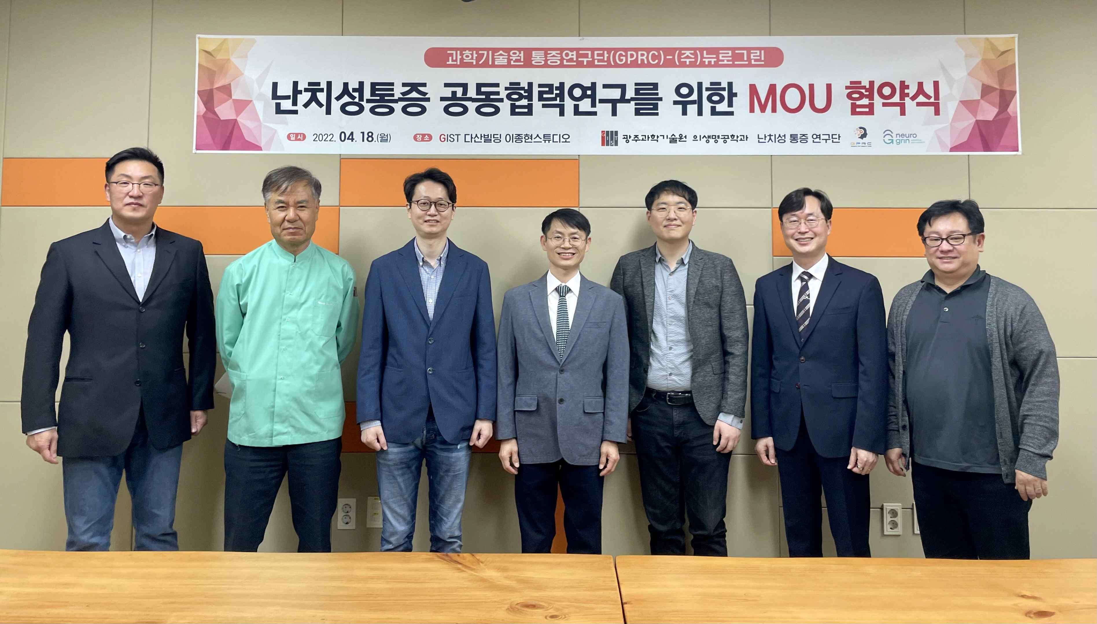
▲ (From left): Department of Biomedical Science and Engineering Professor Hyuk Sang Kwon, Professor Hyoung Ihl Kim, Neurogrin Co., Ltd. Co-CEO Seon-kwang Kim, Research Director Euiheon Chung, Neurogrin Co., Ltd. Co-CEO Ji-hun Jung, Department of Biomedical Science and Engineering Dean Jae Gwan Kim, and Professor Tae Kim



