GIST - Korea Air Industry Promotion Association signs a business agreement for the development of the air industry

– MoU held at GIST on the 26th... Promote professional workers and local industry development

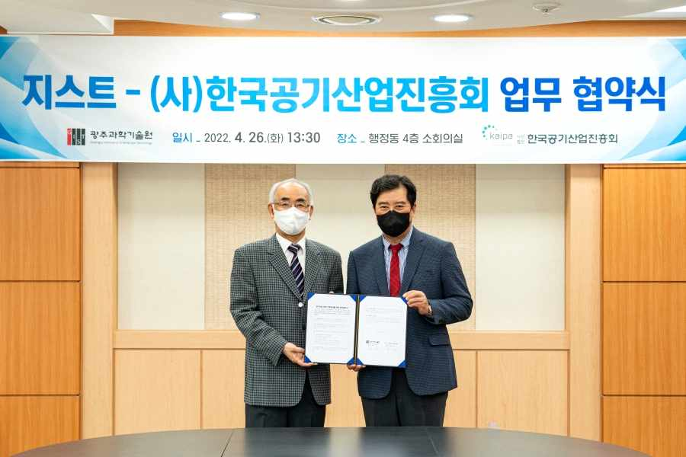
▲ GIST and the Korea Air Industry Promotion Association signed a business agreement for the development of the air industry: GIST President Kiseon Kim (left) and Korea Air Industry Promotion Association Chairman Bo-gon Kim (right)

GIST (Gwangju Institute of Science and Technology, President Kiseon Kim) and the Korea Air Industry Promotion Association (Chairman Bo-gon Kim) signed a business agreement (MoU) for nurturing experts in the air industry and for developing local industries.

GIST and the Korea Air Industry Promotion Association met on April 26 (Tuesday) at 1:30 pm in the GIST Administration Building and the signing ceremony was held in the presence of officials, including GIST President Kim Ki-seon, Vice President for Public Affairs Young-jip Kim, GIST Research Institute Director Chang-Duk Jun, Korea Air Industry Promotion Association Chairman Bo-gon Kim, Vice Chairman Chang-geum Song, and Secretary General Hwa-shin Lee.

Through this agreement, the two organizations will be able to △ exchange information to strengthen technological innovation capabilities △ invigorate the local economy and create jobs △ cultivate professional workers in the air industry △ support local companies with guidance and consulting regarding difficult technologies △ promote the discovery, analysis, transfer, and education of promising public technologies for commercialization.

In addition, the two sides plan to actively cooperate on matters necessary for mutual development and friendship promotion.

President Kiseon Kim said, "GIST will play a pivotal role in strengthening technological innovation capabilities and nurturing professional workers for the development of the air industry in our region, and we will make an active effort to revitalize the local economy and create jobs."

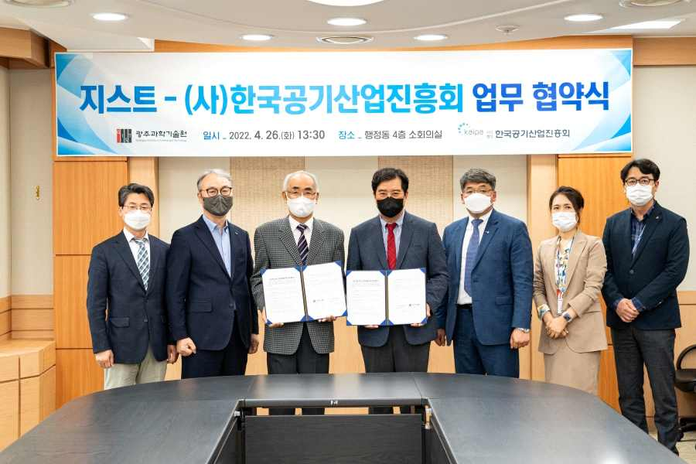
▲ GIST and the Korea Air Industry Promotion Association signed a business agreement for the development of the air industry and are taking a group photo. (From left) GIST Research Institute Director Chang-Duk Jun, President of DK Co., Ltd., In-seong Jang, GIST President Kiseon Kim, Korea Air Industry Promotion Association Chairman Bo-gon Kim, Vice Chairman Chang-geum Song, Secretary General Hwa-shin Lee, and General Manager Kyung-hoon Kwak



