GIST Academy held the April Breakfast Forum

– Professor Jong-rin Mo invited to give a lecture on the theme of "Cultivating Local Brands and Local Brands"

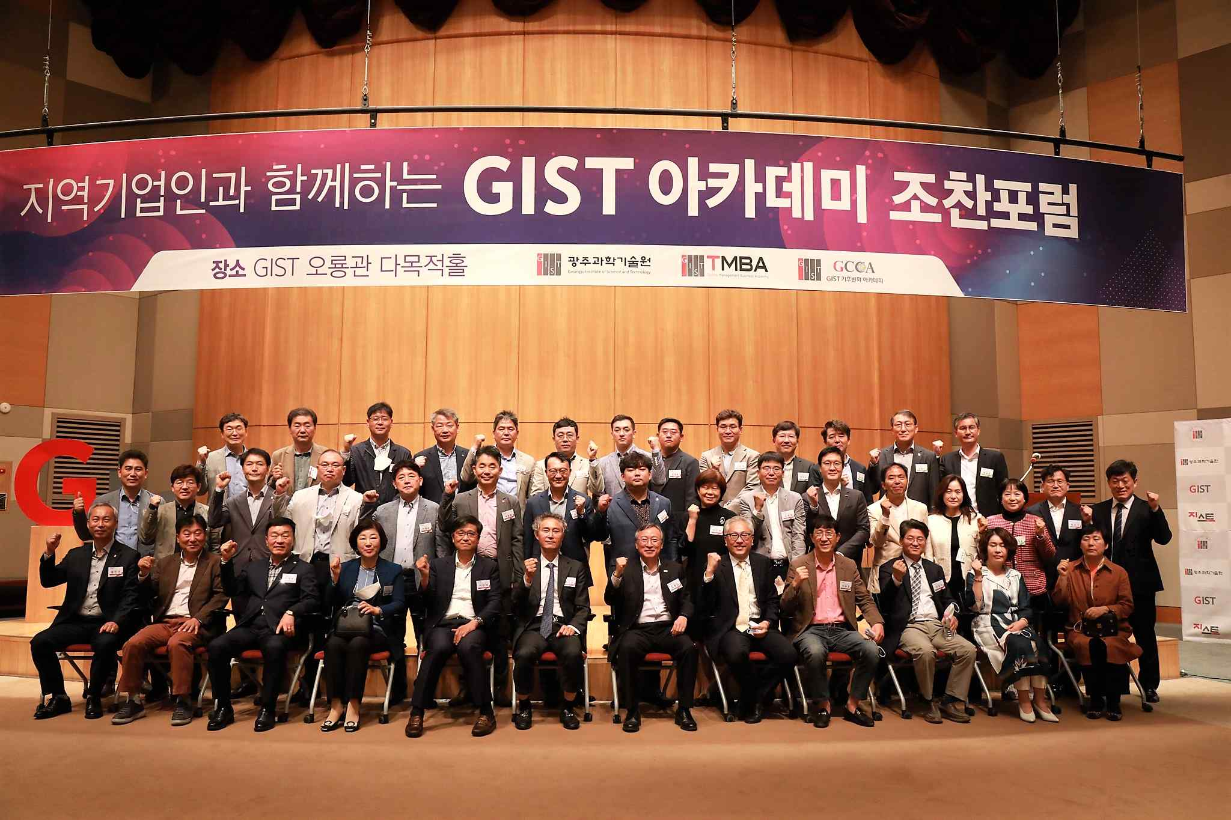
▲ Commemorative photo of GIST Academy holding a breakfast forum in April
under the theme of 'cultivating local brands and local brands'

GIST (Gwangju Institute of Science and Technology, President Kiseon Kim) Academy invited Yonsei University Professor Jong-rin Mo to hold an April Breakfast Forum under the theme of 'cultivating local brands and local brands' at Oryong Hall on April 25.

At the forum, which was attended by more than 40 leading business people in Gwangju and Jeollanam-do, Professor Mo drew keen attention with an explanation of 'Regional Development Indicators Model for Workplaces, Living Places, and Places of Activity' (Work, Live, Play), that refers to a place to work, place to live, and place to play.

Professor Mo explained various types of start-up ecosystems were and emphasized the necessity of diversifying local start-up types by saying, "Small business owners must again become the protagonists of Korean entrepreneurship, and cultural resources and the identity formed through them are the to key competitiveness in the formation of an alley commercial district."

Professor Jong-rin Mo received his BA in economics from Cornell University and his PhD in business Administration from Stanford University. He served as an assistant professor at the University of Texas at Austin, USA, and has been a professor at the Graduate School of International Studies at Yonsei University since 1996.

Economic development and globalization are his main research fields, and, since 2008, through policy research, he has studied policies necessary to enhance diversity and openness in Korean society have been studied under the theme of university gap, foreign investment, English education, immigration, and regional development.

His representative book is "Korean Development Theory: Dynamics of Overcoming Political Economic Imbalance" published by Harvard University Press in 2013.

GIST Academy, which operates the Techno Management Business Academy (opened in 2010) and Climate Change Academy (opened in 2016), hosts the "GIST Academy Breakfast Forum" on the last Monday of every month, inviting alumni and local business executives from various fields.

The GIST Academy is contributing to the vitalization of the local economy and industry-university cooperation by providing the best lectures by experts in Korea and a place to form wide human networks.



