Representative Yong-bin Lee actively examines the R&D source technology site to solve urban household waste

– Emphasizes active cooperation with local communities by visiting major GIST sites such as ECOSysChem Research Center

– Urges GIST to take the lead in solving social problems and become a regional innovation base

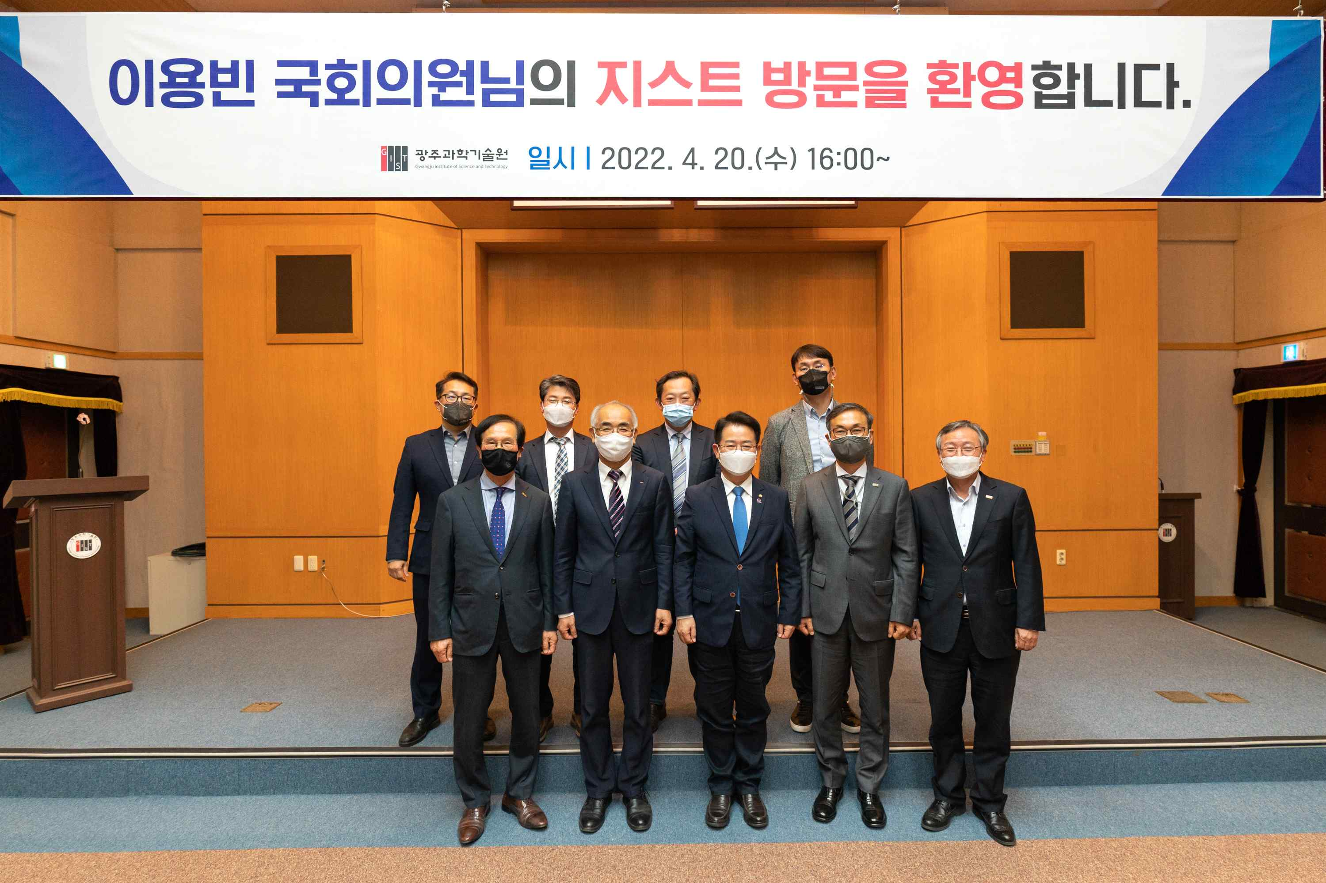
▲ Representative Lee Yong-bin visited GIST on the 20th (Wednesday) and is taking a commemorative photo with the GIST management and the Industrial-Academic Development Committee Chairperson Ki-soo Na, on the theme of supporting R&D in solving social problems. (Front row center: Representative Lee Yong-bin; second from the left President Kiseon Kim)

On the afternoon of April 20 (Wednesday), Representative Yong-bin Lee of the Democratic Party of Korea (Gwangju Gwangsan-gap, Science, ICT, Broadcasting and Communication Committee) visited GIST to find a research and development site for solving social problems such as urban waste treatment.

First, at 3 pm on the day, in the conference room on the second floor of the GIST Administrative Building, a meeting was held with GIST executives, including President Kiseon Kim and GIST Industrial-Academic Development Committee Chairperson Ki-soo Na (C&S Korea CEO, Gwangju/Jeonnam Economic Association Chair).

After the meeting, Representative Lee looked at the site of the △ GIST ECOSysChem Research Center △ AI Graduate School Practical Training Center △ High Performance Computing-based Artificial Intelligence Joint Utilization Facility (HPC-AI) △ the site of GIST's planned 'Future Social Strategy Center.'

In particular, Representative Lee personally visited the laboratory of 'ECOSysChem Research Center,' which opened at GIST last year, and worked with Center Director In Seop Chang (professor in the School of Earth Science and Environmental Engineering) and discussed ways to support R&D of source technology to solve environmental problems through recovery and increase added value.

Urban household waste is the third largest source of greenhouse gas emissions in Korea, and it is currently being incinerated because landfill use is prohibited.

The 'ECOSysChem Research Center,' which started as a joint research council with the Korea Energy Research Institute and was selected as a leading research center supported by the Ministry of Science and ICT, will solve social problems through eco-friendly treatment of urban waste and development of upcycling technology. Research is being carried out with the goal of securing source technology.

ECOSysChem Research, which will receive a total of KRW 13.5 billion by 2028, focuses on 'gasification' as a future technology to replace domestic waste incineration and utilizes gaseous substances generated after gasification reaction to promote technology development for reduction of carbon dioxide emissions. It plans research on biological technology for conversion of all gas to syngas derived from municipal waste, a catalyst for conversion of residual carbon dioxide after syngas reaction, and recovery of organic and inorganic by-products derived from syngas.

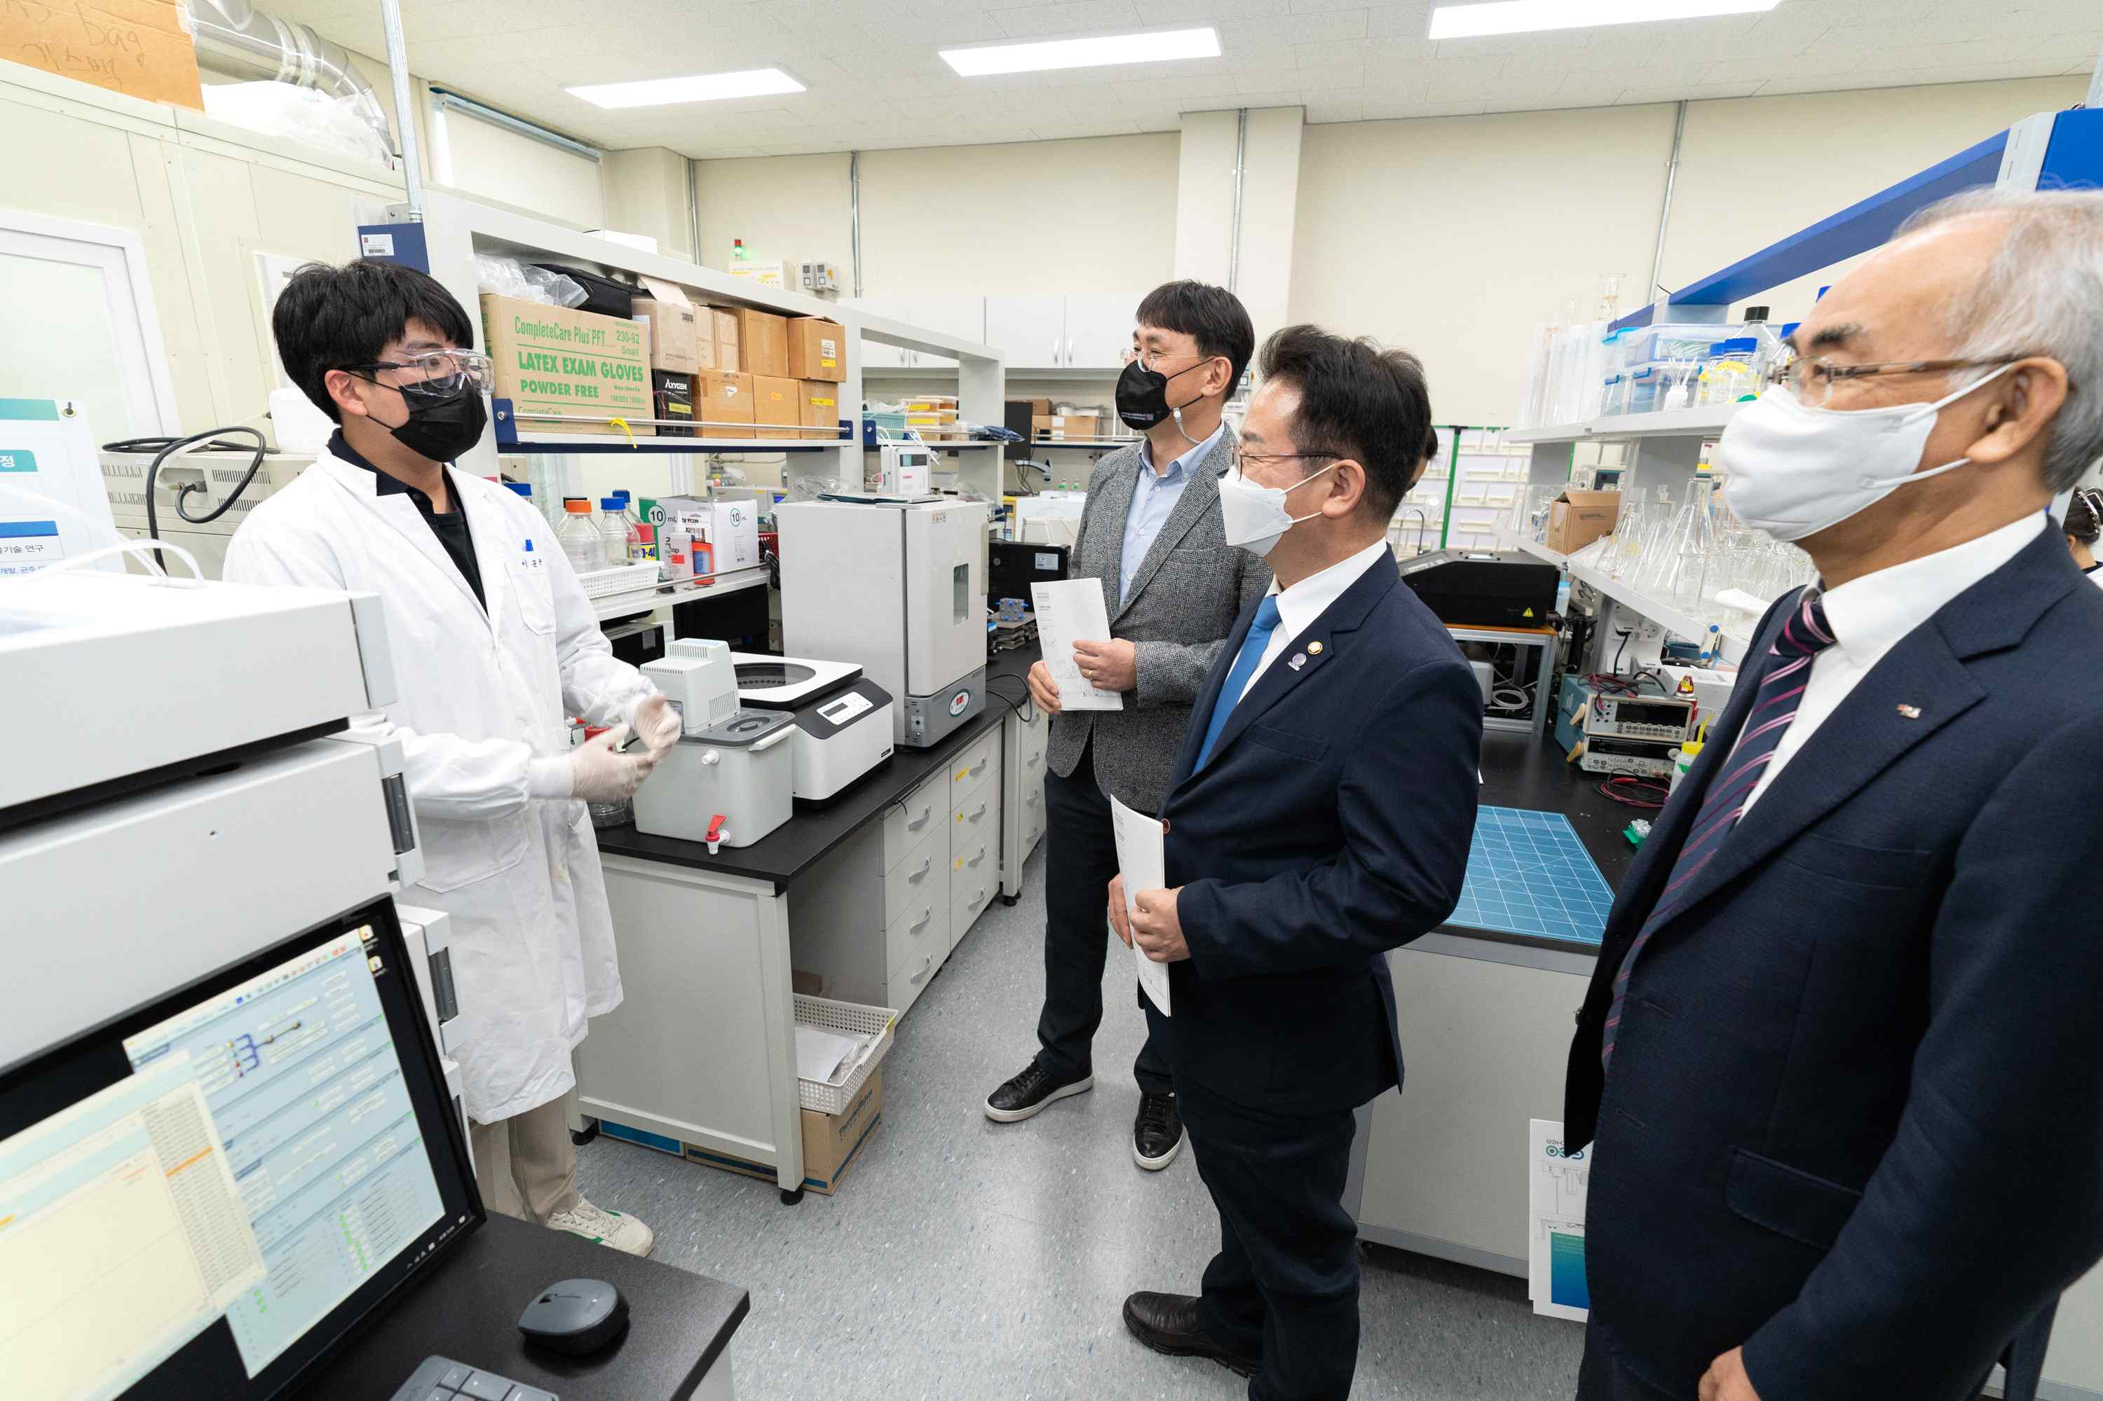
▲ Representative Yong-bin Lee visits with members of the ECOSysChem Research Center and tours the facilities to discuss ways to solve social problems and support R&D of original technologies.

Representative Yong-bin Lee, who is focused on solving social problems using science and technology with support for R&D, said, "Conflict between local governments and residents is getting serious as the amount of urban household waste has increased rapidly due to the impact of COVID-19. In this regard, we will actively support efforts to develop source technologies to improve the environment of local communities and contribute to citizens' lives in a comfortable environment."

He continued, "To solve various social problems caused by technological development, it is important to have a variety of new ideas and problem-solving methods based on science and technology. Please make an effort so that young students who will become future scientists and engineers understand the role and social responsibility of science and technology to solve social problems and participate in R&D."

Meanwhile, Representative Lee recently proposed the 'Science and Technology Convergence Specialist Promotion Act (partial amendment to the Special Act on Support for Science and Engineering),' which will actively support human resources necessary to create essential national strategic skills.



