"Can I become an entrepreneur?"
GIST runs entrepreneurial experience education for youths

– "2022 Regional Entrepreneurship Experience Center" education started... Participated in 7 local middle and high schools including Jangdeok-jung
– Entrepreneurship and idea expansion practice to experience startup culture and develop entrepreneurial spirit

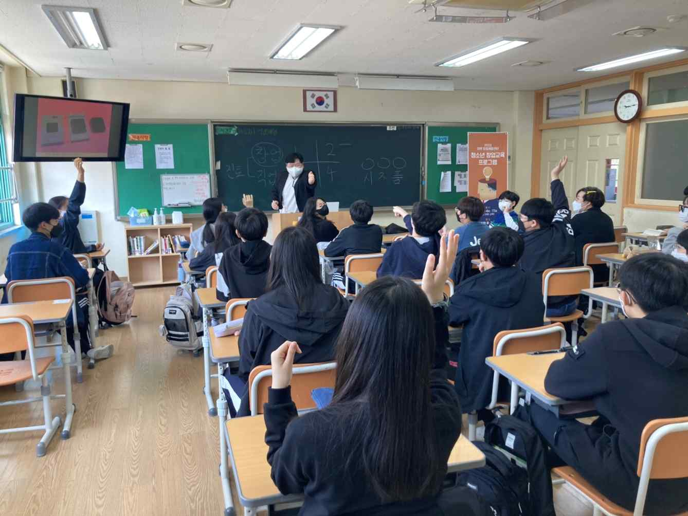
▲ Students at Jangdeok Middle School in Gwangju, which started their
first class this year, are taking a quiz about starting a business.

GIST (Gwangju Institute of Science and Technology, President Kiseon Kim) is operating the "2022 Regional Entrepreneurship Experience Center Education Program" for Gwangju middle and high school students to spread the entrepreneurial culture in the region and cultivate the entrepreneurial spirit of young people.

The start-up education program, which marks its third year this year, started with a business agreement between GIST and the Gwangju Institute of Education and Research and Information in 2020, provides start-up-related practice and education that can actually help teenagers set their careers and foster entrepreneurship.

This year, starting with Jangdeok Middle School in Gwangsan-gu (April 11), the program will be held 26 times until December at seven schools, including △ Pyeongdong Middle School △ Chungjang Middle School △ Gakhwa Middle School △ Gyeongshin Middle School △ Gwangju Promotion High School △ Munseong Middle School.

Students learn about successful and unsuccessful companies, idea commercialization, and technology commercialization through light quizzes in class. After expanding the ideas with the mandala (lotus technique)*, a thinking technique originating in Japan, they practice converging and combining each other's ideas to materialize them.

* mandala: An idea technique developed in 1987 by Japanese designer Hiroaki Imaiizumi. It is a thinking technique that helps you to come up with various ideas using the shape of a lotus flower in full bloom.

Afterwards, they share their ideas with other teams through a '3 minute speech' and see how they can sell more to consumers, and they will experience concerns from the perspective of entrepreneurs, such as how to proceed with product distribution and promotion.

As a result of a satisfaction survey conducted on participants last year, students' satisfaction and sense of achievement were high with regard to these practical training and entrepreneurship education tailored to their level.

GIST Business Incubator Director Byeong-gwan Cho said, "I hope that it will be an opportunity for more young people to become interested in starting a business and develop a challenging spirit through the programs of the local entrepreneurship experience center. GIST plans to continuously strive to nurture the entrepreneurial spirit of local youth and develop creative career paths through the spread of a start-up culture using startup capabilities and infrastructure."



