The age of autonomous driving! Nurturing experts who will advance the era of autonomous driving

– Training future vehicle research personnel...
Expected to be a leader in autonomous driving

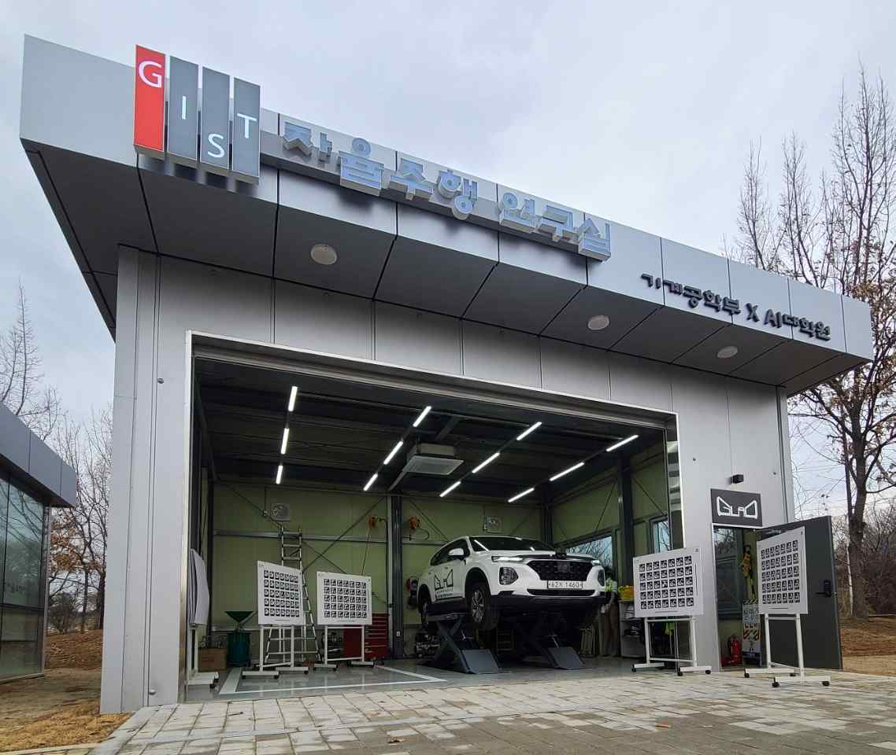
▲ GIST Autonomous Driving Research Facility: GIST has a garage that can maintain and renovate future-oriented cars that can drive autonomously based on high-performance NVIDIA Xavier.

GIST (Gwangju Institute of Science and Technology, President Kiseon Kim) announced that it will nurture experts in core technology for future automobiles, which are attracting attention as a future strategic project, jointly with Yonsei University, Sogang University, and Korea University.

The team of four universities will be selected for the Ministry of Trade, Industry and Energy's future vehicle core technology specialist training project and will receive a total of 11.8 billion won for five years until 2027 (business period: 2022.03 ~ 2027.02).

GIST is producing key professionals at national bases for innovation in local industries (automobiles) and artificial intelligence (AI). This project supports seven AI Graduate School (Director JongWon Kim) students every year. In the first semester of 2022, an advanced autonomous driving major track was opened.

GIST has a self-driving vehicle maintenance building, self-driving vehicles, parallel computing facilities worth 10 billion won, and world-class artificial intelligence experts. Through this project, GIST plans to continuously supply core autonomous driving personnel to the region.

It also explained that a number of autonomous driving companies participate in the curriculum and carry out field-oriented projects.

The companies that have been confirmed to participate are ▲ SOS Lab (Co.) ▲ AU ▲ Autonomous A2G (Co.) ▲ Spring Cloud (Co.) ▲ Fine Specialty Co., Ltd. ▲ TenergySoft Co., Ltd., and a number of other companies will be added. These companies are specialized in radar, lidar, vehicle, and artificial intelligence, covering all related industries for autonomous driving.

The joint team will share roles and conduct education according to the expertise of each university in the project.

GIST and Yonsei University provide specialized training for autonomous driving. Sogang University and Korea University specialize in connected car education, but mutual credit is recognized through research exchanges. They plan to maximize synergy by hosting joint contests.

GIST Professor Yong Gu Lee said, "If GIST produces high-quality professionals specialized in autonomous driving for five years, following the recent success stories of future cars such as Tesla and Lucid, Gwangju Metropolitan City is expected to play a leading role in the future of self-driving cars."

Meanwhile, GIST plans to focus on developing human resources to secure rapid and continuous development capabilities of future autonomous automobile driving technology that combines virtual and real driving linking AI + automobile specialization efforts pursued by the national artificial intelligence complex being built in Gwangju and the e-mobility convergence valley promoted by Yeonggwang-gun, Jeollanam-do.

Through cooperation with the Artificial Intelligence Industrial Convergence Project Group and the Green Car Promotion Agency, it plans to pursue the stabilization of virtual environment driving simulation technology using a large driving simulator in the cluster, which is scheduled to be built in 2023. It is expected to contribute to rapid performance and reliability improvement through virtual driving based on autonomous driving scenarios.

In addition, it will promote the selection of an e-mobility regulatory free zone in Yeonggwang-gun, the development of micro electric vehicles centered on the e-mobility research center built in the Daemasan Industrial Complex, and the development of personnel using indoor evaluation equipment for core parts, outdoor test beds, and crash test sites.



