GIST launches Special Committee for the Improvement of Integrity

– The 1st meeting of the Special Committee for the Improvement of Integrity meeting held on the 28th

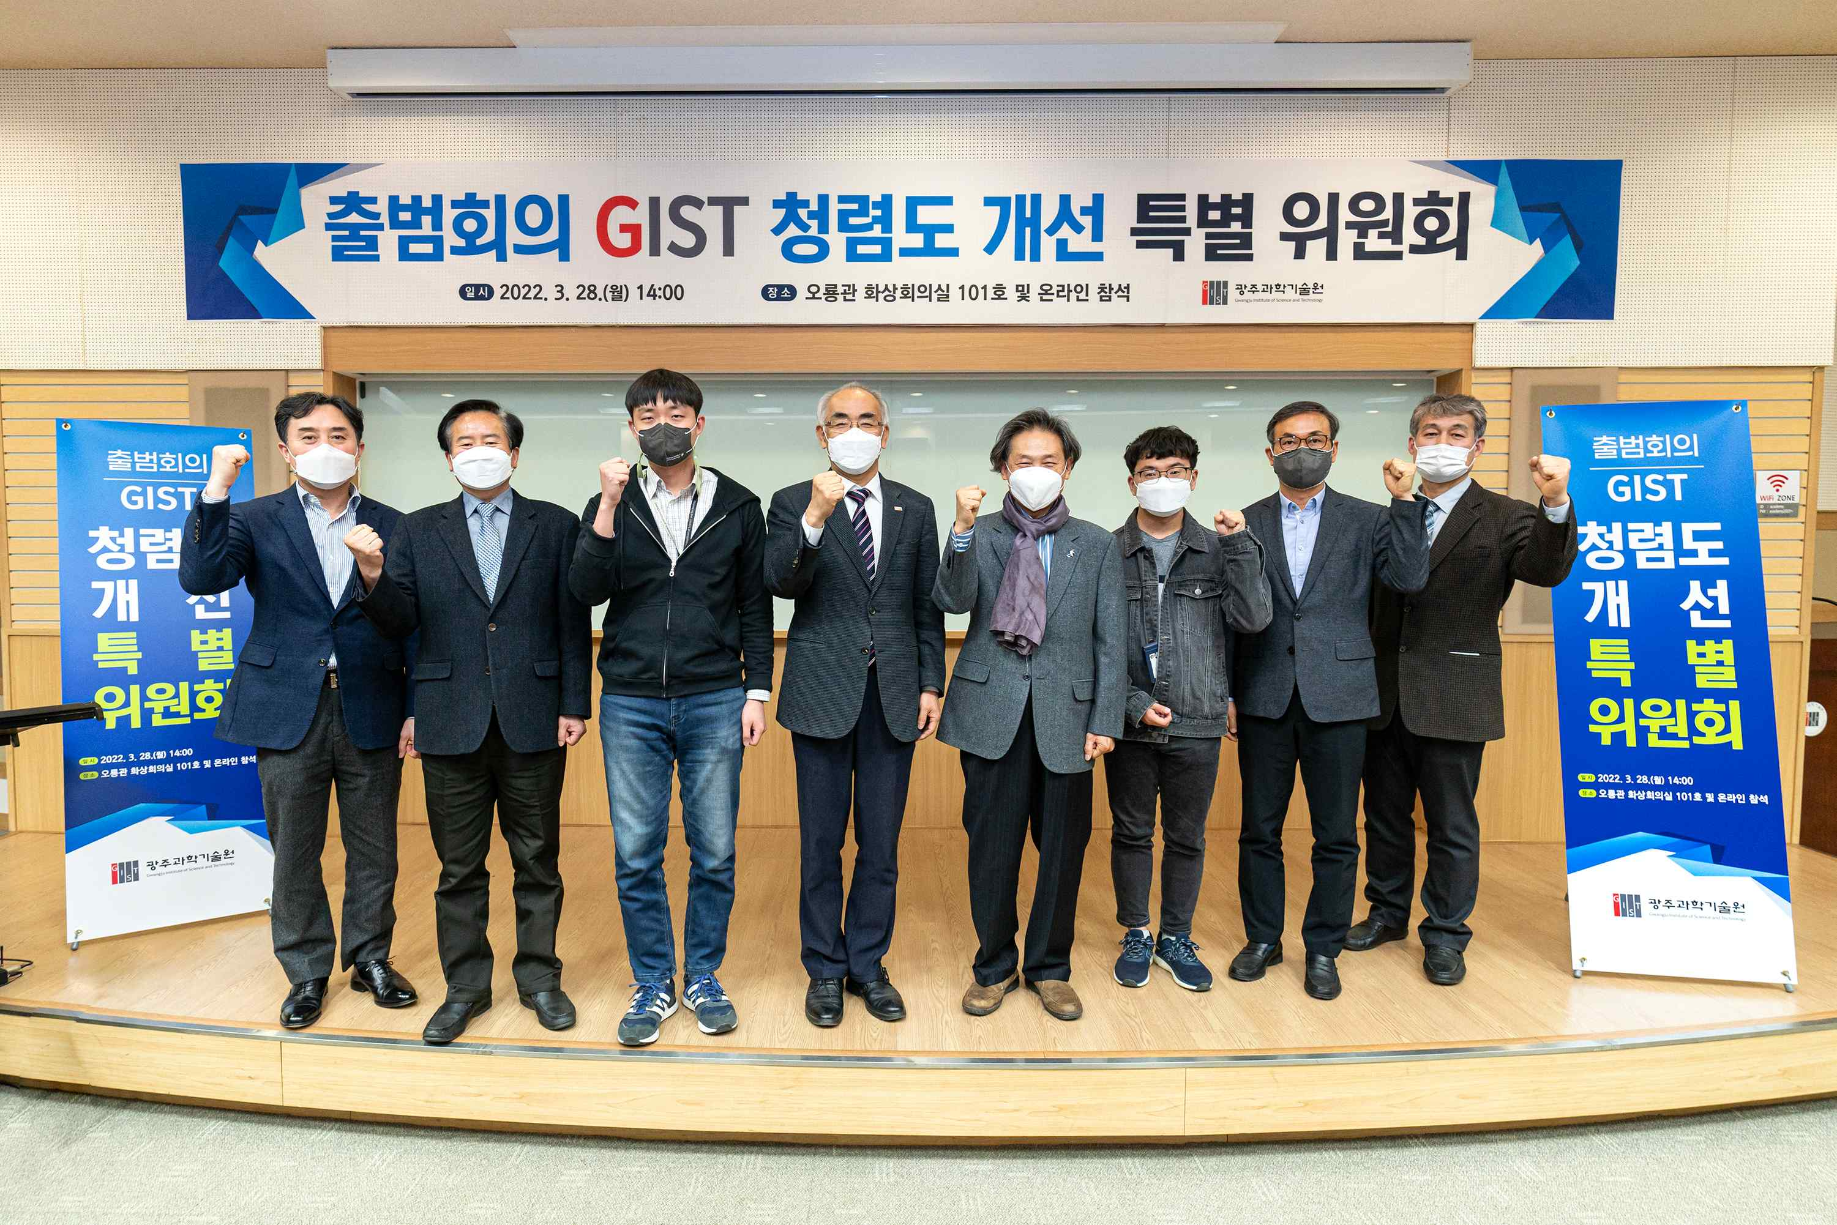
▲ GIST formed a special committee to improve institutional integrity and held its first meeting at Oryong Hall on the 28th. Commemorative photo of the members and officials attending the face-to-face meeting. From left: External Advisor Sang-hoon Lee, Graduate School Student Association President Hae In Jung, President Kiseon Kim, Chairperson Sang-yoon Kim, Graduate School Student Council Vice President Dongjae Kwon, and Vice President of Academic Affairs Raekil Park

GIST (Gwangju Institute of Science and Technology, President Kiseon Kim) in February formed a special committee to improve institutional integrity and held the first meeting in Oryong Hall on the 28th.

The meeting was conducted as both an online meeting and face-to-face meeting with only a small number of attendees to prevent the spread of COVID-19. As major agenda items, a report on the composition of the special committee, sharing of the results of the integrity evaluation in 2021, and ways to improve were discussed.

To improve the results of the Anti-Corruption and Civil Rights Commission's integrity measurement, which is evaluated at a lower level every year despite the importance of integrity, the special committee oversees related tasks such as deliberation of policies to improve institutional integrity and deriving improvement plans.

The Special Committee deliberates on policies to improve institutional integrity in order to improve the results of the Anti-Corruption and Civil Rights Commission, which is evaluated at a lower level every year, and coordinates related tasks, such as deriving improvement plans, etc.

It plans to establish improvement plans for each area of integrity, such as establishing measures to improve unfair work orders, and conduct practical discussions to improve integrity, specifically: ▲ Research: Establishment of measures to prevent embezzlement, illegality, and unfair execution of research funds ▲ Administration: Establishment of measures to limit HR-related money, goods, entertainment, and conveniences, and establishment of measures to prevent illegal and unjust execution of budget ▲ Organizational culture system: business handling to prevent improper solicitation.

The Integrity Committee was chaired by former GIST Auditor Sang-yoon Kim and Vice Chairperson Raekil Park (Vice President of Academic Affairs). The chairperson and advisory committee members were all appointed as outsiders, and all members, including key officials, union leaders, and representatives of the student body, were encouraged to participate for the improvement of integrity.

President Kiseon Kim said, "In spite of various efforts such as self-integrity survey, the low integrity evaluation result should be used as an opportunity for innovation by all members through reflection. I hope that GIST will join resources to become a trusted school that realizes ethical management by leaping forward as an exemplary integrity institution."



