GIST Academy hosts Breakfast Forum
in March about "Einstein's Legacy"

– GIST Professor Keun-Young Kim, emphasizes understanding
of general relativity and various related phenomena

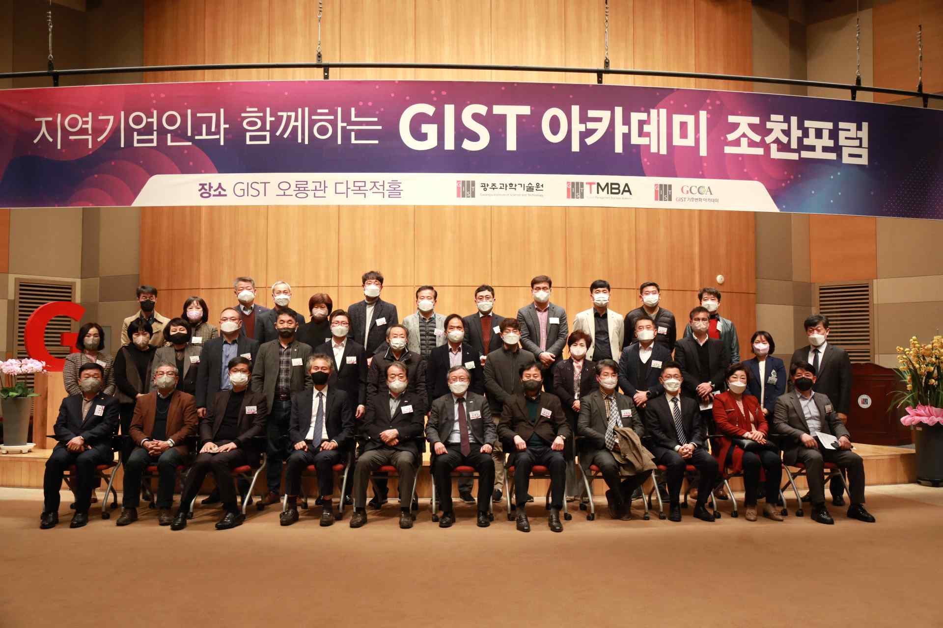
▲ Commemorative photo: GIST Academy hosts a breakfast forum in March at Oryong Hall.

GIST (Gwangju Institute of Science and Technology, President Kiseon Kim) Academy hosted a Breakfast Forum for representatives of 40 companies from Gwangju and Jeollanam-do on March 28 at Oryong Hall on the themes of 'Einstein's Legacy: Black Holes, Gravitational Waves, and GPS.'

At the forum, Department of Physics and Photon Science Professor Keun-Young Kim drew great attention by explaining Einstein's general theory of relativity, black holes, gravitational waves, and GPS in an easy-to-understand manner.

Professor Keun-Young Kim introduced interesting predictions of the general theory of relativity, and he cited observations of black holes and gravitational waves as representative examples. In particular, the observation of gravitational waves is the result of the collision of two black holes, and he emphasized that this will play an important role in studying the properties of black holes.

Professor Kim also aroused the interest of the participants by suggesting that GPS navigation cannot work without the general theory of relativity.

Meanwhile, on the last Monday of every month, the GIST Academy Breakfast Forum provides opportunities for innovation awareness, technology transfers, and industry-university cooperation through lectures by experts from various fields for alumni and local business executives.

GIST Academy operates two courses: GIST Techno Management Business Academy (opened in 2010) and GIST Climate Change Academy (opened in 2016). The Academy is contributing to the revitalization of the local economy and industry-university cooperation by cultivating the local economy and forming a wide human network.



