GIST signs MoU with Yeonggwang-gun to train professionals in e-mobility and AI convergence

– Revitalizing education innovation and international joint research through the Future Innovation Committee (tentative name)

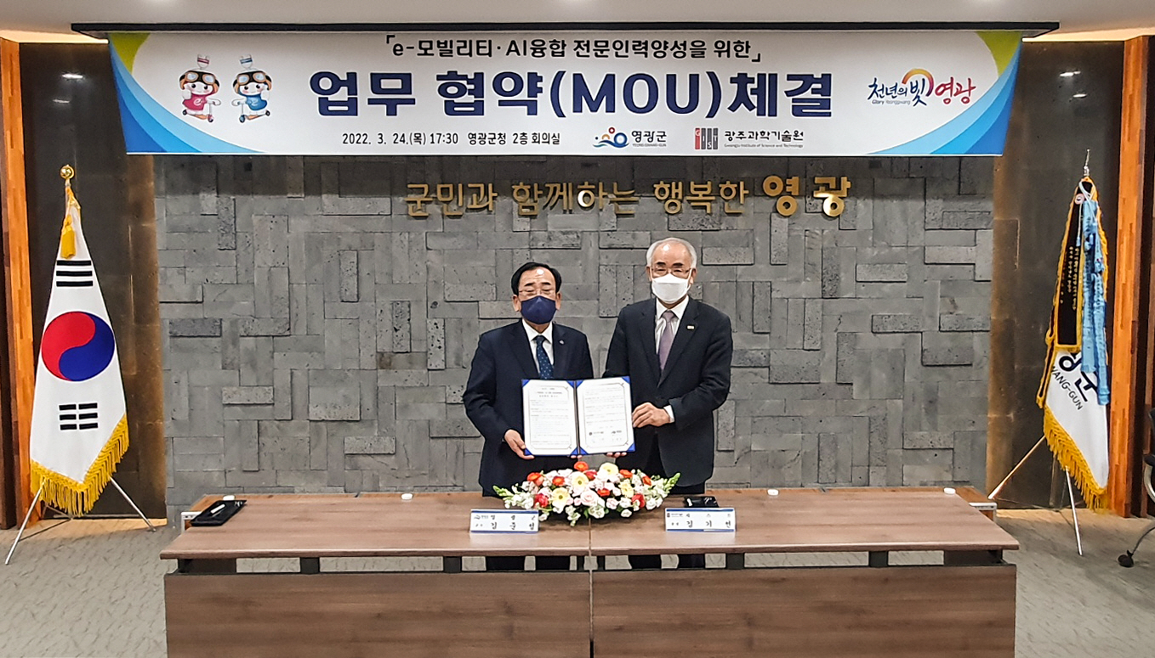
▲ GIST signs MoU with Yeonggwang-gun on the 24th to train professionals in e-mobility and AI convergence. From left: Yeonggwang-gun Governor Jun-sung Kim and GIST President Kiseon Kim

GIST (Gwangju Institute of Science and Technology, President Kiseon Kim) signed a business agreement (MoU) with Yeonggwang-gun (Governor Jun-sung Kim) to train outstanding professionals in e-mobility and artificial intelligence (AI) convergence and to carry out related projects.

The signing ceremony was held on March 24 at the Yeonggwang-gun office with key officials attending, including GIST President Ki-seon Kim and Yeonggwang-gun Governor Jun-sung Kim.

The main contents of the agreement included support for opening a Smart Mobility Demonstration Center (tentative name) for the creation of an industry-academia convergence facility within the Daemasan Industrial Complex and a plan to train professional manpower after the establishment of the GIST Mobility Yeonggwang Campus.

Yeonggwang-gun will provide administrative and financial support for the e-mobility professional training project, and GIST will develop educational programs for nurturing specialists after the establishment of the Smart Mobility Research Center and a specialized graduate school. In addition, the plan is to organize a TFT for the successful implementation of the related tasks and actively cooperate on matters necessary for mutual development and friendship promotion between GIST and Yeonggwang-gun, such as securing a budget.

GIST President Kiseon Kim said, "Through the cooperation of GIST, which possesses cutting-edge technology and equipment in the field of artificial intelligence, and Yeonggwang-gun, Korea's representative e-mobility city, we expect the best performance and development in the field of smart mobility education and research."

An official from Yeonggwang-gun said, "By combining the military's future strategic project, e-mobility industry, and the excellent educational and research capabilities of the Gwangju Institute of Science and Technology, we will do our best to lead the era of the 4th Industrial Revolution by training the best e-mobility personnel in Korea."

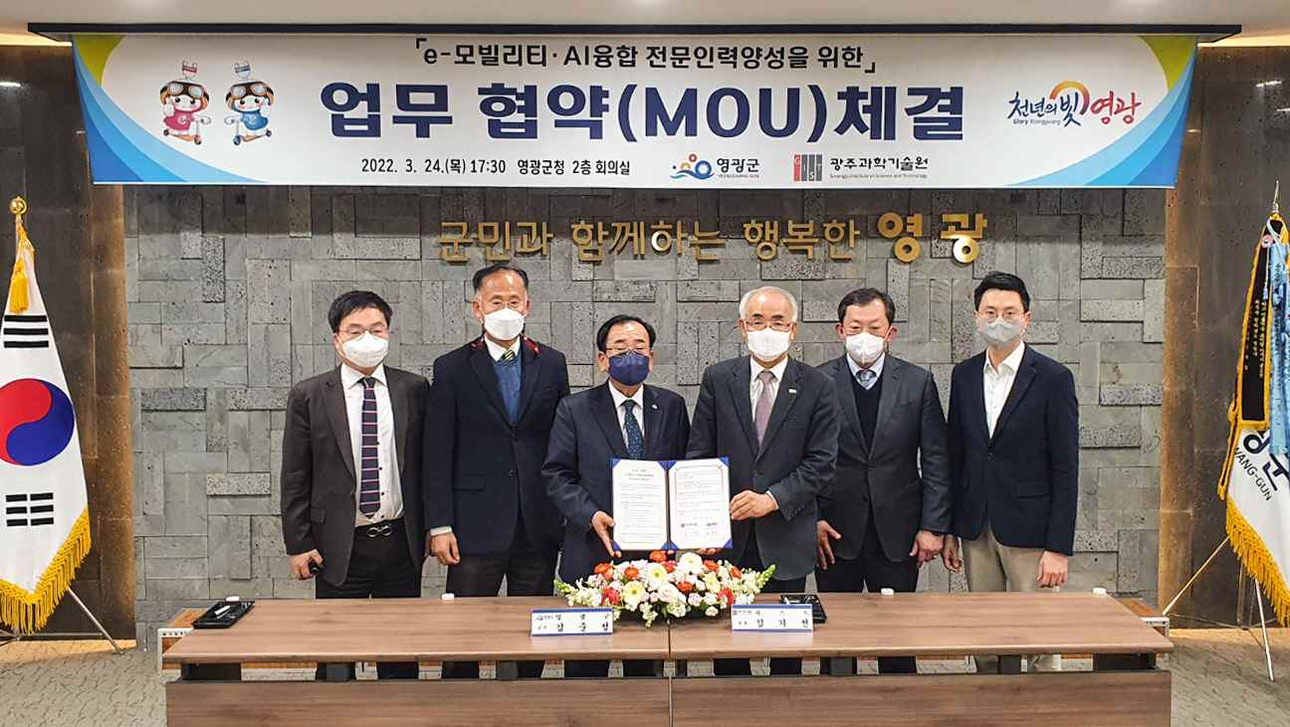
▲ From left: Immobility Industry Director Jae-cheol Han, GIST Institute for Artificial Intelligence Director Heung-No Lee, Yeonggwang-gun Governor Jun-sung Kim, GIST President Kiseon Kim, Office of Planning Dean Zee-Yong Park, Research Innovation Center Director Deuk-jo Gong

Meanwhile, in February, the two organizations established a research facility in the industrial complex in accordance with the Ministry of Trade, Industry and Energy's selection for a future vehicle core technology specialist training project to establish a virtuous cycle system of R&D - manpower development - employment, and it plans to contribute by training experts in the future automobile industry, such as e-mobility, and by revitalizing the local economy.



