GIST hosts Climate Change Academy matriculation ceremony and Development
Fund donation ceremony

– 40 students enrolled for the 5th GIST Climate Change Academy
– Alumni Ok-nam Seo, CEO of Hanbada Co., Ltd., donated to the Development Fund

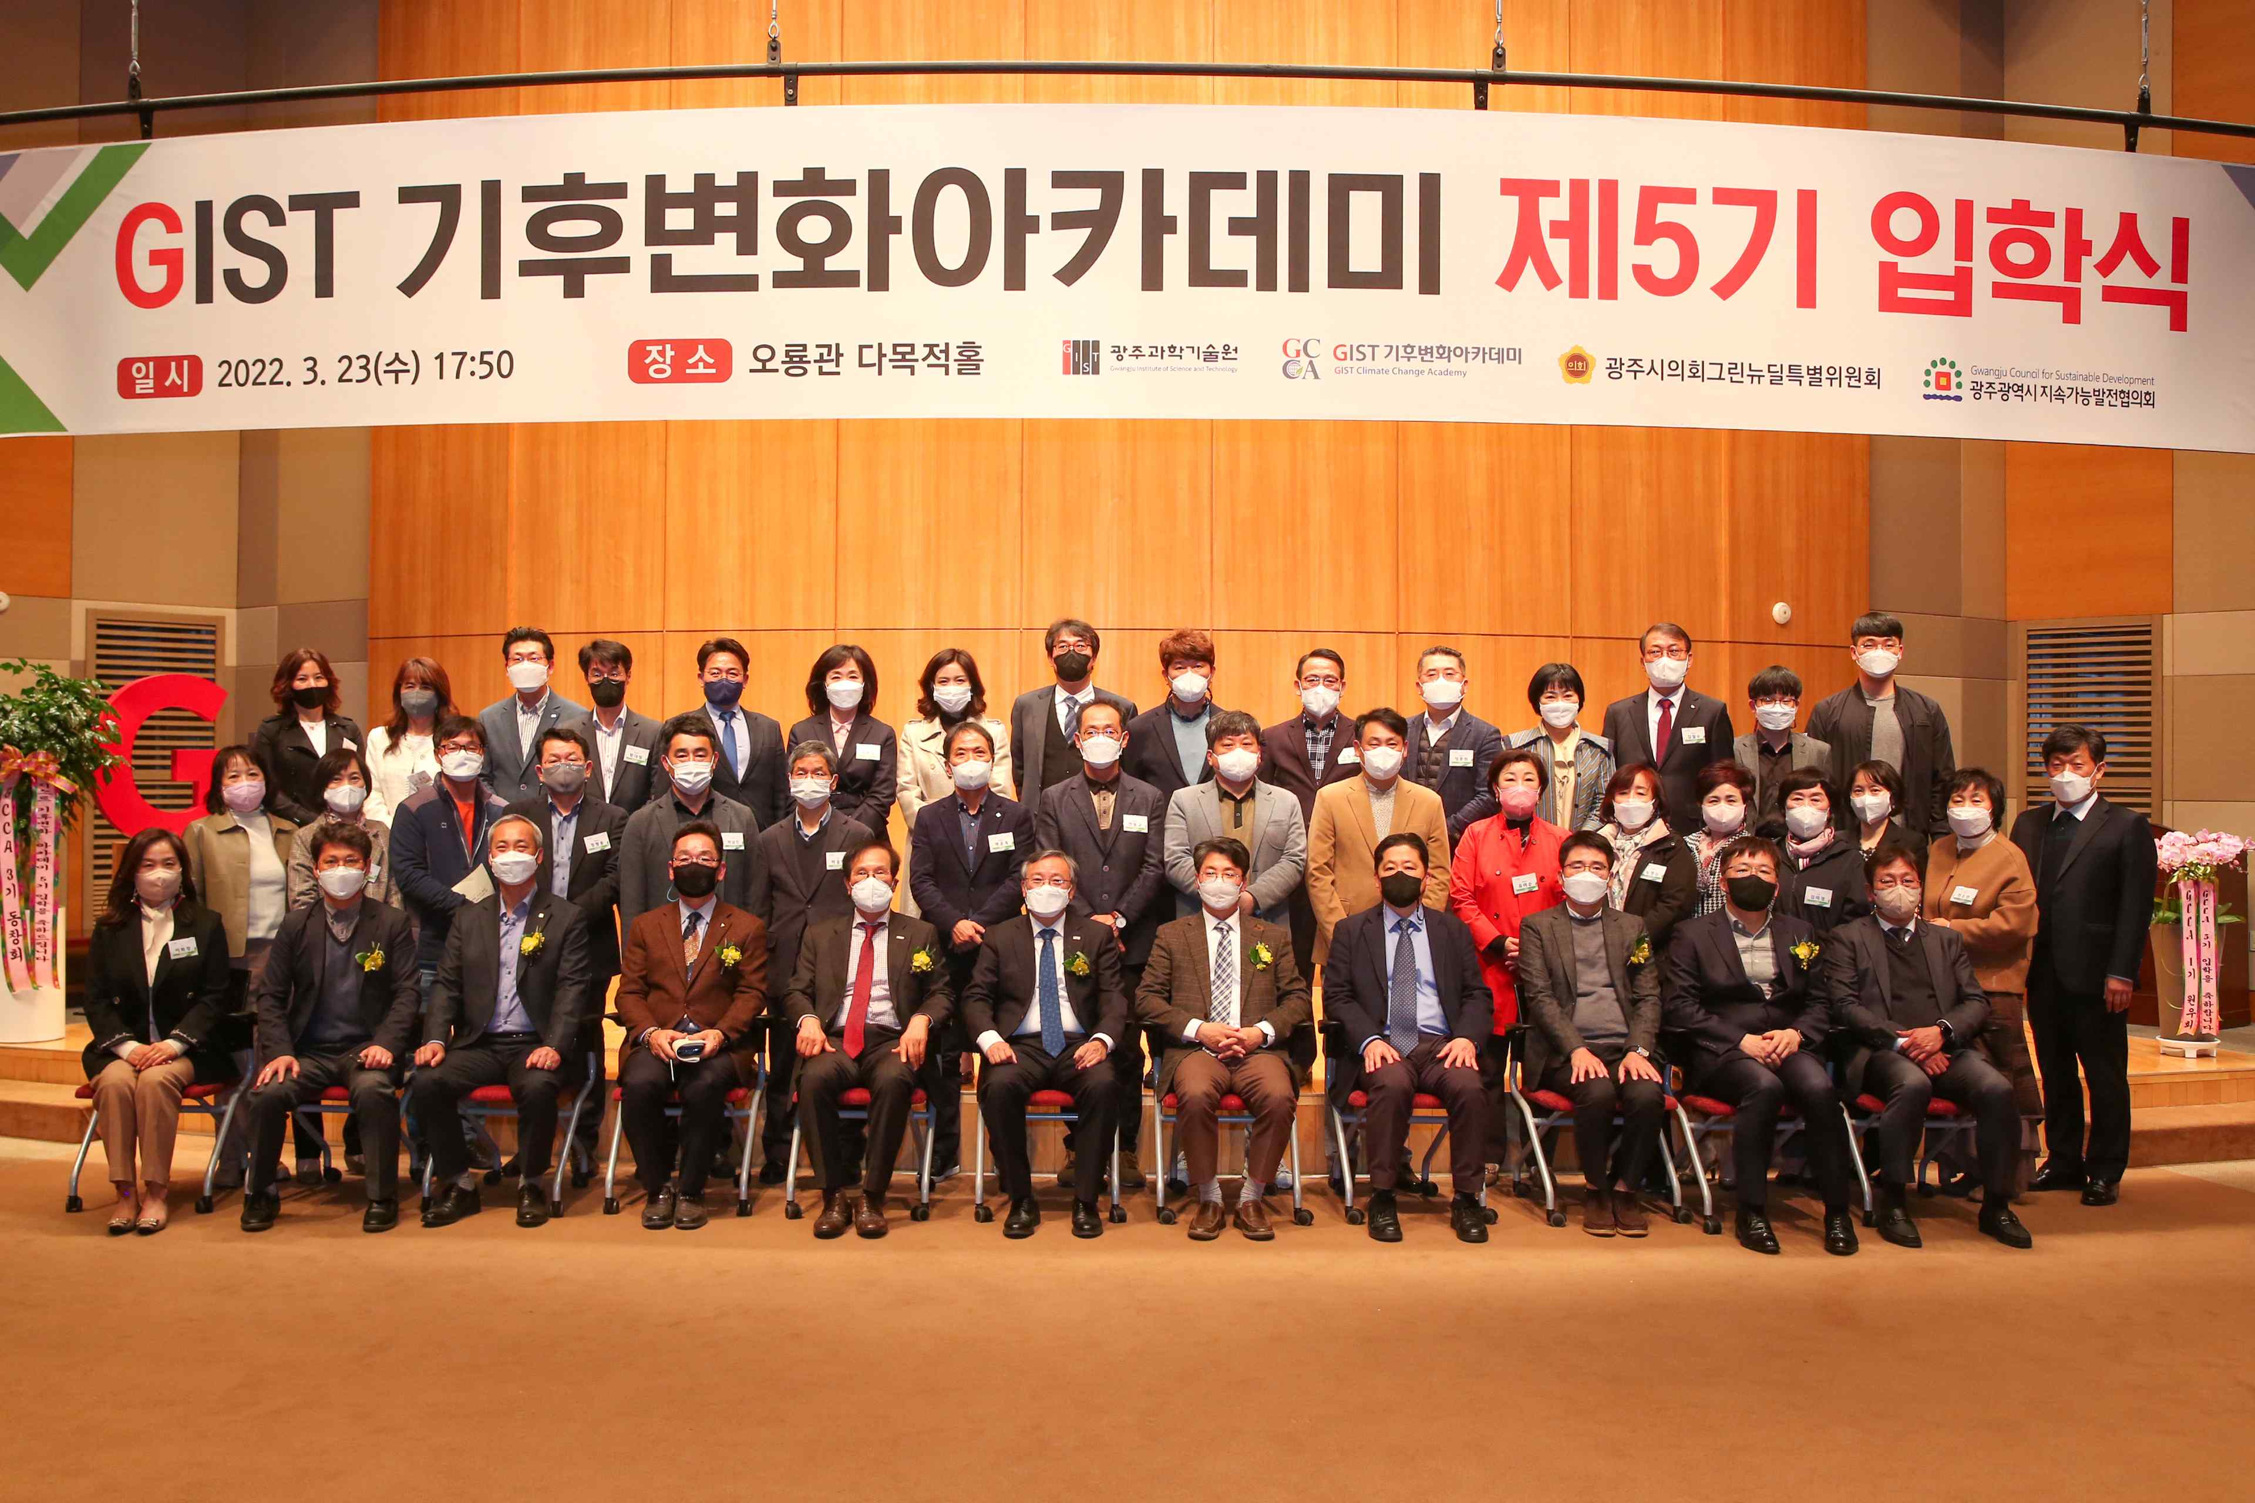
▲ Commemorative photo: 5th GIST Climate Change Academy (GCCA)
matriculation ceremony held at Oryong Hall

GIST (Gwangju Institute of Science and Technology, President Kiseon Kim) Climate Change Academy (GCCA) held its 5th matriculation ceremony on March 23 at GIST Oryong Hall.

The event was held in the presence of 40 students and senior GIST officials, including Vice President of Public Affairs Young-jip Kim, Research Director Chang-Duk Jun, and Senior Professor Kyoung-Woong Kim.

In his welcoming remarks, Vice President of Public Affairs Young-jip Kim said, "I hope that the discussions on climate change that will take place in this Academy will serve as a platform for sustainable growth to predict future changes and adapt to the changing environment."

On the same day, alumni Ok-nam Seo (CEO of Hanbada Co., Ltd.) donated 10 million won to the Development Fund, which will be used to improve the GIST Climate Change Academy.

Hanbada Co., Ltd., is a specialized company that mainly distributes various kinds of live fish, fresh fish, frozen seafood, and seafood through the operation of major production areas nationwide. In addition to the steady development of new products, it provides the best products and services with marketing strategies for customer satisfaction.

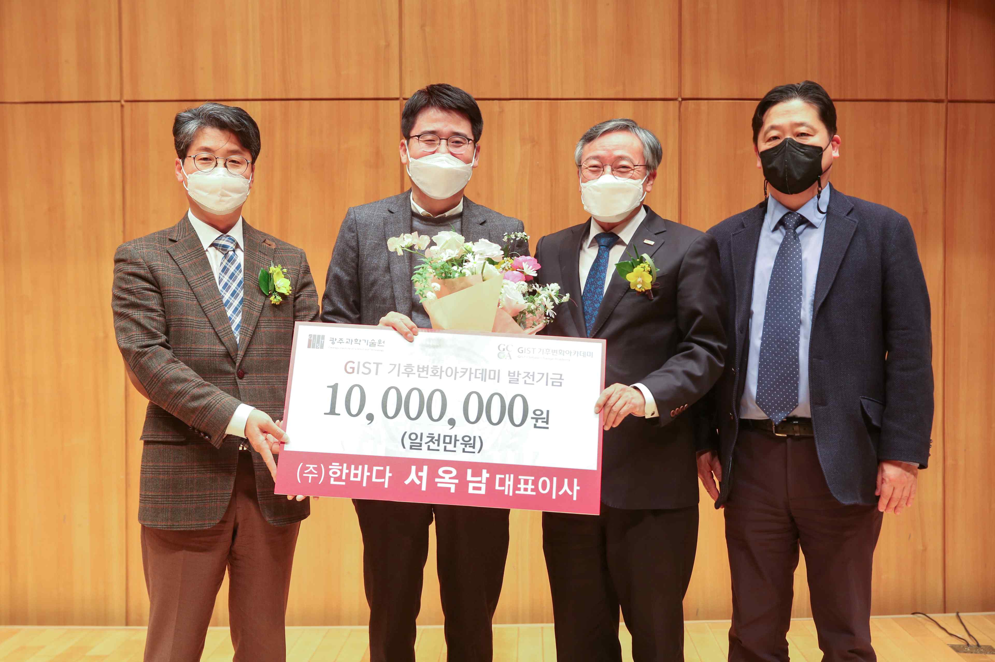
▲ Alumni Ok-nam Seo (CEO of Hanbada Co., Ltd.) donates to the Development Fund. From left: Research Director Chang-Duk Jun, Alumni Ok-nam Seo, Vice President of Public Affairs Young-jip Kim, and Senior Professor Kyoung-Woong Kim

Alumni Ok-nam Seo said, "I am delighted to be able to contribute even a little to the development of the GIST Climate Change Academy. I hope that it will emerge as an innovative brand that will lead the post-corona era."



