Professor SeungJun Kim's team won the excellent paper award for developing a wayfinding app UI for visually impaired pedestrians

– Improving the quality of life for visually impaired people

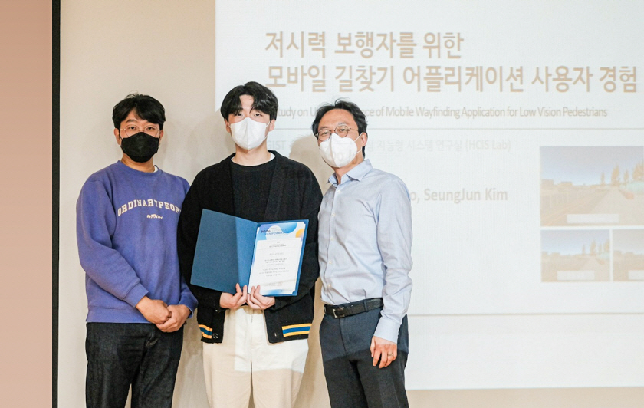
▲ School of Integrated Technology Professor SeungJun Kim's research team won the Best Paper Award at the 2022 Korean HCI Conference for the "Development of a navigation application UI for people with poor vision." From left: Ph.D. student Dohyeon Yeo, master's student Taewoo Jo, and Professor SeungJun Kim

GIST (Gwangju Institute of Science and Technology, President Kim Ki-sun) School of Integrated Technology Professor SeungJun Kim's research team won the Best Paper Award at the '2022 Korea HCI Conference' hosted by the HCI (Human-Computer Interaction) Society of Korea, the highest level of HCI conference in Korea.

Master's student Taewoo Jo (first author) and doctoral student Dohyeon Yeo simulated age-related macular degeneration, one of the symptoms of poor vision, based on virtual reality technology.

Through usability evaluation, the research team confirmed that even if there is damage that degrades vision, the visual experience can be raised to the level of normal vision if a suitable mobile application UI (user interface) for the symptoms is provided.

The paper ('A Study on User Experience of Mobile Wayfinding Application for Low Vision Pedestrians') submitted by the research team for the "Development of a navigation application UI for people with poor vision" was selected as one of the final 10 papers (within the top 9.5%) from a total of 105 papers submitted.

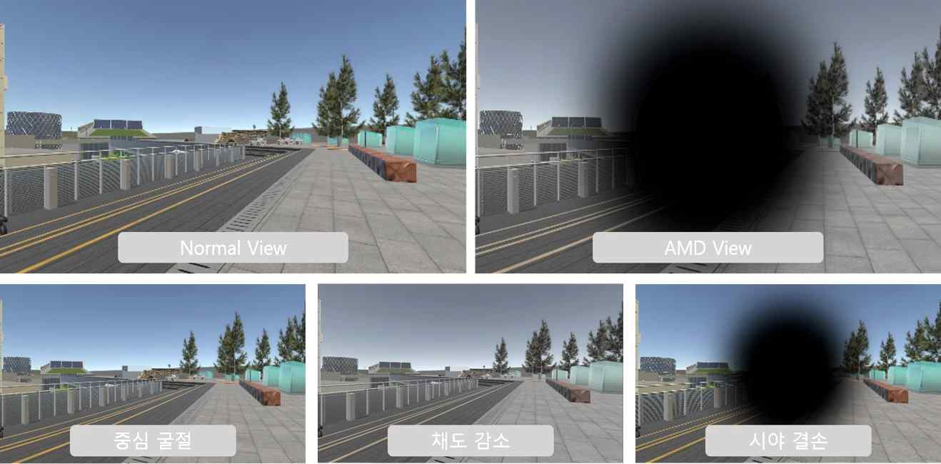▲ Various vision deficit symptoms were implemented in VR space from the perspective of the subject with simulated low vision symptoms

Professor SeungJun Kim said, "The UI of the existing route finding application mainly provides information in the central part of the display, so it is difficult and inconvenient to use for people with poor central vision. To improve the quality of life of people with poor vision, it is very meaningful to improve the UI of mobile applications and conduct in-depth research."

Student Taewoo Jo, the first author of the paper, said, "This paper seems to have been highly praised for suggesting a methodology that analyzes and resolves many inconveniences in the user stage. We plan to develop a human-centered simulation system through joint research with MIT and, based on this, continue to research UI/UX (user interface/experience) for other poor vision symptoms in addition to age-related macular degeneration symptoms."

Professor SeungJun Kim's research team has been promoting 'HCI + AI for Human-Centered Physical System Design' for a total of 5 years through an AI international cooperation project with MIT since April of last year.

The 20th Korean HCI Conference this year will be held online due to the digital transformation caused by the global pandemic and will hold invitational presentations, oral presentations, and poster presentations on the topics of research results and theories of human-computer interaction, including autonomous driving, virtual reality/augmented reality, metaverse, and digital human technology.

