Professor Jung Won Yoon receives the grand prize at the Lab Start-up Festival

– Presenting an ultra-thin 360-degree treadmill that
can become a key interface device for the metaverse

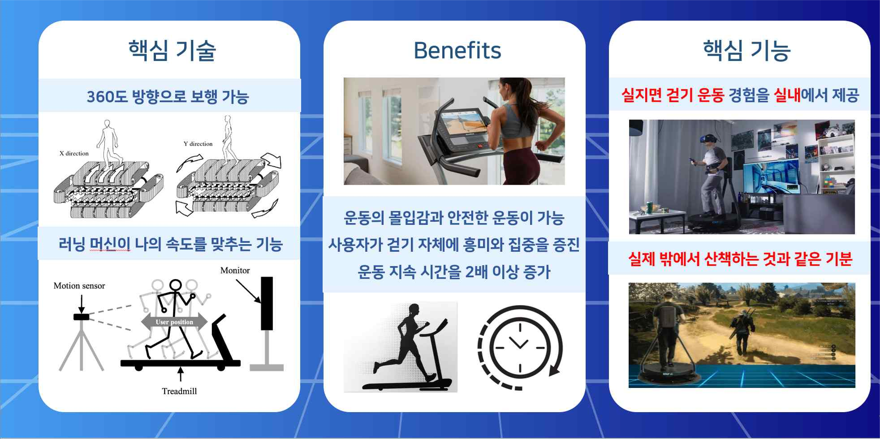
▲ Introduction of services provided by the 360-degree treadmill

GIST (Gwangju Institute of Science and Technology, President Ki-seon Kim) School of Integrated Technology Professor Jung Won Yoon's research team (Center for Nanorobotics in Brain) proposed an ultra-thin 360-degree treadmill* that allows users to walk in two dimensions at high speed/high acceleration/deceleration, which won the grand prize in the exhibition category at the Lab Start-up Festival (LAB START UP 2022).

* 360-degree treadmill (omni-directional treadmill): A general treadmill supports walking motion only in one dimension (unidirectional), but the 360-degree treadmill can freely go in the direction desired by the user.

Under the guidance of Professor Jung Won Yoon, Sanghun Pyo (team representative), Hosu Lee, and Hoyoung Kim from the School of Integrated Technology and Tae-ye Moon of MI Limited formed the Invite team and participated in this competition.

This year's Lab Start-up Festival was attended by 116 teams selected from major universities across the country that participated in the Public Technology-Based Market-Linked Start-Up Search Support Project*. The technical excellence of the 360-degree treadmill presented by the Invite team was recognized for its great ripple effect on the market.

* Public Technology-Based Market-Linked Start-Up Search Support Project: Hosted by the Ministry of Science and ICT and supervised by the National Research Foundation of Korea and the Korea Youth Entrepreneurship Foundation, this is a project that supports the research results of laboratories with commercial and business feasibility to be linked to start-ups.

The 360-degree treadmill is a next-generation walking interface device that was first developed by the U.S. Army Research Laboratory (ARL) in the early 2000s and commercialized in the early 2010s. It is a device that can physically interface with the space implemented in the metaverse by grasping the walking intention (speed, direction) in real time to keep the user's position at the reference position.

The team has developed a power transmission mechanism that can realize two-dimensional motion in an ultra-thin space through a new gear transmission method (continuous positioning screw gear). To solve the overall problem of excessive thickness and noise of the currently developed 360-degree treadmill, special screw gears arranged in two stages were laminated to implement a high-speed/high-speed two-dimensional infinite surface.

The Invite team has secured motion performance (3.5 m/s, 3.5 m/s2) and has a new electric mechanism that can solve the problems of the previously developed 360-degree treadmills even at a thickness of about 25 cm so that it can be easily be installed stably at home. The team developed a control algorithm for a gait interface based on ankle joint torque prediction that enables a gait interface.

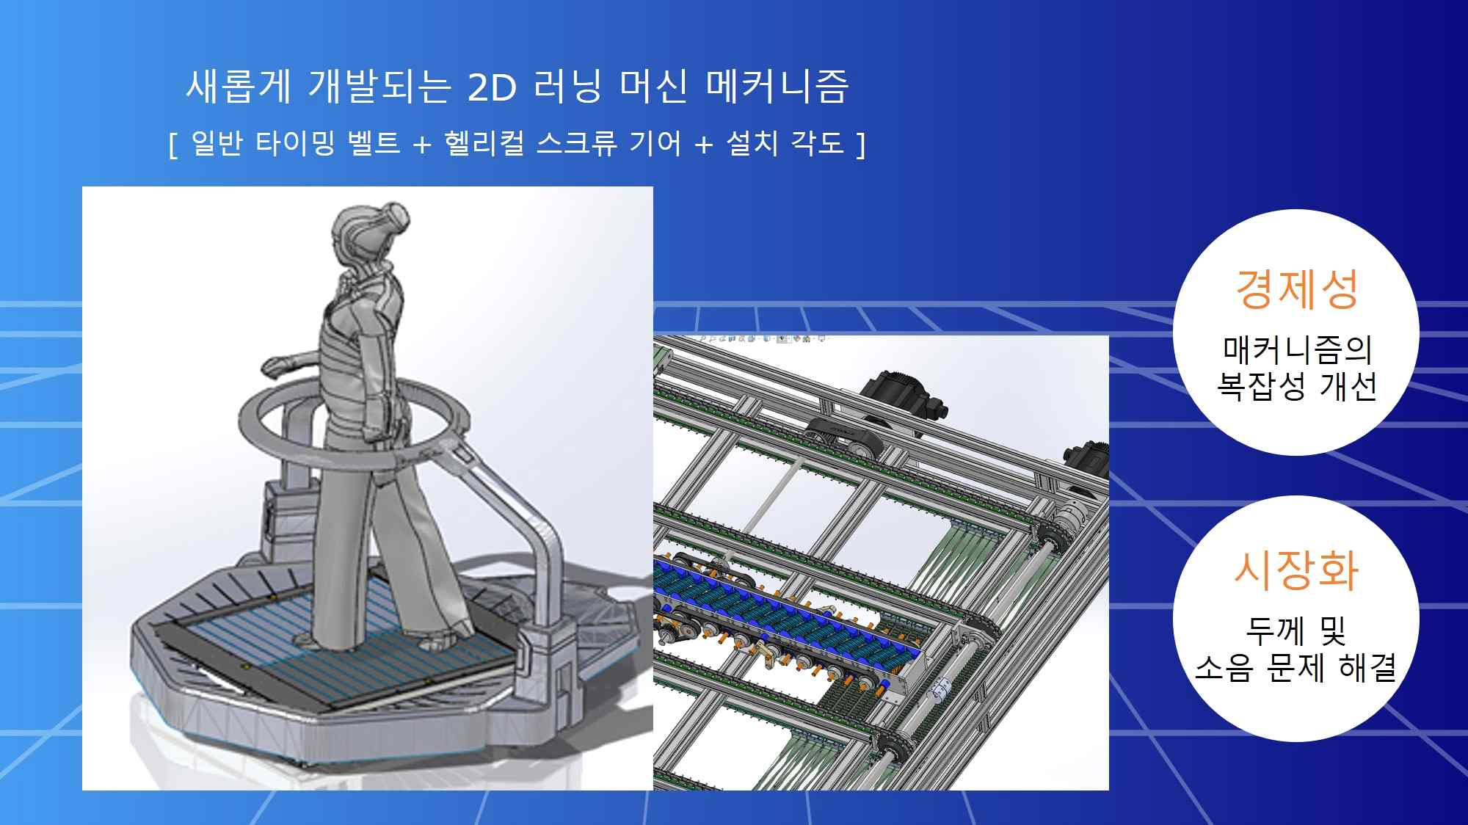
▲ Conceptual diagram of the developed 360-degree treadmill and basic structure design of the gear used

Professor Jung Won Yoon said, "Amid the growing demand for devices that can actually walk in the metabus world, walking interface services can be provided in various places such as homes, hospitals, and research institutes. In the future, a major change in the walking exercise method is expected so that the two-dimensional walking exercise can be realized in a safe place."



