GIST Techno Management Business Academy matriculation ceremony and Development Fund donation ceremony

– The 12th matriculation ceremony and a 10 million won donation ceremony for Young-hee Choi, CEO of Course Co., Ltd.

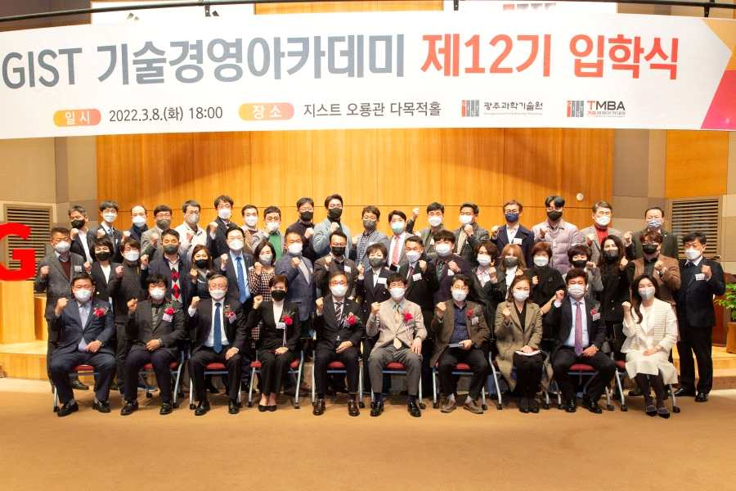
▲ Group photo of the 12th GIST Techno Management Business Academy matriculation ceremony

GIST (Gwangju Institute of Science and Technology, President Kiseon Kim) Techno Management Business Academy (GTMBA) held the 12th GTMBA matriculation ceremony at GIST's Oryong Hall.

The event was held in the presence of 46 students and major officials of GIST, including Vice President for Academic Affairs Raekil Park and Vice President for Public Affairs Young-jip Kim.

Vice President for Academic Affairs Raekil Park gave an opening remark, saying, "I sincerely congratulate you on your admission to the GIST Techno Management Business Academy, which is leading the growth of our region and is becoming a prestigious academy. We hope that GIST's uniquely differentiated programs will actively respond to rapidly changing global technological changes and globalization paradigms to develop innovative growth capabilities."

Meanwhile, on the same day, alumni Young-hee Choi (CEO of Course Co., Ltd.) donated 10 million won to the Development Fund, and the donations will be used for the development of the Techno Management Business Academy.

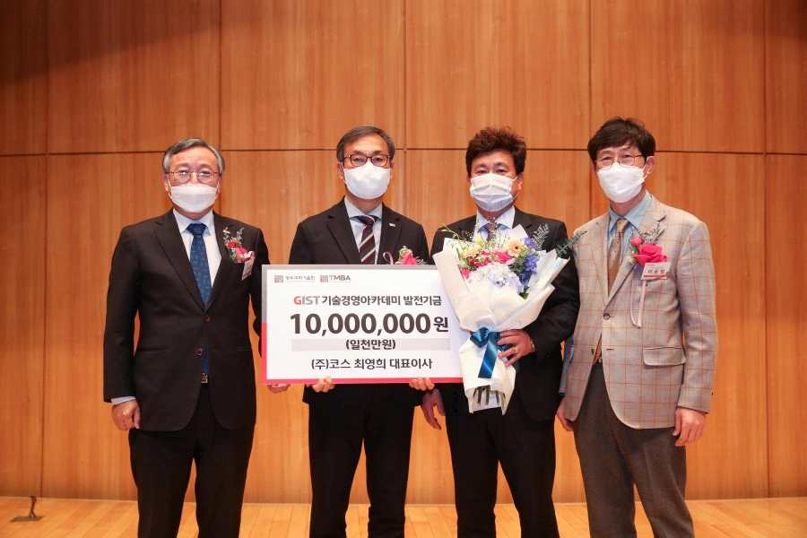
▲ On the same day, alumni Young-hee Choi (CEO of Course Co., Ltd.) donated 10 million won to the Development Fund. (From the left) GIST Vice President for Public Affairs Young-jip Kim, Vice President for Academic Affairs Raekil Park, Course Co., Ltd., CEO Young-hee Choi, and Protech Chairman Yong-beom Lee

Course Co., Ltd., is a pipe welding and processing company established in Jangseong, Jeollanam-do, and has been selected as a technological innovation type company and a global small giant by the Small and Medium Business Administration.

Alumni Young-hee Choi said, "We hope that 12th class of students will become CEOs who can develop together with the region through GTMBA's systematic curriculum. I hope that GIST will contribute to national science and technology and regional balanced development and emerge as a global prestigious university."



