GIST selected as the host organization for the preliminary start-up package support project for four consecutive years

– Supported a total of 111 companies for 3 years... Sales of KRW 1.26 billion, employment of 229 people, and investment attraction of KRW 700 million

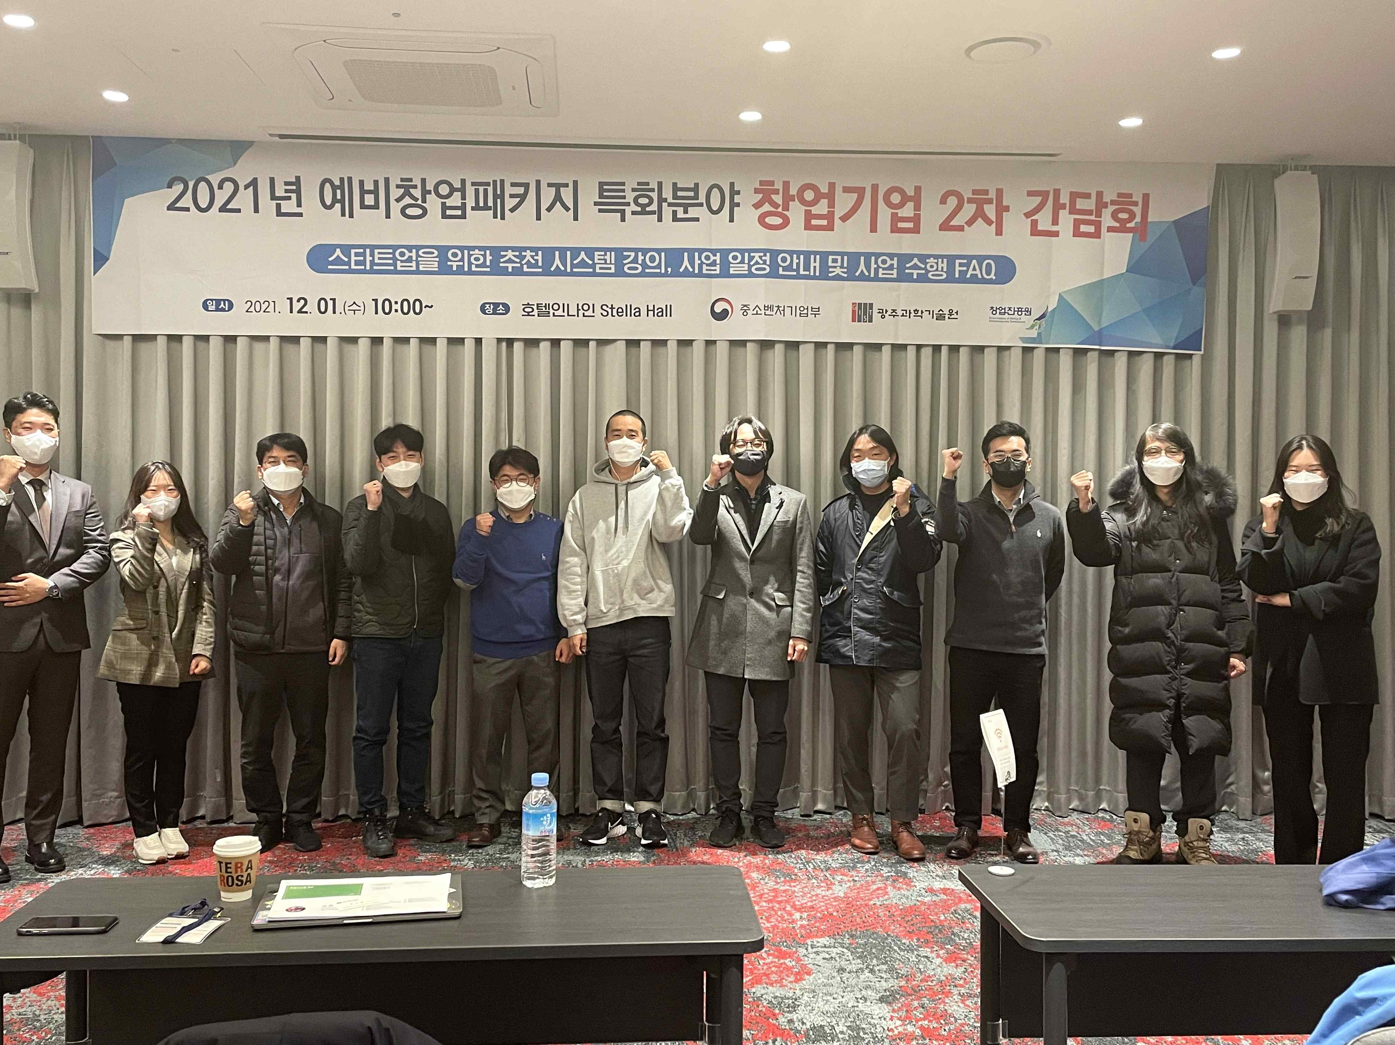
▲ GIST Business Incubator held a meeting about commercialization of prospective entrepreneurs

GIST (Gwangju Institute of Science and Technology, President Kiseon Kim) was selected as the host organization for the preliminary start-up package support project of the Ministry of SMEs and Start-ups in 2022. GIST has been selected as the host organization for the last four years in a row from 2019.

The preliminary start-up package support project of the Ministry of SMEs and Start-ups is a project that provides practical start-up support such as start-up education and mentoring, market connection, and global expansion, as well as financial commercialization support for the smooth business start-up of prospective entrepreneurs with innovative technology start-up materials.

The GIST Business Incubator (Director Byeong-kwan Cho) recently completed the final inspection of 37 entrepreneurs for the 2021 Preliminary Start-up Package. From June of this year, it will start supporting pre-startup companies in D.N.A fields such as digital (D), network (N), and artificial intelligence (AI).

The center plans to support start-up companies by forming an organization in charge of supporting start-ups, forming an investment organization and securing investment funds, and utilizing campus infrastructure to transfer technology, support start-up space, and start-up clubs.

Starting with the 4th industrial field (artificial intelligence) of the preliminary start-up package in 2019, GIST has been continuing the preliminary start-up package for four years to foster prospective start-ups in the artificial intelligence field in 2020 and 2021.

In 2021, 37 companies had sales of 590 million won and 60 employees, and a total of 111 companies were supported over the past three years to generate business results of 1.26 billion won in sales, 229 employees, and 700 million won in investment attraction.

Director Byeong-kwan said, "As we have been selected as the host organization for the preliminary start-up package for four consecutive years, we will spare no effort in providing full support and effort to start-ups tailored to each stage to create a preliminary start-up ecosystem. By actively utilizing GIST's start-up infrastructure, we will do our best to revitalize the local economy along with the success of start-up companies."



