GIST held a briefing session for the practical use of an automatic fishing gear identification monitoring system

– Establishing a practical implementation plan for the introduction of an automatic fishing gear identification monitoring system for real-time enforcement in 2023

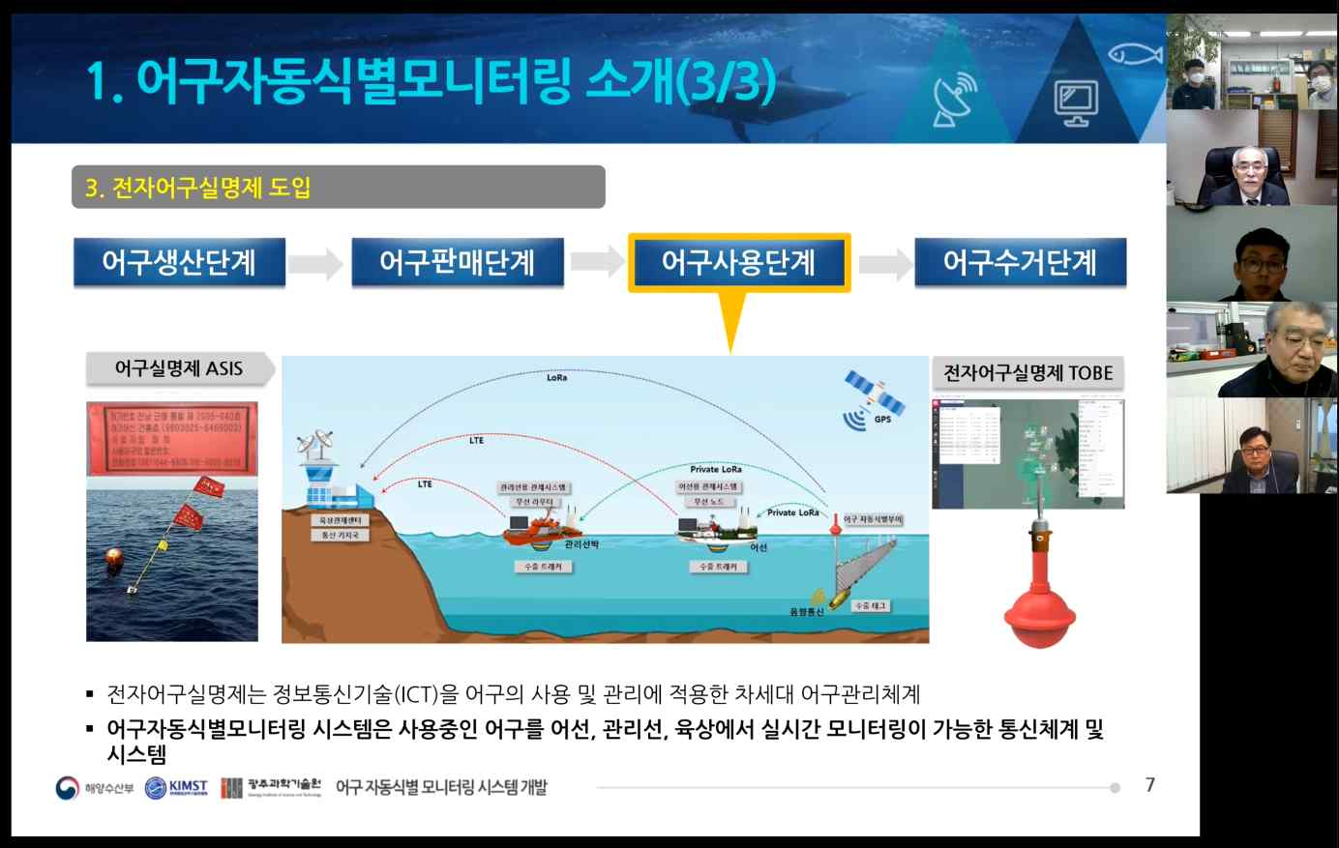
▲ Online briefing session to promote the key technologies of
the automatic fishing gear identification and monitoring system

Korea is in danger of depleting aquatic resources due to overfishing caused by excessive use of fishing gear and the damage to the marine environment caused by abandoned fishing gear. However, the need for an electronic system for identifying fishing gear with low effectiveness has been pointed out since 2012.

GIST (Gwangju Institute of Science and Technology, President Kiseon Kim) Institute for Artificial Intelligence (Center Director Heung-no Lee) recently held an online briefing session to prepare for the full-scale implementation of the automatic identification monitoring system for fishing gear.

The electronic fishing gear monitoring system is a next-generation fishing gear management system to promote the efficiency of fishing gear management by applying information and communication technology (ICT) to the use and management of fishing gear. The Ministry of Oceans and Fisheries is preparing for the introduction of the electronic fishing gear monitoring system in accordance with the complete revision of the 「Fisheries Act」.

The center promoted the development of 3 areas of the automatic fishing gear identification monitoring system: ▲ marine IoT wireless communication-based fishing gear identification buoy ▲ fishing gear identification buoy control system ▲ lost gear management technology. To establish a management plan for each target fishery for the introduction of the electronic fishing gear monitoring system, real sea verification and demonstrations were conducted.

Based on maritime IoT (Internet of Things) technology, electronic buoys are attached to each fishing gear, and wireless communication with fishing vessels, management vessels (fishery management groups), and the land is used. It is a system capable of providing real-time location information to management ships and on the land, where control was conducted only with the naked eye by monitoring the position of fishing gear in real time.

The GIST Institute for Artificial Intelligence secured a 25 km offshore IoT range by conducting a small-scale trial operation in the sea area in 2021. In 2022, in cooperation with the Jeollanam-do Provincial Office, it plans to expand and operate the demonstration of the actual sea area involving fishermen to secure practical use.

The center has been developing technologies for reducing lost gear in the management and use of fishing gear among the entire life cycle management system of fishing gear for a total of 6 years from 2017 to 2022, and it has applied for 26 domestic patents and 5 international patents and registered 8 domestic patents.


▲ Online briefing session



