Former Minister of SMEs and Startups
Young-sun Park visits GIST

– Promises to support Gwangju's artificial intelligence (AI) oriented city and asks for GIST's active role

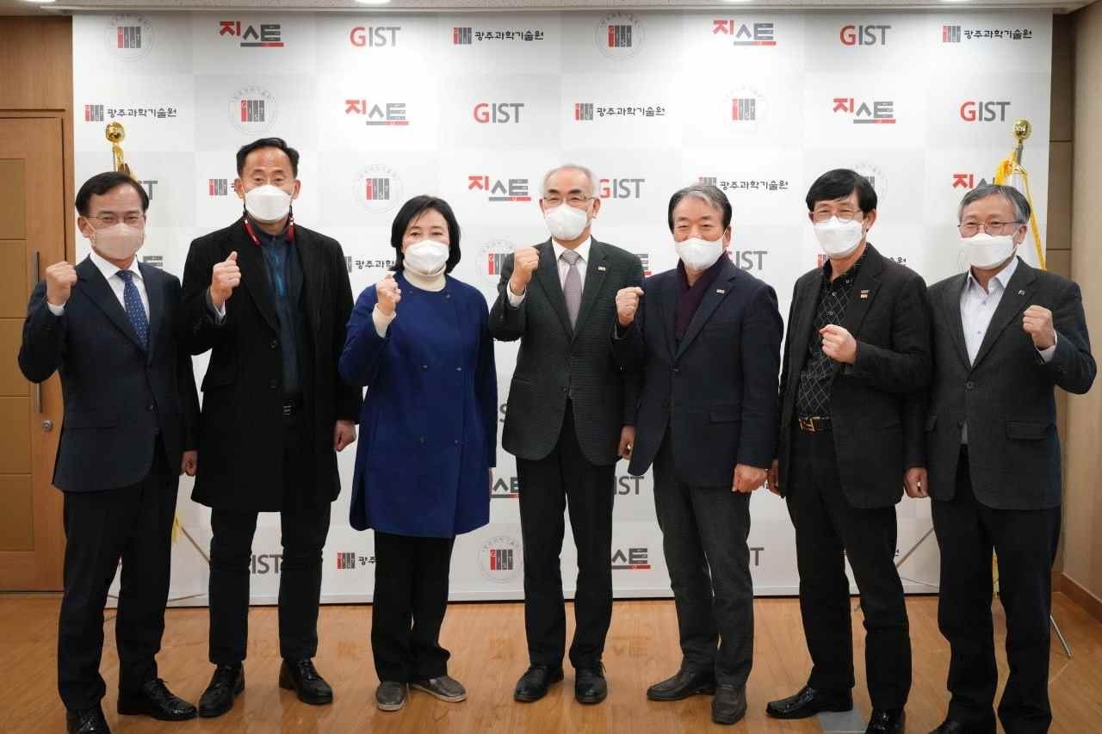
▲ From left: GIST Public Affairs Advisor Sam-ho Kim, GIST Institute for Artificial Intelligence Director Heung-No Lee, former Minister of SMEs and Startups Young-sun Park, GIST President Kiseon Kim, Korea Development Foundation Chairperson Jung-joo Koh, GTMBA Alumni Association Chairperson Yong-beom Lee, GIST Vice President for Public Affairs Young-jip Kim

Former Minister of SMEs and Startups Young-sun Park visited GIST (Gwangju Institute of Science and Technology, President Kiseon Kim) on the 28th and promised to support Gwangju's artificial intelligence (AI) oriented city.

Former Minister Young-sun Park, chairman of the Democratic Party's Digital Innovation Grand Transformation Committee, visited GIST unexpectedly during his visit to Gwangju and spoke with President Kiseon Kim and other officials, saying, "The Lee Jae-myung government will actively support the Gwangju artificial intelligence city policy to be maintained and strengthened." He encouraged "GIST to make more policy and publicity efforts."

In response, President Kiseon Kim said he is preparing a second-phase policy for an artificial intelligence oriented city, and GIST Institute for Artificial Intelligence Director Heung-No Lee explained that he is promoting the metaverse blockchain industry that advances artificial intelligence.

After the meeting, former Minister Park toured the Hall of Fame and urged students and faculty to work together to realize a science and technology powerhouse.

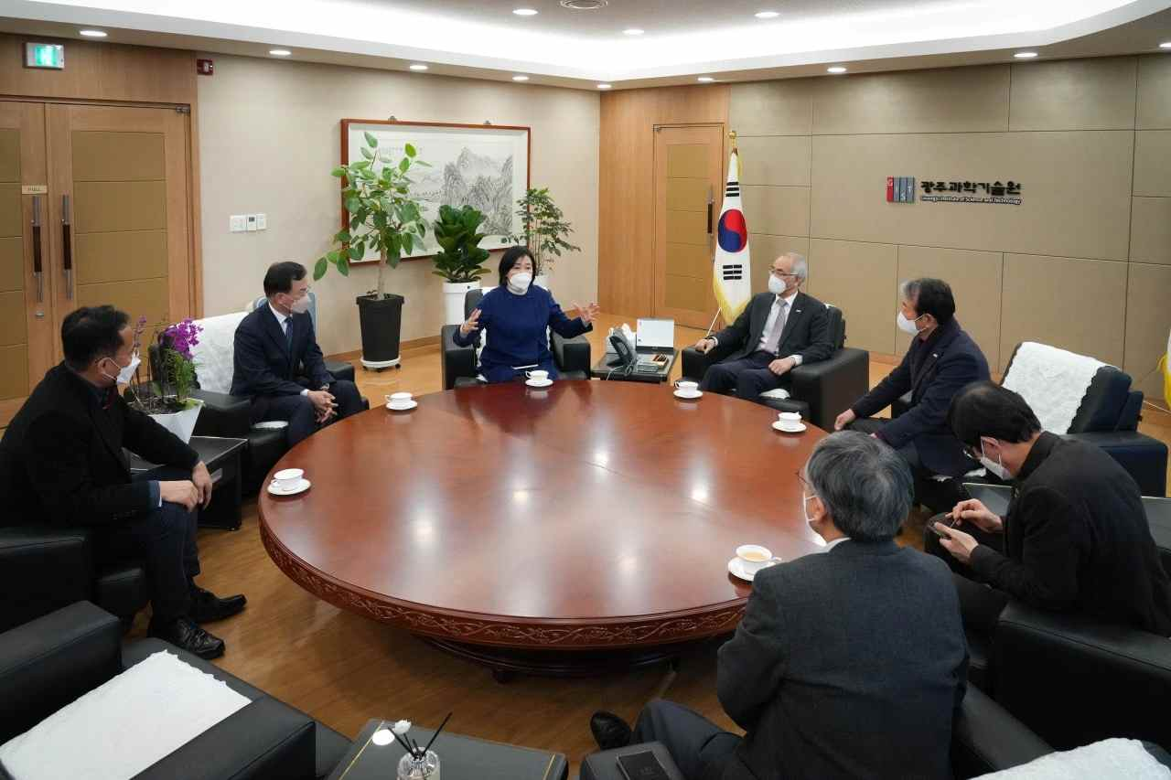
▲ Former Minister Young-sun Park visited GIST and met with relevant officials, including President Kiseon Kim in the president's office



