Former GIST President
Seung-Hyeon Moon retires

– Ceremony to thank Professor Seung-Hyeon Moon of the School of Earth Sciences and Environmental Engineering for his tireless effort during his tenure and to congratulate him on his honorable and well-deserved retirement

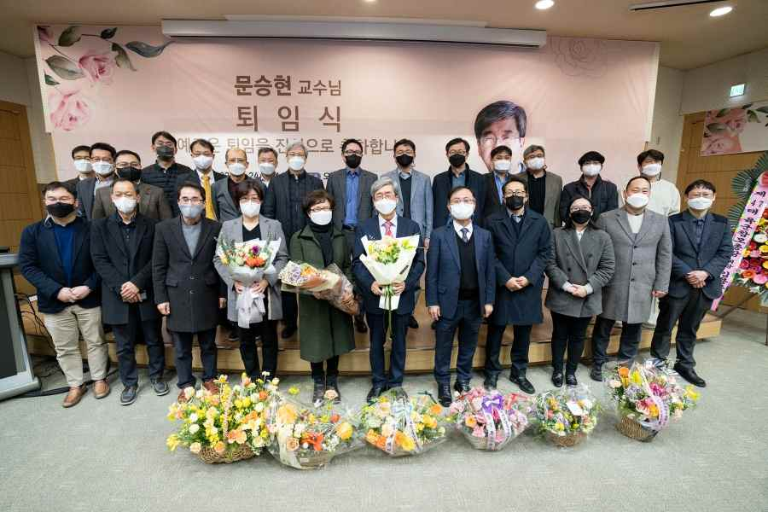
▲ Retirement ceremony for former GIST President Seung-Hyeon Moon
(School of Earth Sciences and Environmental Engineering professor)

The retirement ceremony for former GIST (Gwangju Institute of Science and Technology) President Seung-Hyeon Moon (School of Earth Sciences and Environmental Engineering professor) was held on the 24th.

After receiving his Ph.D. in engineering from the Illinois Institute of Technology, Professor Seung-Hyeon Moon worked as a researcher at the Argonne National Laboratory and was appointed to GIST in August 1994.

Professor Moon served as the 7th president of GIST for four years from February 2015 to February 2019 and is praised for his extensive contribution to the growth and advancement of the institution to a higher level. After his retirement, he will be appointed as an emeritus professor and visiting scholar at GIST and will continue to nurture the scientific talents of students and researchers.

Professor Moon's numerous achievements and extensive service record at GIST includes: the deanship of the School of Earth Sciences and Environmental Engineering, the directorship of the International Environmental Research Institute, the deanship of the Office of Academic Affairs, GIST Vice President, the directorship of the Solar Energy Research Center, GIST President, receiving the Best Paper Award from the Korean Federation of Science and Technology Societies in 2001, GIST Academic Award (2002), Korean Presidential Citation (2003), the Science and Technology Award (2008), and more.

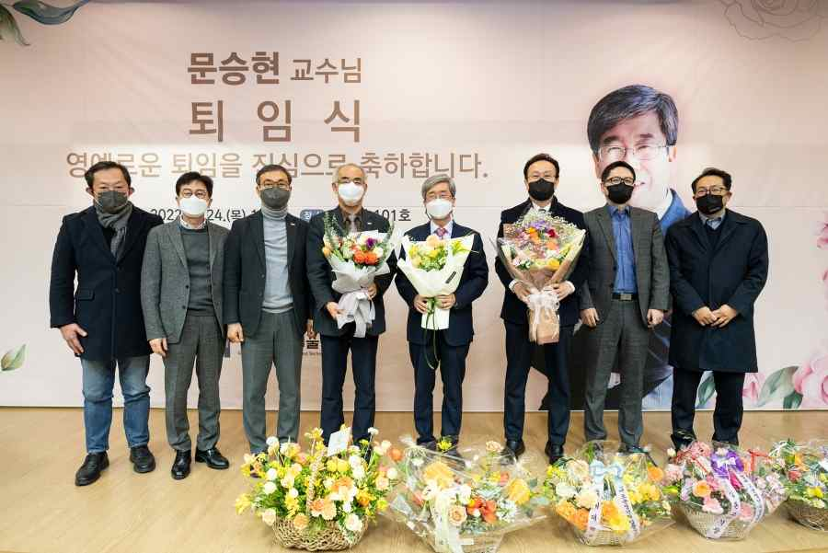
▲ Commemorative photo of the retirement ceremony for former GIST President Seung-Hyeon Moon (School of Earth Sciences and Environmental Engineering professor) with key officials



