GIST hosts appointment ceremony for the Public Affairs Advisory Committee

– Efforts are made to strengthen regional and external cooperation by forming a committee with external personnel from various fields in the region

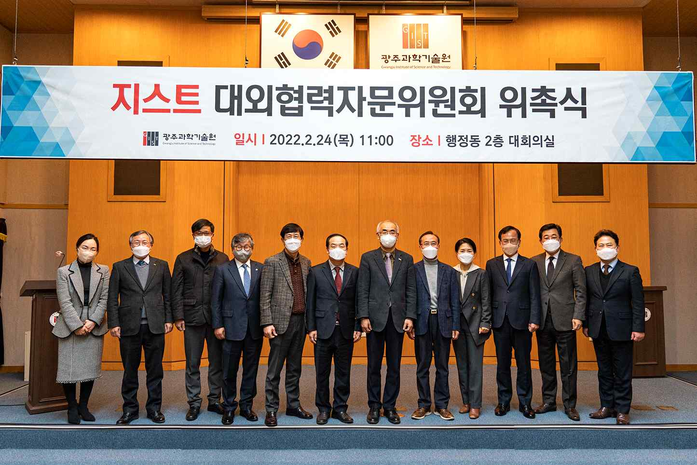
▲ GIST held an appointment ceremony for the GIST Public Affairs Advisory Committee for the development and activation of external cooperation activities. From left: GIST International and Public Affairs Acting Director Hyo Jung Kin, GIST Vice Presiden for Public Affairs Young-jip Kim, Youngmu Construction CEO Hun-taek Park, SRB Media Group Chairperson Duk-seon Cho, CEO of Optonix CEO Yong-beom Lee, Gwangju Chamber of Commerce and Industry President Jong-man Choi, GIST President Kiseon Kim, Chonnam National University Hospital Innovation Committee (Former) Chairperson Hyeon-seop Kang, Empathy Communication Research Institute CEO Jin-young Park, Mayor of Gwangsan-gu Mayor Sam-ho Kim, President of Kumho Express President Hyun-cheol, and Gwangju MBC President Nak-gon Kim

GIST (Gwangju Institute of Science and Technology, President Kiseon Kim) held the appointment ceremony on February 24 for the GIST Public Affairs Advisory Committee to strengthen and invigorate external cooperation.

The main activities of the GIST Public Affairs Advisory Committee, which consists of 11 outsiders from various fields in the region, include: ▲ advising the direction of GIST’s external cooperation activities ▲ advising on development of external cooperation projects ▲ spreading consensus on the role and vision of the GIST in the region ▲ advising on how to strengthen GIST's capabilities through external cooperation ▲ policy proposals to strengthen external cooperation.

GIST President Kiseon Kim said, "Together with experts in each field who have been appointed as members of the GIST Public Affairs Advisory Committee, we will do our best to provide an opportunity for GIST to grow while benefiting the local community."

