GIST hosts the matriculation ceremony
for the 2022 academic year

– February 23: 219 undergraduate students and 219 graduate students for a total of 438
– Undergraduate program on-time recruitment competition ratio 82 to 1... the highest ever

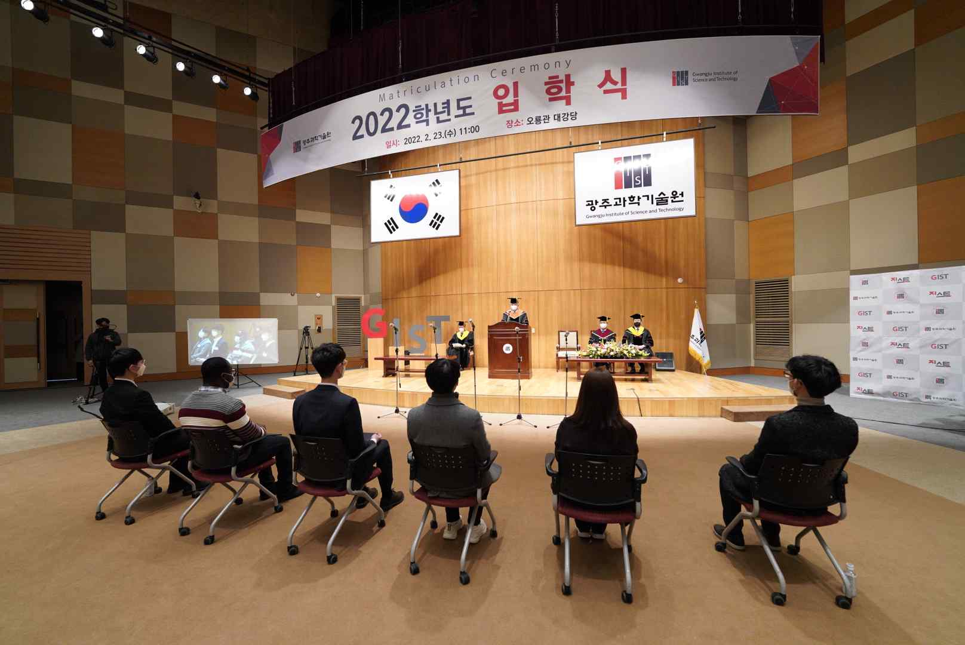
▲ GIST hosts the matriculation ceremony for the 2022 academic year

GIST (Gwangju Institute of Science and Technology, President Kiseon Kim) held the matriculation ceremony for the 2022 school year at 11 am on February 23rd at the GIST Oryonggwan Grand Auditorium with about 20 people, including representatives of incoming students, representatives of the president's scholarship students, and key officials.

In the first half of this year, a total of 438 students, including 219 for the undergraduate program, 121 for the master's program, 52 for the combined master's and doctoral program, and 46 for the doctoral program, are expected to study and research as GIST members.

To prevent the spread of COVID-19, only a minimum number of people participated in the matriculation ceremony, which could be viewed in real time through YouTube live streaming.

The entrance ceremony begins with the academic report by the Dean of Student Affairs and Admissions Keun-Young Kim, followed by the declaration of admission by the President Kiseon Kim, followed by representatives of admitted students taking the oath of admission and reading the spirit of GIST: ▲ Beom-gi Cho (BMSE, Ph.D.) ▲ Aqua Emmanuel (BMSE, Ph.D.) ▲ Soo-hoon Cho (SME, integrated) ▲ Myung-joo Cha (SME, master’s) ▲ Jeong-in Hong(liberal arts, undergraduate). Afterwards, ▲ Seung-jae Hwang (DPPS, integrated course) was awarded the President's Scholarship Certificate.

President Kiseon Kim said, "While living at GIST, I hope that you will continue to question and explore in order to create your own future. As a laboratory and playground, GIST will do its best to help you grow into a true global scientist and engineer with the ability to understand others and respect diversity through a happy campus life."

A total of 1,646 on-time applicants for the GIST undergraduate program for the 2022 academic year, which resulted in the highest competition ratio of 82.30 to 1. GIST introduced liberal arts the first time in Korea to its undergraduate program, and it is nurturing a small group of global science and technology leaders with humanities literacy through various essential lectures in the humanities, social studies, and arts and sports as well as science and engineering subjects such as math and science.



