GIST hosts degree conferment ceremony
for the 2021 academic year

– On February 18 (Fri), 293 students including Ph.D. students were awarded degrees, and Ph.D. graduates published an average of about 5 SCI-level papers each

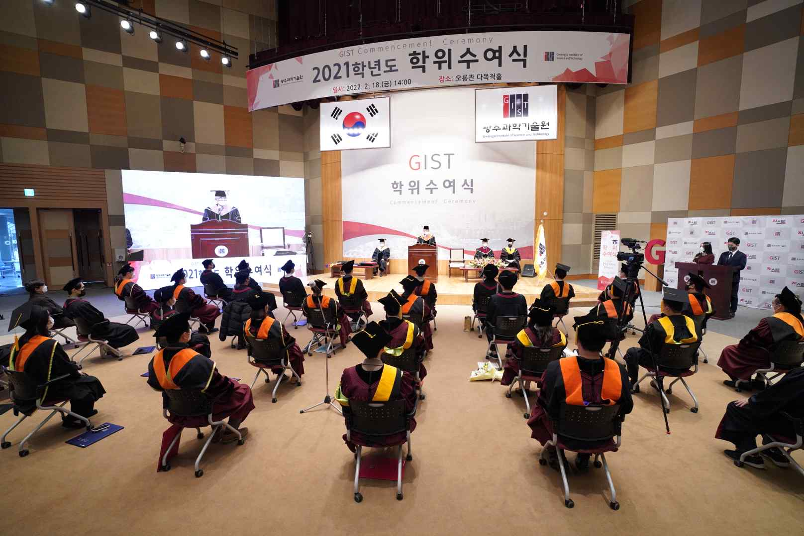
▲ GIST hosts degree conferment ceremony for the 2021 academic year

GIST (Gwangju Institute of Science and Technology, President Kiseon Kim) held the '2021 Academic Year Conferment Ceremony' on February 18 at 2:00 pm at GIST Oryong Hall in the presence of about 50 graduates and class representatives.

A total of 293 degrees were conferred at the ceremony, including 63 doctoral degrees, 109 master's degrees, and 121 bachelor's degrees. As a result, since its establishment in 1993, GIST has produced a total of 7,284 advanced scientific and technological personnel, including 1,652 Ph.D. recipients, 4,645 master's recipients, and 987 bachelor's recipients.

To prevent the spread of COVID-19, a video containing messages from teachers and students was produced and screened, and representatives of graduates were selected through a lottery, and the event was held with a small number of participants.

Degree recipients and parents who could not attend the event were able to watch the graduation ceremony in real time through YouTube live streaming.

The average number of papers that 63 recipients of doctoral degrees published in SCI (Science and Technology Citation Index) journals during their enrollment period was about 5 per person.

In particular, at this degree conferment ceremony, the Graduate School of Energy Convergence, which was established in 2020, had its first Ph.D. graduates. The Graduate School of Energy Convergence awarded doctoral degrees to three students: Doh-yeong Kim and Seung-woo Lee (advising Professor Chanho Park) and Won-hee Kim (advising Professor Hyeong Jin).

Dr. Seung-woo Lee published a total of 13 papers in the renowned international SCI-level journals in materials science under the theme of electrochemical catalyst design research that controlled oxidation and pore structure for oxygen generation reactions in acidic media. In addition, he has two patents and won the 2021 Graduate School Catalyst Research Award hosted by the Korea Chemical Engineering Association at the conferment ceremony.

School of Mechanical Engineering student Dae-wook Song (advising Professor Hyo Sung Ahn), a graduate of the undergraduate program, co-founded Cloudstone, a startup company, and successfully operated the delivery food bundled delivery platform 'Baedalgeek' while attending school, and he received the Future Talent Award given to students who excel at 3C1P.

Student Dae-wook Song said, "GIST is the best environment for preparing and challenging future innovation. Based on the capabilities accumulated through Cloudstone and the humanities literacy and technology learned from GIST, I want to grow as a GIST person who continues to challenge and lead the future beyond innovation in the delivery market."

At the conferment ceremony, President Kiseon Kim said, "I would like to congratulate the 293 graduates who have lived on the GIST campus for the past several years and have challenged themselves towards their goals and dreams. I hope that you will become a heart-warming scientist and engineer who contributes to the development of national science and technology with the capabilities and pride obtained from GIST."

Meanwhile, GIST, which celebrates its 29th anniversary this year, has been faithfully carrying out its establishment goal of leading the local industry and the national mission of developing science and technology with the focus on convergence and internationalization.

GIST is ranked 4th in the world (1st in Korea for 14 consecutive years) in the category of 'citations per faculty,' which shows the academic influence of the institution's research capabilities and research performance, and GIST is internationally recognized for its excellent research capabilities.



