GIST Eco World Farm Co., Ltd., CEO and Alumni Association President Seok-joong Oh participated in the GIST relay donation

– Donation of 50.2 million won for training
scientific and technological specialists

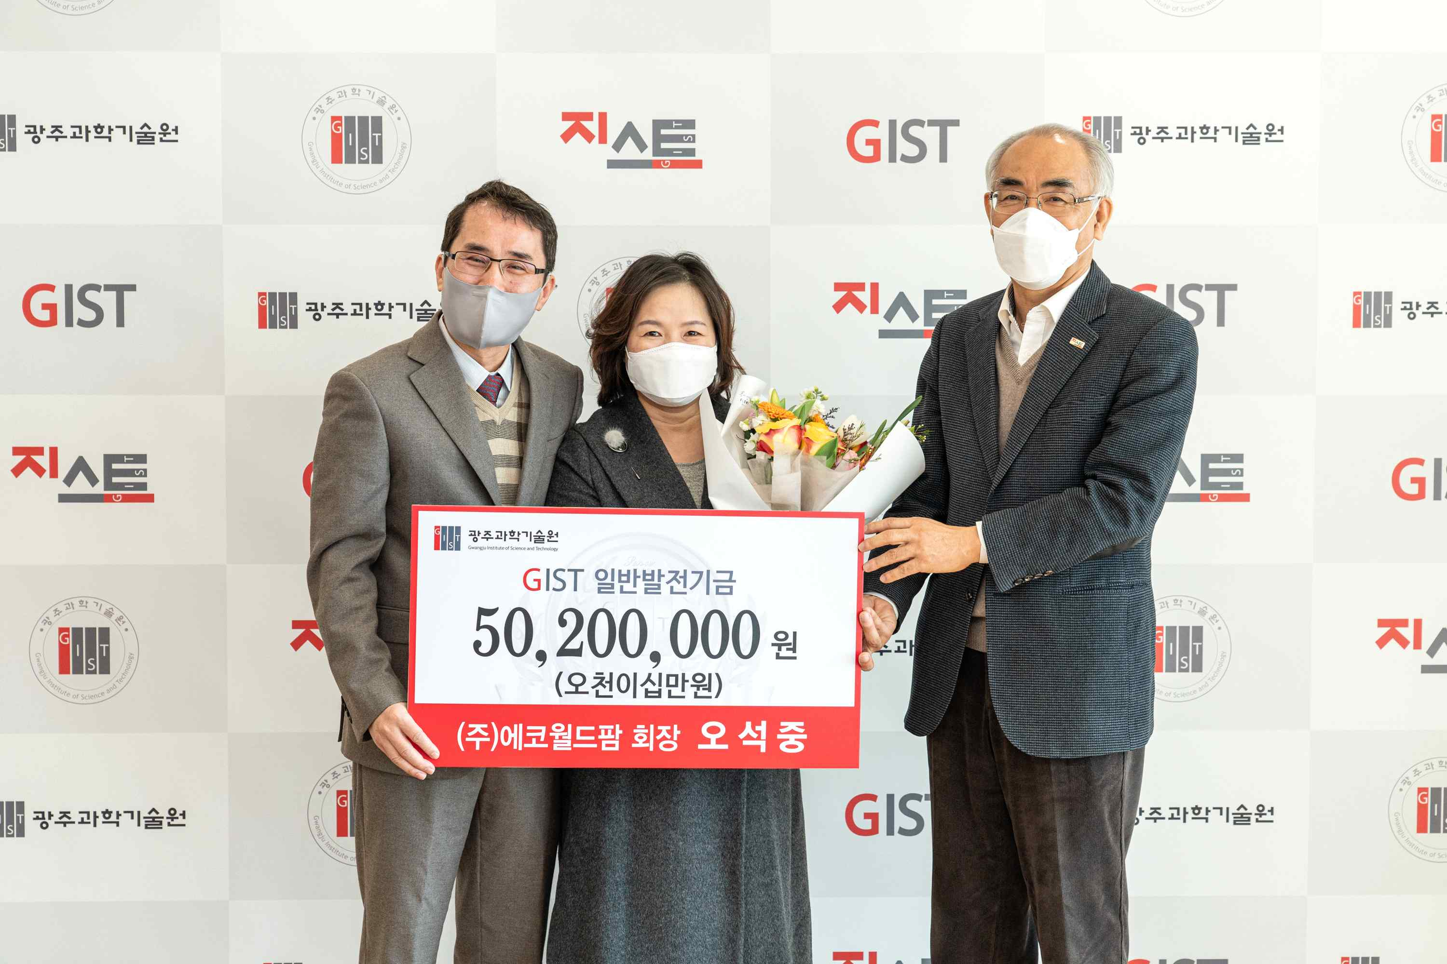
▲ From left: Eco World Farm Co., Ltd., CEO Seok-joong Oh, his spouse, and GIST President Kiseon Kim

Following last year, the relay donations for the GIST (Gwangju Institute of Science and Technology, President Kiseon Kim) Development Fund have continued this year. In the new year, donations are being made in the hopeful spirit of changing the development atmosphere of GIST.

In particular, with the high interest of GIST Techno Management Business Academy (GTMBA) alumni have beeng participating with donations starting from the second half of last year: Mujin Service Chairman Eun-mo Choi (200 million won), Sungil Livestock Farming Association CEO Yong-gi Lee (20 million won), NH Co., Ltd., Networks CEO Geun-shin Lee (20 million won), Suyoung ENG CEO Min-seon Hwang (20,000 masks donated), Woosung Precision Co., Ltd., Chairman Hwa-seok Park (20 million won), G.O.C. CEO In-cheol Park (50 million won)and Goun City I Co., Ltd., Chairman Ki-seop Jeong (20 million won).

GIST School of Earth Sciences and Environmental Engineering graduate and Eco World Farm Co., Ltd., CEO Seok-joong Oh was the first donor of the year and donated 50.2 million won on the 27th.

Eco World Farm Co., Ltd., CEO Seok-joong Oh is currently serving as the director of the GIST Development Foundation and was the first president of the Alumni Association, and he has been striving for the development of his alma mater and exchanges between alumni. Eco World Farm has developed and produced all natural mouthwash products such as alcohol-free, surfactant-free and preservative-free, toothpaste, hand sanitizer, and corona sterilizer with safer and healthier eco-friendly bio technology through 20 years of accumulated know-how. It is a representative development and manufacturer of oral health hygiene products in Korea.

In addition to the health hygiene products business, Eco World Farm has six top domestic and foreign Ph.D. professional researchers, spurring various health functional foods development and extensive technology research and development in the field of 3D bioprinting.

CEO Seok-joong Oh said, "I am very happy to be able to add a helping hand to my alma mater as well as juniors, and I hope this will help develop specialists even a little bit. I want to continue to help juniors study hard and take on challenges to achieve their goals in the future."

President Kiseon Kim said, "I am very grateful that the donations have been made steadily since last year with the united spirit of GIST alumni. In accordance with the precious sentiments of Chairperson Oh and other alumni, we will do our best to nurture scientific and technological specialists and develop the local community.

Meanwhile, GIST plans to gradually strengthen its donation campaign this year, targeting not only GTMBA alumni but also GIST family members and outsiders such as GIST graduates and parents.



