GIST Techno Management Business Academy hosts inauguration ceremony for alumni president

– Protech Co., Ltd., CEO Yong-beom Lee took office
as the 5th president of the Alumni Association

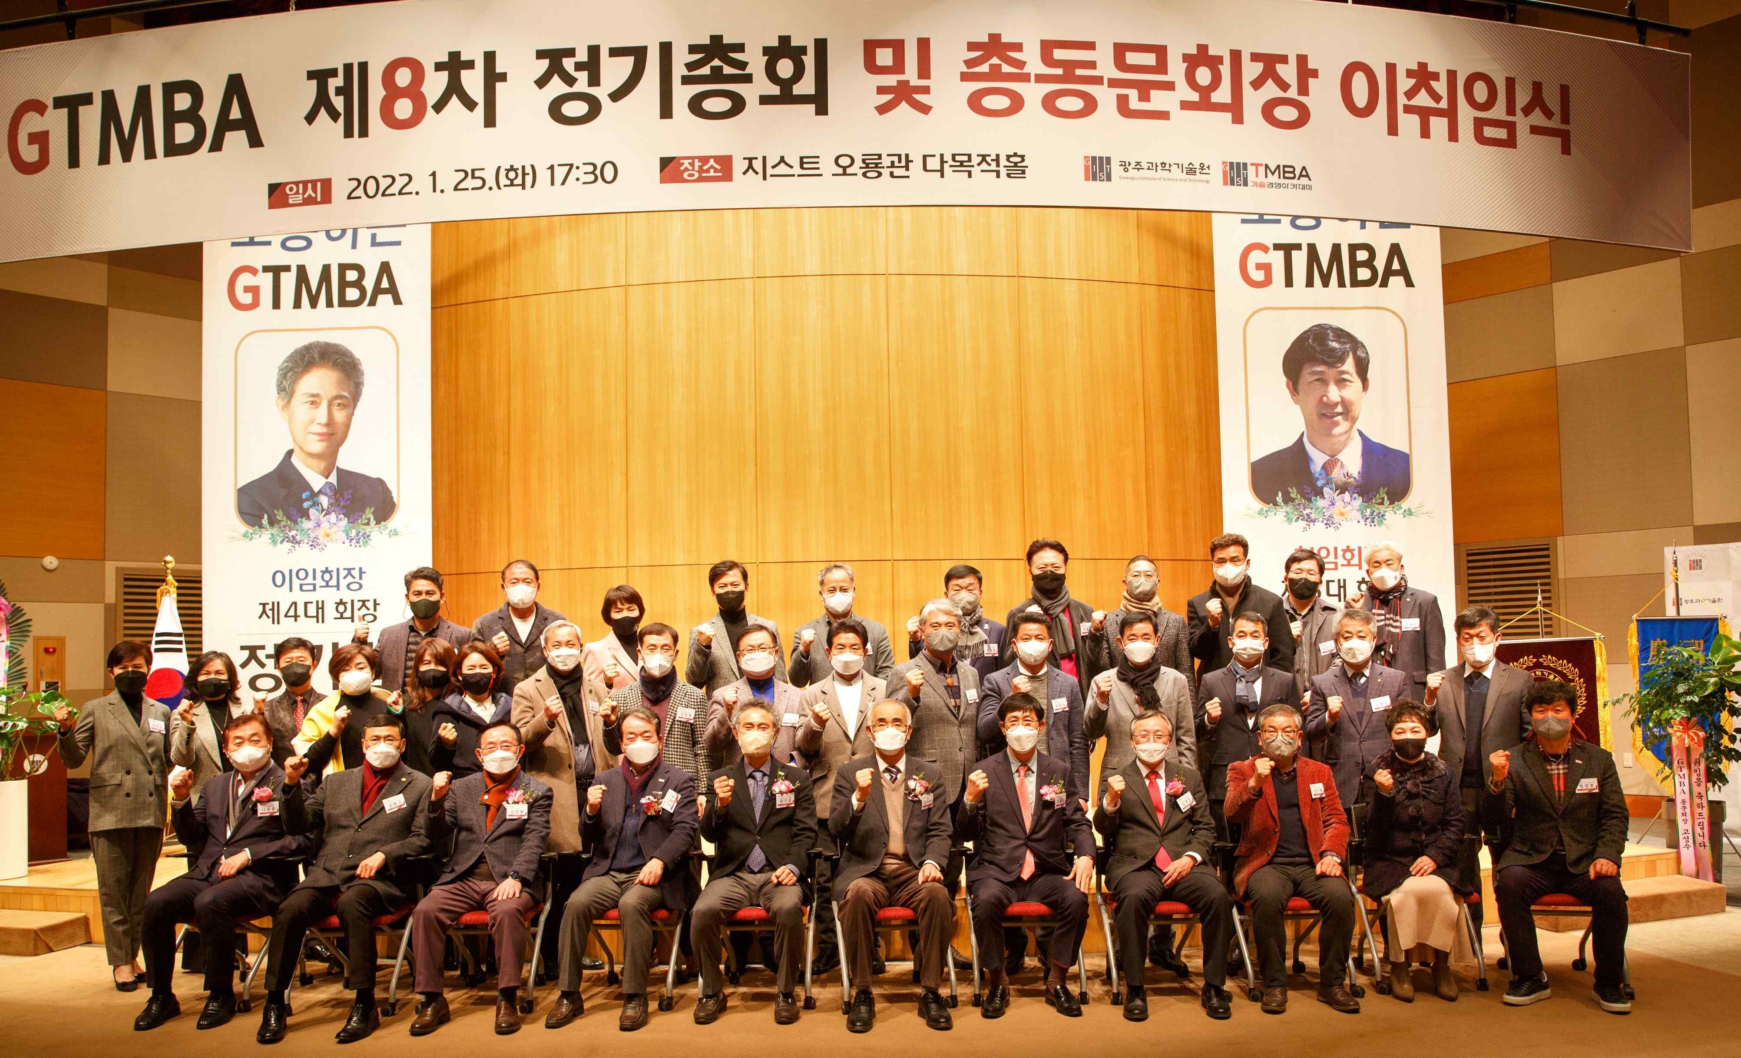
▲ The 8th regular general meeting and the inauguration ceremony for the alumni president

GIST (Gwangju Institute of Science and Technology, President Kiseon Kim) Techno Management Business Academy (GTMBA) held the 8th regular general meeting of GTMBA and the inauguration ceremony for the new Alumni Association President Yong-beom Lee at GIST Oryonggwan on the 25th.

The ceremony to inaugurate Protech Co., Ltd., CEO Yong-beom Lee as the 5th president of the Alumni Association was attended by GIST President Kiseon Kim, Vice President for Public Affairs Young-jip Kim, the 4th Almuni Association president TI Co., Ltd., President Ki-Seop Jeong, and 40 almuni members.

4th Almuni Association President resident Ki-Seop Jeong said, "Thank you for your generous love and support to fulfill your duties, which helped me successfully lead the GTMBA Alumni Association. Through the experience of the past year or so, we will do our best to serve as a foundation for the development of the Alumni Associations in the future."

5th Almuni Association President Yong-beom Lee said in his inauguration speech, "During my tenure, I will do my best so that the GTMBA Alumni Association can further develop and take a new leap forward. We will actively promote GTMBA projects so that all alumni can grow and interact with GIST."

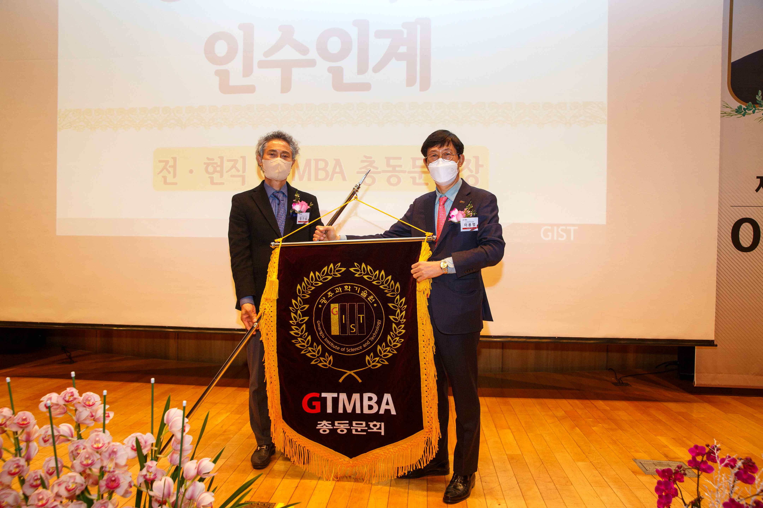
▲ From right: 5th Almuni Association President Yong-beom Lee is taking over the GTMBA flag from the 4th Almuni Association President resident Ki-Seop Jeong.

Meanwhile, GTMBA has opened a top technology management course to serve as a hub for business through systematic CEO education programs, and more than 440 alumni have successfully played a role as global leaders in various fields of society, including business, politics, and relations.



