Goun City I Co., Ltd., Chairperson Ki-seop Jung donates 20 million won to GIST

– To train local scientific talents and
promote research and development

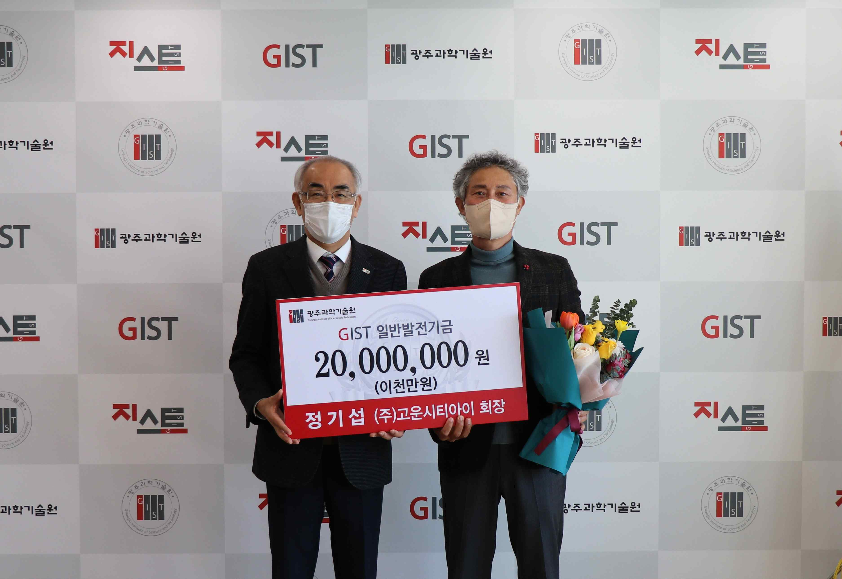
▲ From left: GIST President Kiseon Kim and Goun City I Co., Ltd., Chairperson Ki-seop Jung

GIST (Gwangju Institute of Science and Technology, President Kiseon Kim) announced on the 24th that it had received a donation of 20 million won from Goun City I Co., Ltd., Chairperson Ki-seop Jung

Goun City I Co., Ltd., Chairperson Ki-seop Jung is currently serving as the 4th Alumni President of GIST Techno Management Business Academy (GTMBA) and is also the director of the GIST Development Foundation. The donation ceremony was held on January 21 in President Kisepon Kim's office along with GIST Development Foundation Chairman Jung-joo Ko and the next chairman of the GTMBA Alumni Association Yong-beom Lee.

Goun City I Co., Ltd., is a construction company with 26 years of construction know-how in all areas, including apartments, roads/ports, tunnels and plants, with civil engineering, construction, housing construction, electricity, firefighting, and landscaping licenses. In Gwangju and Jeollanam-do, it is already well known as the 'Goun Heights' brand and is recognized nationwide for its skills.

Goun City I Co., Ltd., has recently achieved more than 10 construction achievements every year, showing rapid growth. Major achievements include Yeongam Samho Gounrapine New Construction, Incheon Geomdan District Housing Site Development Project, and Seongnam Janghowon Road Construction.

Chairperson Ki-seop Jung said, "Sharing is being practiced wherever and whenever necessary for the development of the local community. I hope that GIST will be of some help to lead the future of the Gwangju and Jeollanam-do and to nurture excellent specialists."

GIST President Kiseon Kim said, "I would like to express my gratitude to Chairperson Ki-seop Jung for his efforts to develop GIST. The generous funds will be used meaningfully to train excellent scientists and carry out industry-university cooperation not only in the region but also globally."



