GIST Professor Wonil Choi publishes a translated book: "How does aging and language affect each other?"

– In the era of centenarians, a guide to a
healthy and prosperous life through language

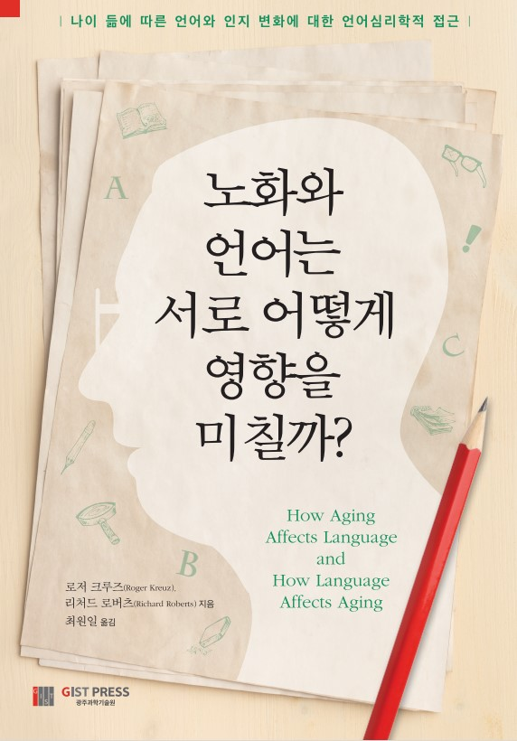
▲ "How does aging and language affect each other?" book cover

GIST (Gwangju Institute of Science and Technology, President Kiseon Kim) Division of Liberal Arts and Sciences Professor Wonil Choi published a translated book "How does aging and language affect each other?" through GIST PRESS.

This is a translation of "Changing Minds," a book written by Roger Kreuz, a professor of psychology at the University of Memphis and Associate Dean of the College of Liberal Arts, who studies language psychology.

Language is a complex phenomenon that depends on other cognitive processes such as perception and memory. When we try to remember someone's name, we can see how dependent language is on memory. When we try to listen to our companions or read menus in a noisy restaurant, we can see that language relies on perception.

So how can language survive when the tides of aging sweeps away the foundations of perception and memory? The changes in language for adults show remarkable resilience against cognitive decline, showing improvement from decline, adaptation, recovery, and even improvement.

Language changes in adults adapt with decline, showing remarkable resilience against cognitive decline and sometimes even showing improvement after recovery.

This book reveals the effects of aging on language and even the effects of language on aging, especially from a cognitive perspective, among various fields that have studied the relationship between aging and language.

In addition, the book deals with the interrelationship between language development, language use, and language and aging by presenting various examples and research results reflecting various cultural contexts.

The translator, Professor Wonil Choi received his Ph.D. in cognitive psychology from the University of North Carolina at Chapel Hill, USA. He currently serves as a professor in the GIST Division of Liberal Arts and Sciences where he teaches psychology to his students.

Professor Choi is conducting research on what happens to the eyes and brain when humans think, understand language, and speak; and, recently, he has been expanding his field of interest to include interactions between humans, machines, and society.

Professor Choi said, "Reading well, writing well, listening well, and speaking well can make the second half of our life healthier and more prosperous. I hope that this book will be helpful to readers who are preparing and hoping for a healthy and meaningful long life or who want to expand their knowledge in the field of human language information processing."



