Science Hallyu from Vietnam to Cambodia

– GIST International Environmental Research Institute, Korea International Cooperation Agency, and the Royal University of Phnom Penh Department of Environmental Engineering project to open bachelor's and master's courses in Cambodia

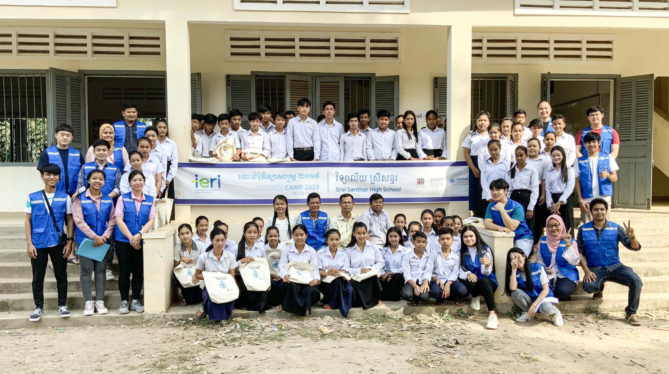
▲ GIST International Environmental Research Institute has been operating
science camps students in rural areas of Cambodia since 2017

GIST (Gwangju Institute of Science and Technology, President Kim Ki-sun) International Environmental Research Institute (Director Kyoung-Woong Kim) with support from the Korea International Cooperation Agency (KOICA), a representative organization in Korea for development cooperation, will start a project to open a bachelor's and master's course at Royal University of Phnom Penh (RUPP) in Cambodia from 2022.

This project was recently signed after a preparation period of more than two years since October 2019. Among KOICA's 'Higher Education for a Better Future' program, which starts in 2022, this will be promoted as a project to establish the Department of Environmental Engineering at the Royal University of Phnom Penh to develop high-level specialists in Cambodia.

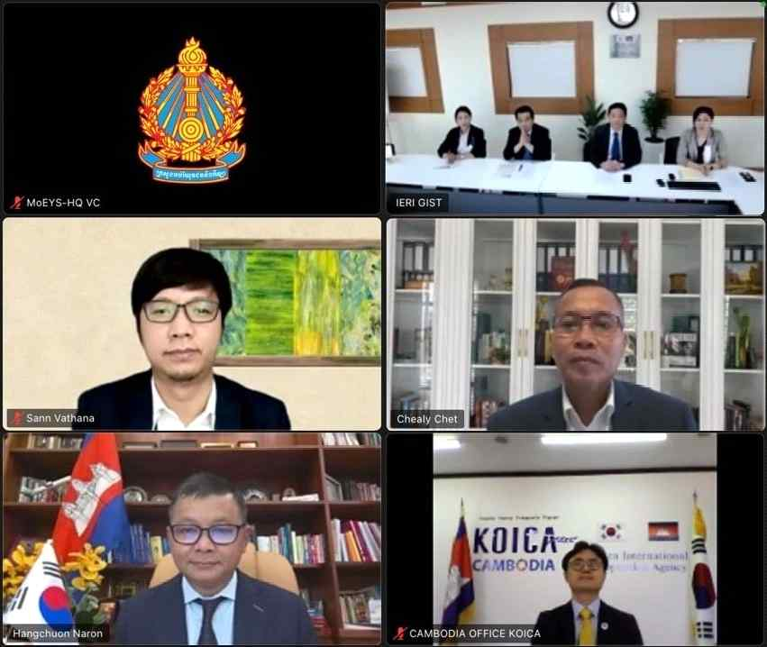
▲ Project participants who are discussing the minutes of the agreement online prior to the signing of the agreement (clockwise from top right): International Environmental Research Institute researchers, Royal University of Phnom Penh President H.E. Chet Chealy, KOICA Cambodia Office Director Hyun-yun Roh, Cambodia Ministry of Education, Youth and Sports Minister H.E. Hang Chuon Naron, and Assistant Secretary H.E. San Vathana

As a South-South cooperation project to spread the factors and experiences of educational development that acted as the driving force for the national development of Korea, it includes strengthening climate change capabilities through environmental engineering programs and contributing to sustainable human development and environmental preservation through educational cooperation between countries.

For this program, the Royal University of Phnom Penh made an entire five-story building on campus available for use by the Department of Environmental Engineering, which is scheduled to be established this year, and KOICA promised US $6.9 million (about 8.35 billion won) of support for six years.

GIST's exclusive responsibility for this project dates back to 2005, and it can be said that the International Environmental Research Institute successfully attracted students from the Hanoi University of Science and Technology to GIST's graduate program with support of US $1.9 million from the Vietnam Ministry of Education and Training.

Currently, more than 100 graduates are active in Vietnam's environmental field. Based on that experience, it is expected that local experts who will be produced in the future by establishing an environmental engineering education system in Cambodia and developing high-level specialists will lead Southeast Asia's response to climate change and the development of an environmental industry.

Director Kyoung-Woong Kim, who is in charge of this project, said, "For the past 20 years starting with Vietnam, GIST International Environmental Research Institute's investment in continuous education and training has paid off in Cambodia. I hope that it will spread further throughout Southeast Asia in the future."



