GIST has the highest competition
rate for regular admissions in 2022

– The number of applicants was an all-time
high of 1,646 (about 82 to 1)

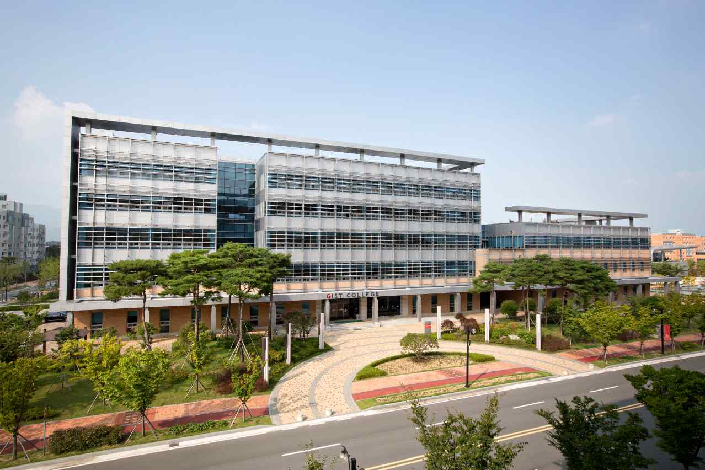
▲ Photo: GIST College Building A

GIST (Gwangju Institute of Science and Technology, President Kiseon Kim), which celebrates its 29th anniversary this year, closed the application process for regular admissions to the 2022 academic year on the January 3.

GIST selects about 20 undergraduate students from the regular admissions process, and the final competition ratio was 82.30 to 1 with applications from 1,646 prospective students. Regular admission is a single screening process for excellent students who are selected entirely based on their college entrance exam scores.

This year, GIST's competition rate for regular admissions applications was 82.30 to 1, the highest competition rate ever for regular admissions. This was also confirmed as the highest competitive rate among the four science and technology institutes.

Dean of Student Affairs and Admissions Keun-Young Kim (Department of Physics and Photon Science professor) said, "Following the previous year, GIST has the highest competition among the four science and technology institutes, which shows the educational preference of future scientists and engineers who will lead science and technology in the future."

GIST has an excellent reputation of a research-oriented university in both name and reality as the amount of research grants received per full-time faculty in 2021 exceeded 700 million won, the highest in the country.

The announcement of successful candidates for the 2022 GIST regular admission is scheduled for February 7 (Monday) at 18:00 and can be found on the GIST College admissions website.



