GIST surpasses KRW 700 million in research grants per full-time faculty per year

– Up to 140 billion won in total external research funds
— Despite the COVID-19 pandemic, the institution focuses
on carrying out its original research tasks

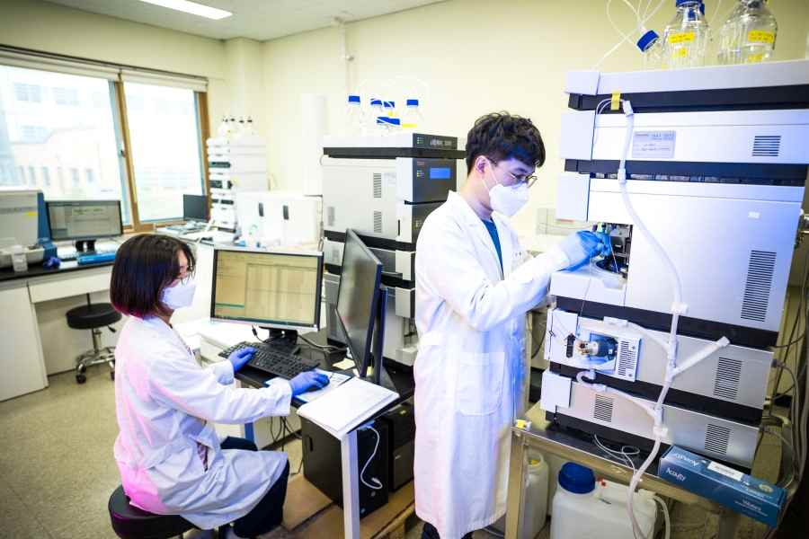
▲ GIST is immersed in research and development for national and regional development

GIST (Gwangju Institute of Science and Technology, President Kiseon Kim) announced that as a result of tallying the details of annual agreements, the amount of external research grant received in 2021 was the largest ever recorded at 142.4 billion won. According to the results of the count, the amount of research funds received per faculty member in 2021 exceeded KRW 700 million and reached KRW 760 million, which is a unique achievement among domestic universities.

Excluding the cost of entrusting research projects to other institutions and conducting cooperative research, pure research funds are also worth 85.7% of external research orders, or KRW 122 billion, proving their own research skills.

In particular, the amount of research grants received per full-time faculty, which intensively shows the achievements of a young GIST, which is celebrating the 28th anniversary of its establishment, has nearly doubled in seven years compared to 430 million won in 2014.

The amount of research grants per full-time faculty of GIST, which has maintained the highest level in Korea since its opening, reached 690 million won, a 24% increase compared to about 560 million won the previous year in 2020 when the global COVID-19 pandemic began and has risen sharply this year.

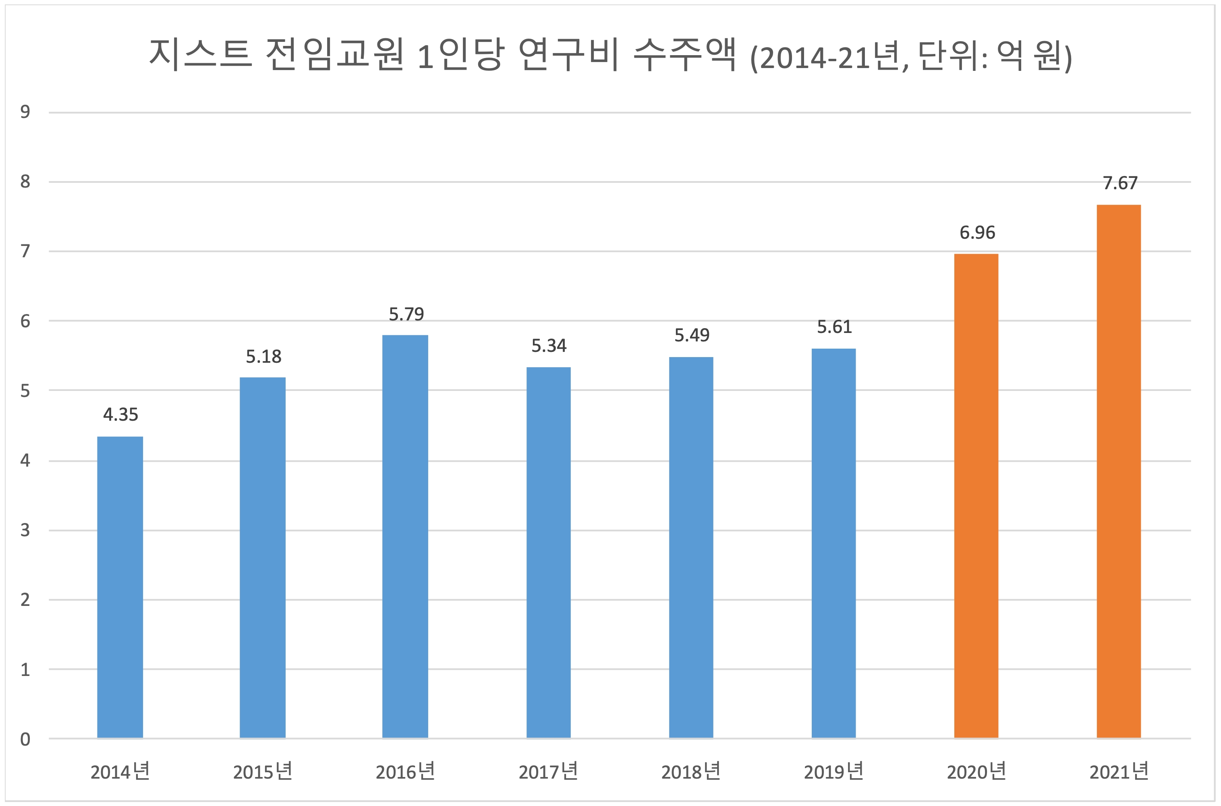▲ Graph of research funding per full-time faculty member for eight years

Regarding the amount of funding GIST received from research grants this year compared to last year, President Kiseon Kim said, "This is the result of all members at GIST paying attention to support challenging and innovative research that crosses the boundaries between academic disciplines and fields with the goal of contributing substantially to the development of humanity, country, and region."

Agreements signed this year with a total contract amount of 1 billion won or more include ▲ 'Laser Dazzling Active Defense Technology Development' (Advanced Photonics Research Institute Principal Investigator Jae Hee Sung) ▲ 'Innovative Energy and Carbon Optimized Synthesis for Chemicals Research Center' (School of Earth Sciences and Environmental Engineering Professor In Seop Chang) ▲ 'Gwangju Advanced Smart Manufacturing High Quality Human Resources Training Project' (School of Mechanical Engineering Professor Jongho Lee) ▲ 'Construction of GIST Nano-Infra for Compound Semiconductor Photonic Convergence' (School of Electrical Engineering and Computer Science Professor Dong-Seon Lee).

GIST, a small but strong research-oriented university with 200 full-time faculty and 2,000 students, has been focusing on convergence and innovation in both education and research since President Kiseon Kim took office in 2019. In the 2022 World University Rankings announced in June by QS, a UK university evaluation institution, the 'Citations per Faculty' category, which is one of the items that can evaluate both the quantity and quality of each university's research capacity, GIST climbed to the top and was ranked 4th in the world.



