GIST successfully completed the 'Buddy Program' for international undergraduate students

– Korean mentors and foreign mentees become a group to exchange culture and language for a semester... Major Exploration Program and interview with desired professors

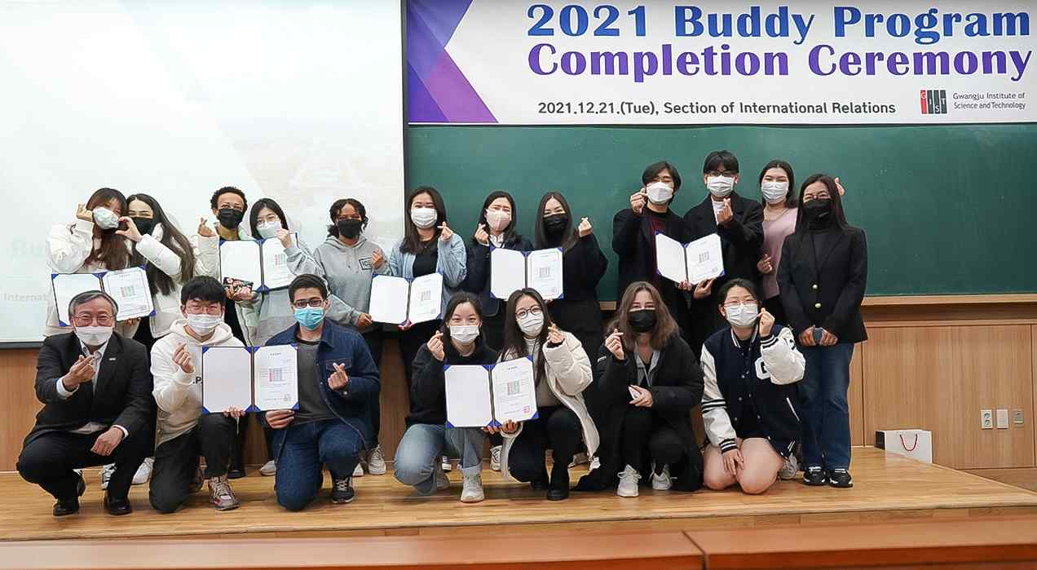
▲ Group photo after the completion of the 'Buddy Program'
for first-year international undergraduate students

GIST (Gwangju Institute of Science and Technology, President Kiseon Kim) announced on December 27 that they had successfully completed the four-month 'Buddy Program' for first-year international undergraduate students.

The Buddy Program matches a current Korean student mentor one-to-one with a foreign freshman mentee to help the foreign freshman undergraduate students adapt at GIST with various activities, such as cultural and language exchanges and academic support.

The graduation ceremony was held on December 21 and was attended by Vice President for Public Affairs Young-jip Kim and Division of Liberal Arts and Sciences Chair Joungmin Song along with 8 Korean mentors and 9 foreign mentees.

Ten teams were active in this year's buddy program, and three teams that showed particularly remarkable performances during the semester were selected and awarded prize money.

The Major Exploration Program, a part of the Buddy Program, was held on the December 22 to provide more systematic help in learning about majors before declaring one. Seven faculty from different departments (electronics, new materials, machinery, earth/environment, life, physics/optics, and chemistry) provided explanations, characteristics, and career opportunities of each major to 11 first-year international undergraduate students. There was also a question-and-anser session for the students.

In addition, the program was structured to provide more detailed help for career decision-making by setting up separate meeting times with professors from each desired major.

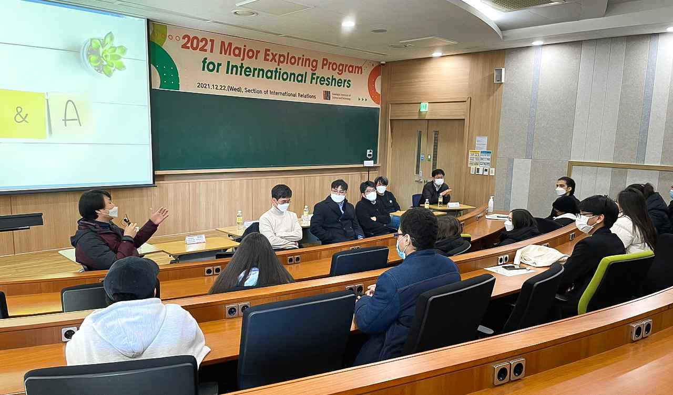
▲ Conducting the Major Exploration Program for first-year international undergraduate students

Farag Mohanad Ahmed (Division of Liberal Arts and Sciences class of 2021) from Egypt said, "The time was short, but I got a lot of help through the Buddy Program, and I think I was able to adapt well to the new semester without much difficulty, especially with the help of my mentor and people around me."

Alizade Meryem (Division of Liberal Arts and Sciences class of 2021) from Turkey said, "Through the Major Exploration Program, it seems that the ambiguous parts I was thinking about and the options for selecting prerequisite courses that might be helpful when declaring my major have become clearer. In addition, other majors that were unfamiliar before this program also felt interesting, which helped expand the range of choices."

Based on the educational philosophy of 3C1P (creativity, communication, cooperation, and problem solving), GIST College aims to nurture global convergence specialists suitable for the 21st century. By taking a wide range of lectures in basic science, humanities, social studies, arts, and physical education, students are given the opportunity to explore a major that suits them.



