GIST participated in the Korea
Science and Technology Exhibition

– Disclosure of cutting-edge research results
in the field of artificial intelligence/SW

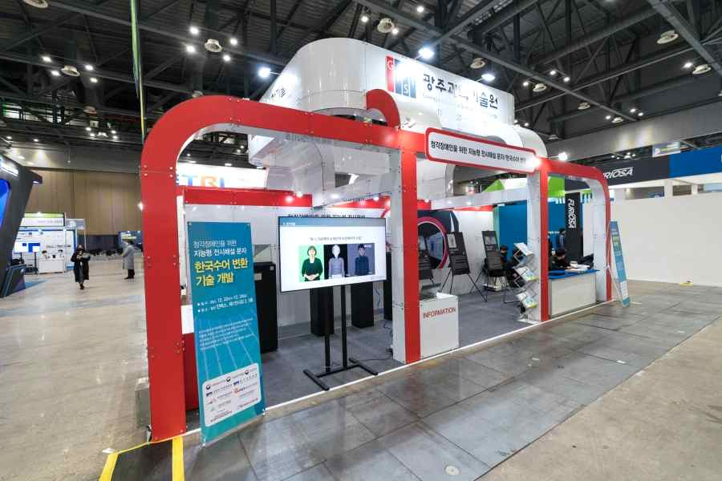
▲ GIST's booth at the '2021 Korea Science and Technology Exhibition'

GIST (Gwangju Institute of Science and Technology, President Kiseon Kim) participated in the '2021 Korea Science and Technology Exhibition' and presented excellent research results.

The '2021 Korea Science and Technology Exhibition' was hosted by the Ministry of Science and ICT and held at KINTEX in Ilsan from December 22 to 24 under the theme of 'A Window to Open the Future, a Journey to Science and Technology.' GIST prepared exhibition space in Halls 2 and 3 of the 1st Exhibition Hall and operated 3 booths for exhibition contents and 1 booth for science and technology career consulting.

GIST is a leader in artificial intelligence/SW and exhibits were organized so that participants who visited the site could experience it firsthand: ▲ Let's compose on the spot with AI composer (Bom Lee)! (Professor Chang Wook Ahn) ▲ AI-based personal spatial sound technology (Professor Hong Kook Kim) ▲ Intelligent exhibition commentary text/Korean language conversion technology for the hearing impaired (Korea Culture Technology Institute/Director Moongu Jeon) was exhibited.

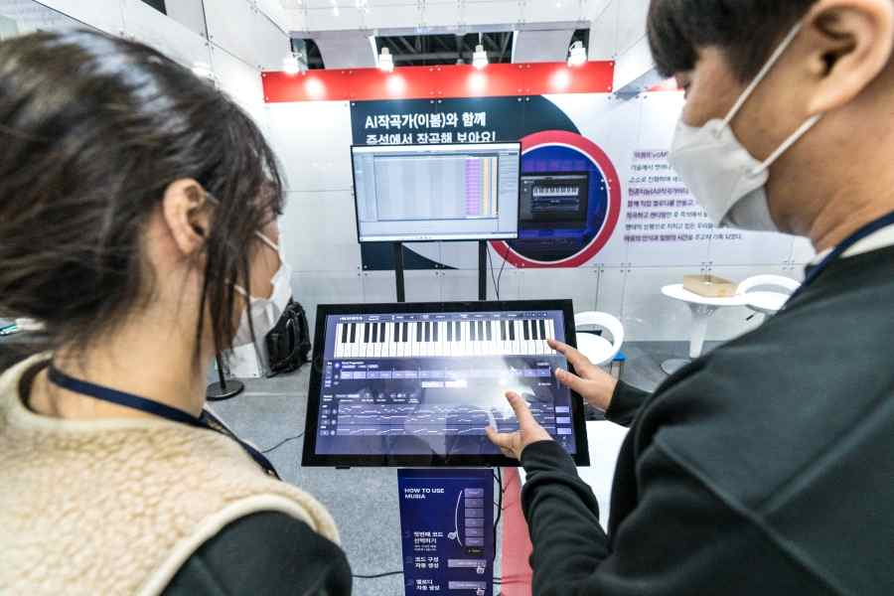
▲ AI composer (Bom Lee) is being introduced to the audience.

At the booth 'Let's compose on the spot with AI composer (Bom Lee)!', we were able to meet Korea’s first artificial intelligence (AI) composer. ‘EvoM’, developed by Professor Chang Wook Ahn, breaks away from the existing deep learning-oriented technology that relies on simple data, and evolves itself with a small amount of data based on music theory and composes new music. By composing and rendering a completed song based on this melody in real time and listening to it on the spot, it delivered a moment of rest and healing to those who are tired of the COVID-19 pandemic.

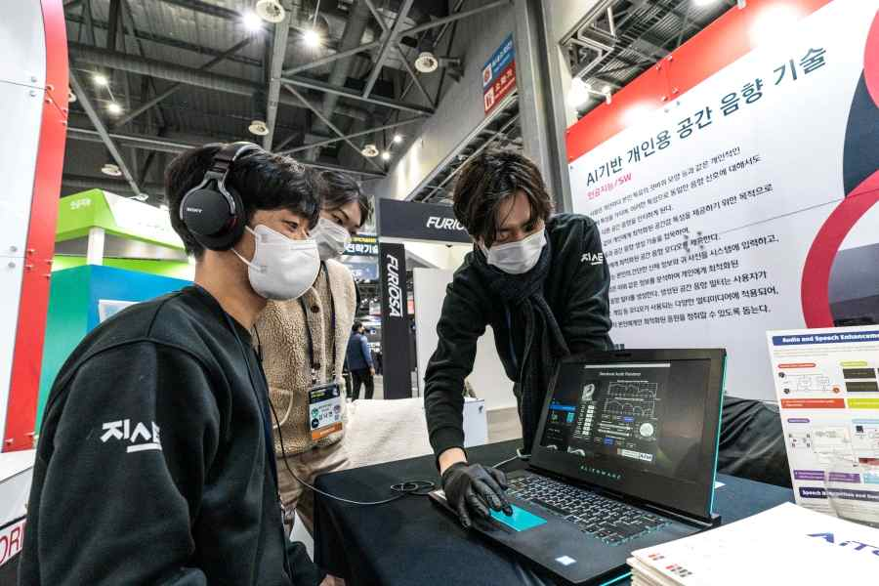
▲ AI-based personal spatial sound technology is being introduced to the audience.

In the 'AI-based personal spatial sound technology' booth, it was possible to experience spatial sound audio optimized for individuals. Professor Hong Kook Kim combined AI technology with spatial sound generation technology, paying attention to the fact that different spatial sounds are perceived for the same acoustic signal according to different body characteristics, such as the shape of the pinna. Simple body information and pictures of the ear are input into the system, and the system analyzes them and creates a spatial acoustic filter optimized for the individual. The created spatial sound filter is applied to various multimedia media where audio is used, such as music and games, so that the user can listen to sound sources optimized only for the user.

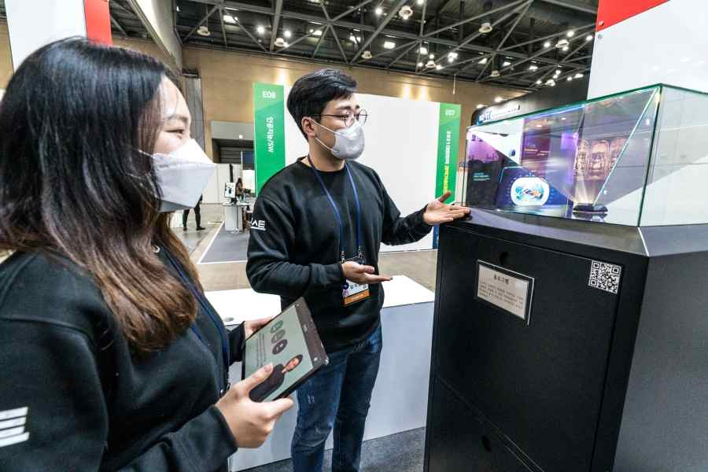
▲ Introducing AI-based cultural infrastructure exhibition commentary text
and Korean language animation service platform technology to visitors.

The 'Intelligent Exhibition Commentary Text/Korean Language Conversion Technology for the Hearing Impaired' exhibit is an AI-based text and Korean language animation service platform technology developed by the Korea Culture Technology Institute. For deaf people to enjoy a cultural life, exhibition explanations (audio guides), facility introductions, and announcements are provided in text (subtitles) and Korean sign language animations at major cultural facilities such as museums, art galleries, and exhibition facilities.

GIST Vice President for Public Affairs Young-jip Kim said, "I am very pleased to be able to introduce the excellent research results of GIST at the Korea Science and Technology Exhibition. GIST will do its best to research and develop science and technology so that science and technology can contribute to solving social problems and improving the quality of life for people."

The event was hosted by the Ministry of Science and ICT and the Korea Foundation for Science and Creativity and co-hosted by the National Research Foundation of Korea and was attended by 130 government-funded research institutes, universities, companies, research institutes, and scientific and cultural organizations to showcase major R&D achievements and scientific and cultural contents.



