GIST alumni companies donate 40
million won to the development fund

– To be used for GIST R&D and scientific technology development

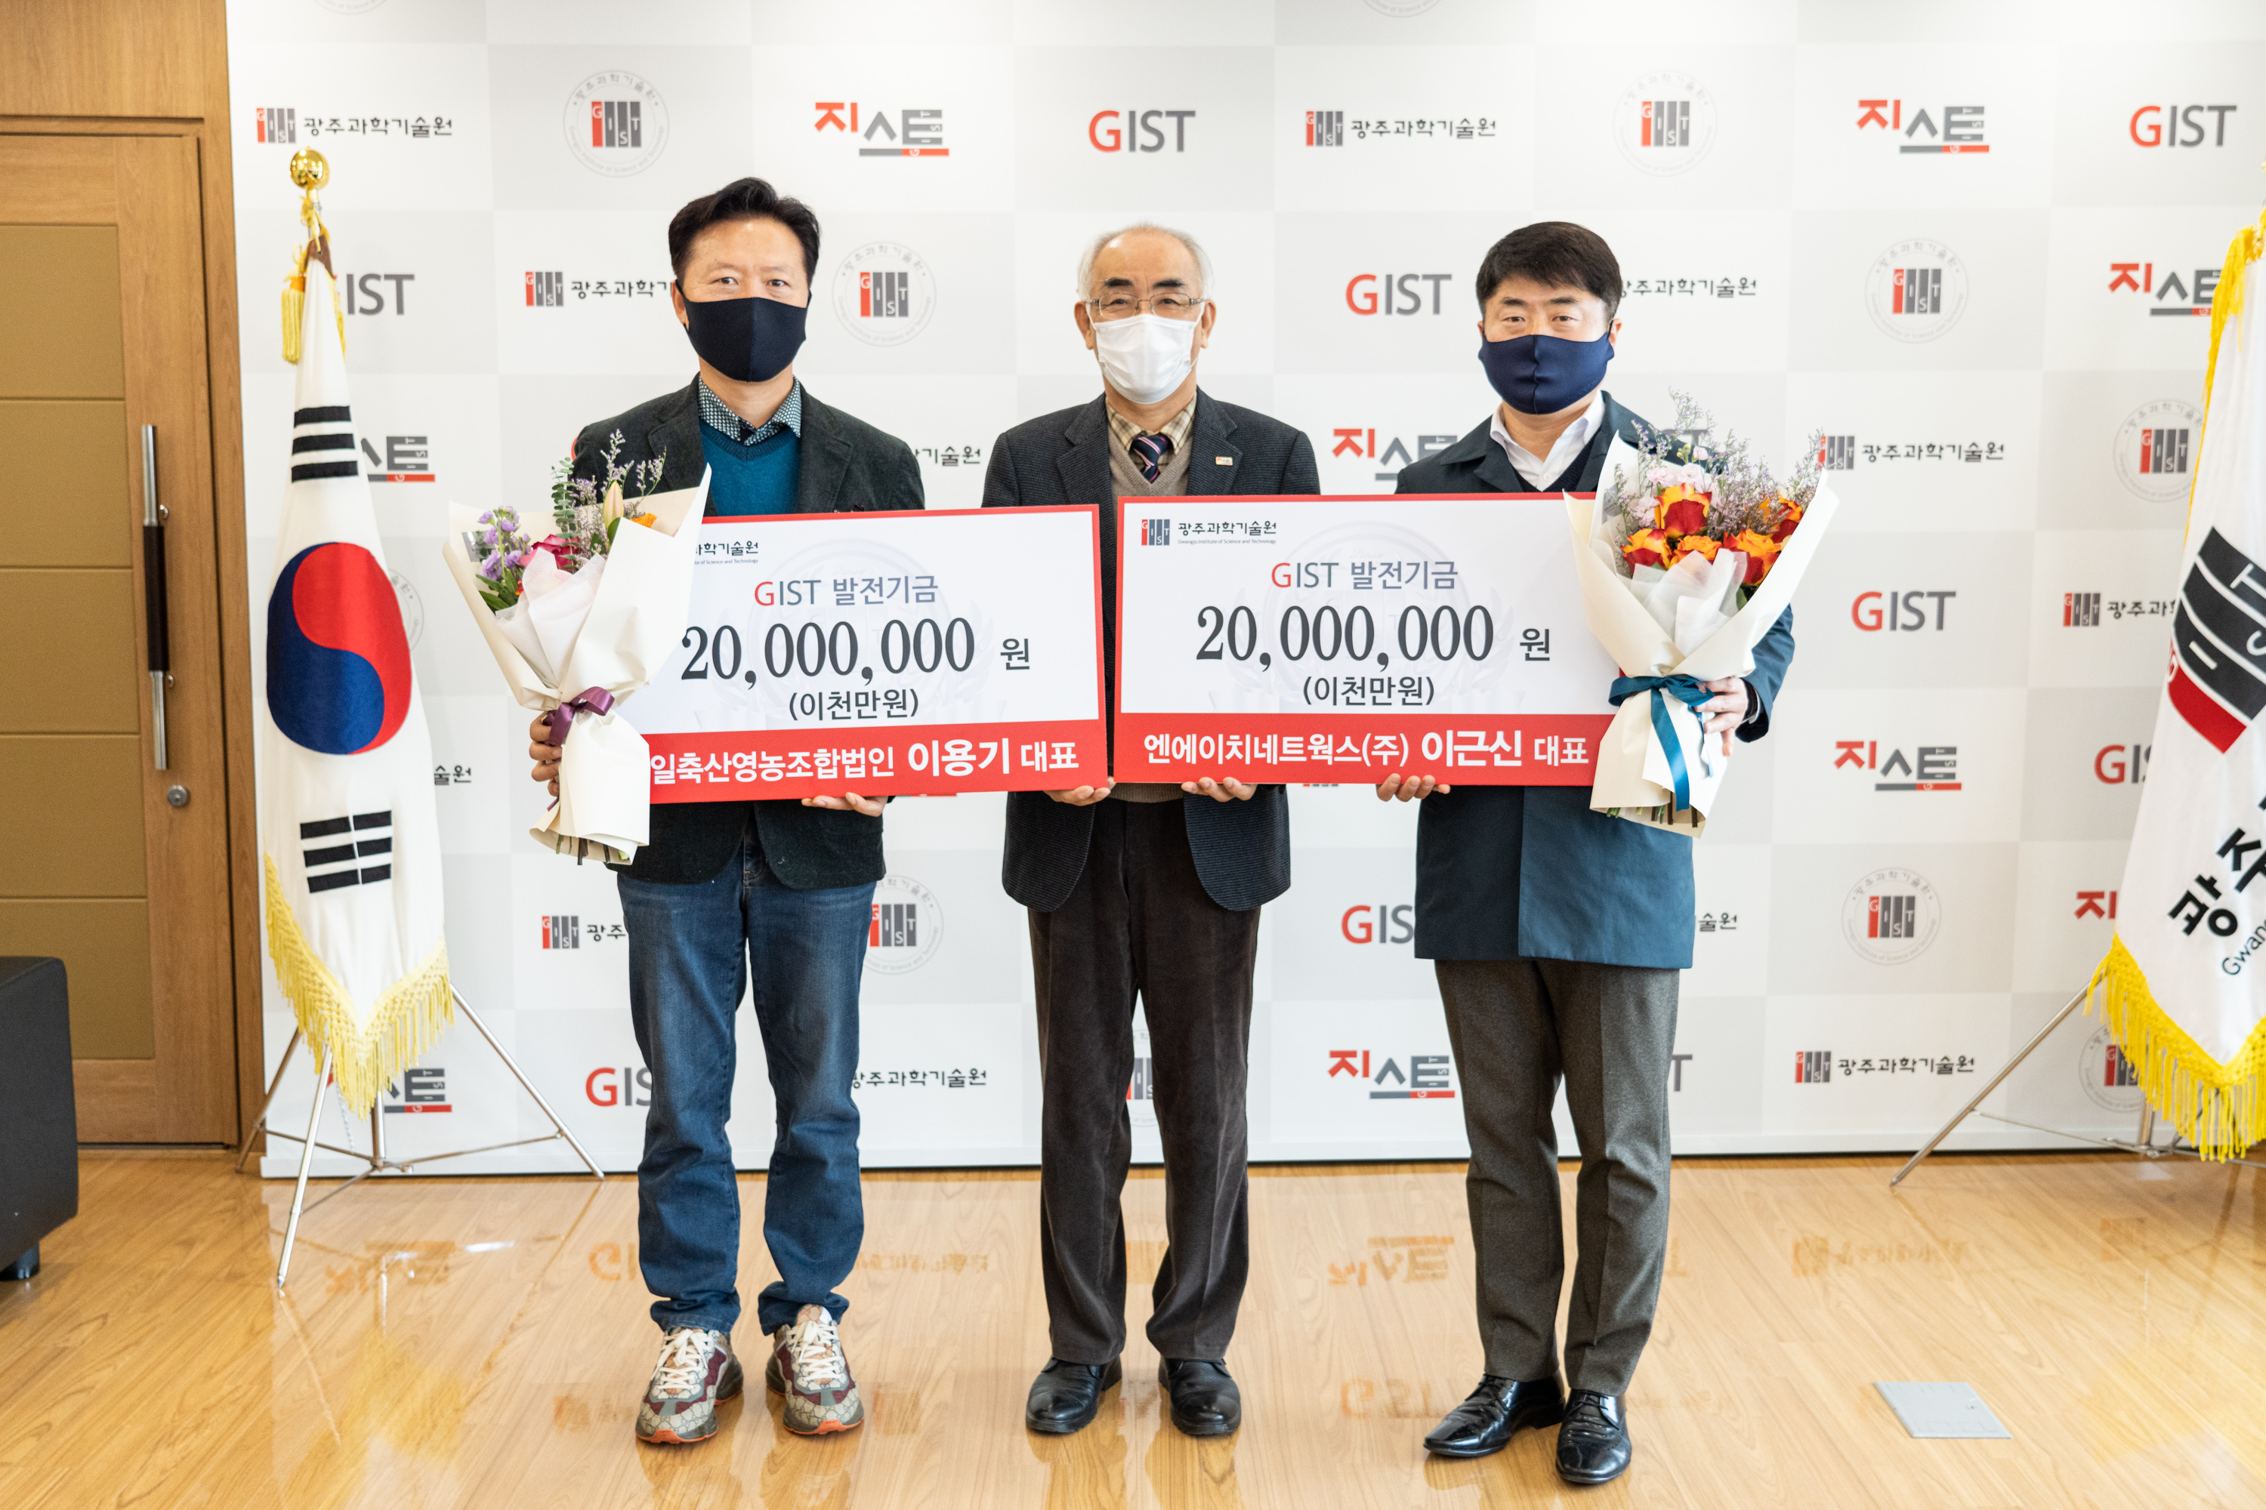▲ From left: From left: SUNGIL Corp. CEO Young Gie Lee, GIST President
Kiseon Kim, and NH Networks CO., LTD., CEO Geun Sin Lee

GIST (Gwangju Institute of Science and Technology, President Kiseon Kim) announced on the December 13 that it had received a total of 40 million won for the GIST Development Fund--20 million each--from SUNGIL Corp. CEO Young Gie Lee and NH Networks CO., LTD., CEO Geun Sin Lee.

CEO Young Gie Lee and CEO Geun Sin Lee are GIST alumni who completed the 7th course of the GIST Techno Management Business Academy (GTMBA) and are representative professional managers in the region who are growing into next-generation leaders in the fields of livestock and security, respectively.

SUNGIL Corp. is an ICT convergence smart farm that modernizes livestock facilities to continuously improve piglets (seed pigs), which is a breed that produces a lot of piglets, and has been recognized for its excellence by acquiring eco-friendly livestock products and HACCP certification.

NH Networks CO., LTD., is a total solution company that provides everything from the development of the CCTV video control system necessary for integrated disaster control for a safe society to design, construction, and maintenance, and is positioning itself as a small ICT company.

CEO Young Gie Lee said, "I have always been grateful to GIST, but I am very proud and happy to be able to actively participate in nurturing excellent specialists." CEO Geun Sin Lee said, "Based on GIST's excellent research achievements, I believe GIST will become a venue for industry-university cooperation representing the region."

GIST President Kiseon Kim said, "I would like to express my gratitude to the two of them for their warm hearts in the development of the institution, and I will actively take the lead so that GIST can cooperate more with local companies for regional development."



