GIST receives 2021 Best Start-up University Award

- Selected as the No. 1 start-up university for three consecutive years since 2017
- Recognized for excellence in the field of start-up support following last year's Start-up Performance Excellence Award

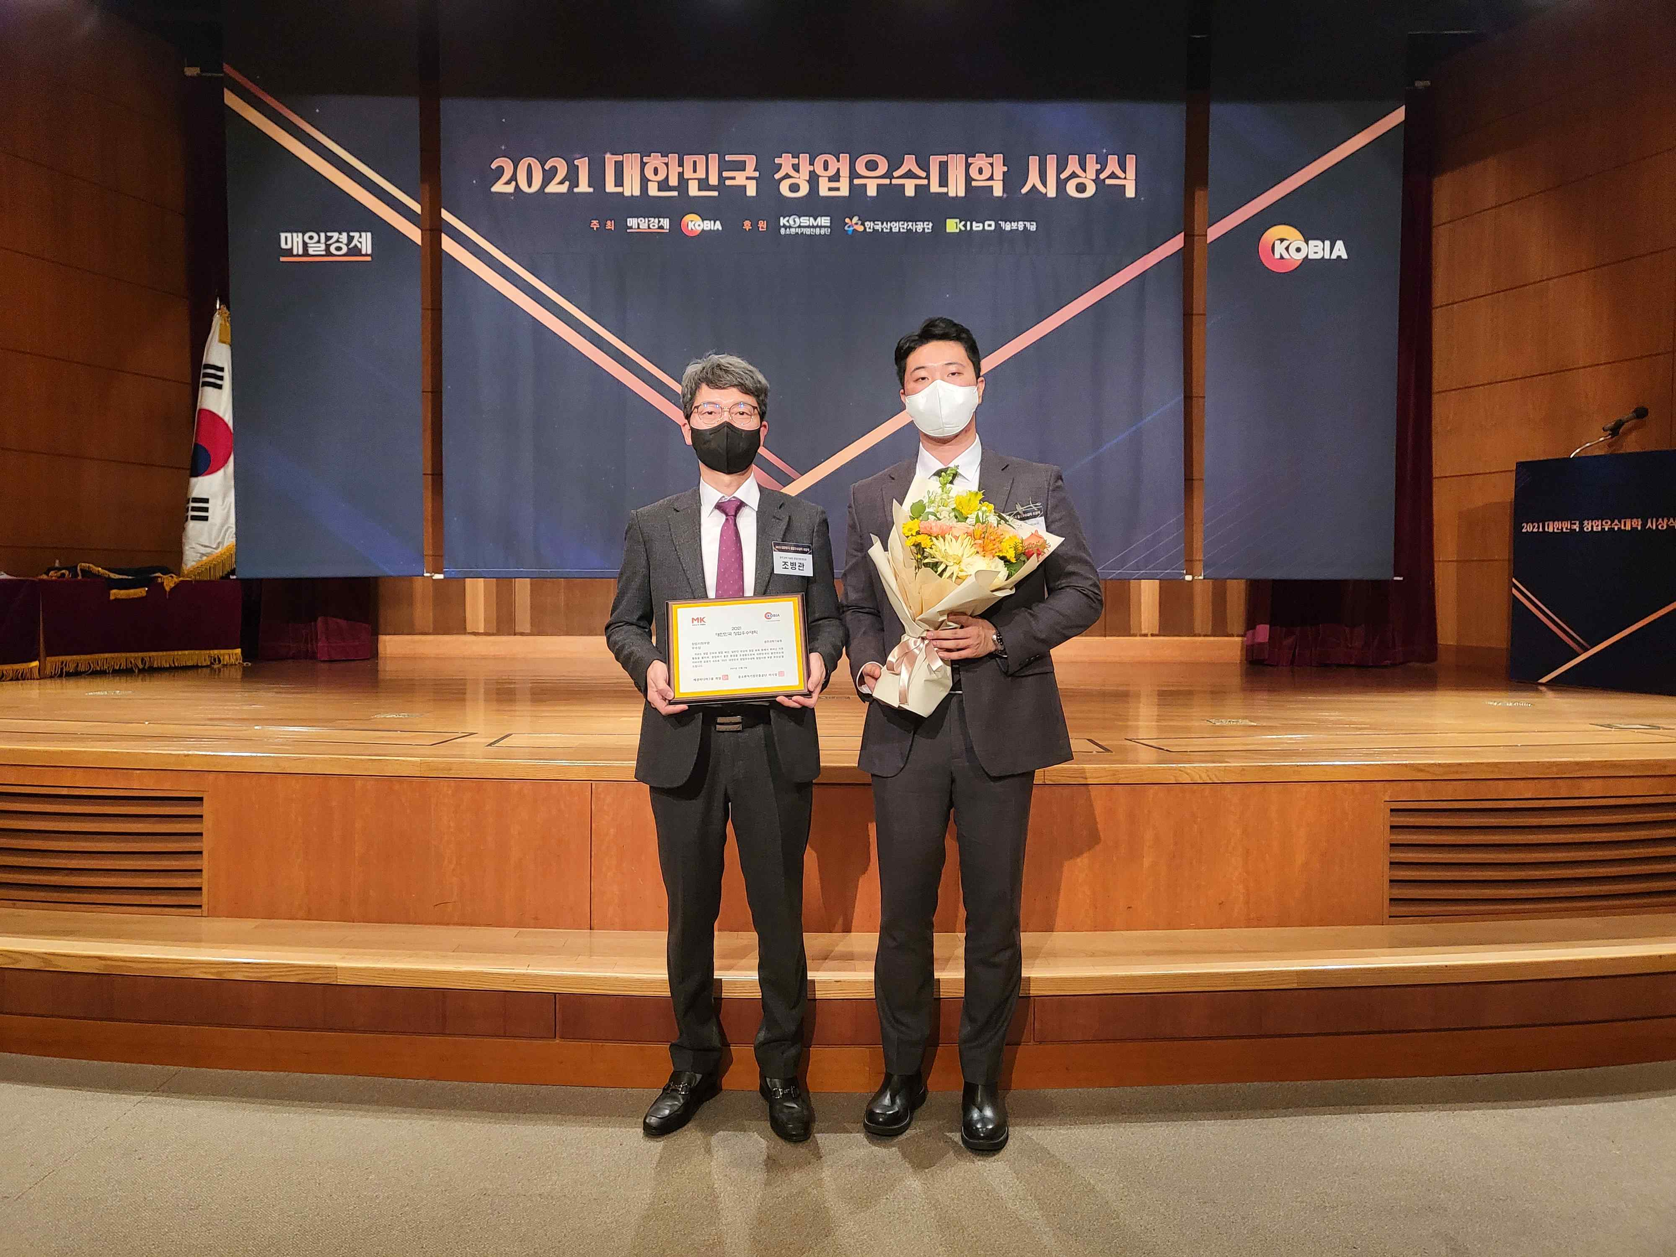
▲ GIST 2021 Best Start-up University Award (from left): GIST Business
Incubator Director Byeong-kwan Cho and Administrator Ji-woong Kim

GIST (Gwangju Institute of Science and Technology, President Kiseon Kim) received the Excellence Award in the Start-up Support category of the 2021 Best Start-up University hosted by the Korea Incubator Association and Maeil Economic Daily.

This year, excellent start-up universities were selected through the Maekyung University Startup Index comprehensive evaluation in three categories, including start-up infrastructure, start-up support, and start-up performance, targeting 248 four-year general colleges and 167 junior colleges. The awards ceremony was held at the Maeil Business Headquarters on Thursday, December 9th.

Since opening the Business Incubator in 2000, GIST has been planning and supporting various start-up support programs and has been awarded the highest grade in the business incubator center operation evaluation by the Ministry of SMEs and Start-ups 13 times.

In addition, in 2015, GIST was selected as an excellent organization for supporting business start-up customized commercialization. In 2016, GIST was also awarded the Minister of Science, ICT and Future Planning (currently the Ministry of Science and IT) Minister's Citation in the field of start-up support group in the Creative Economy Venture Start-up Competition.

In addition, GIST has been selected as the organizer of the Start-up Leap Package for five consecutive years from 2016 and has been selected as the Preliminary Startup Package for three consecutive years from 2019, receiving good evaluations in support for start-ups and performance.

GIST Business Incubator Director Byeong-kwan Cho said, "GIST is actively supporting specialized programs for each start-up stage, such as customized start-up support for consumers, hosting start-up idea contests, and operating mock start-up programs (GSS) and acceleration programs. We will continue to actively support startups to revitalize local specialized industries, including in the field of artificial intelligence (AI)."

From 2017 to 2019, GIST was selected as the best start-up university for three consecutive years. After winning the Excellence Award in the Start-up Performance category in 2020, it received the Excellence Award in the Start-up Support category this year, standing tall as a prestigious start-up university.



