GIST and ProApptech Co., Ltd., signed a technology
transfer for 'Biobetter Cancer Drug Platform'

- Expected to commercialize and industrialize next-generation anti-cancer drugs

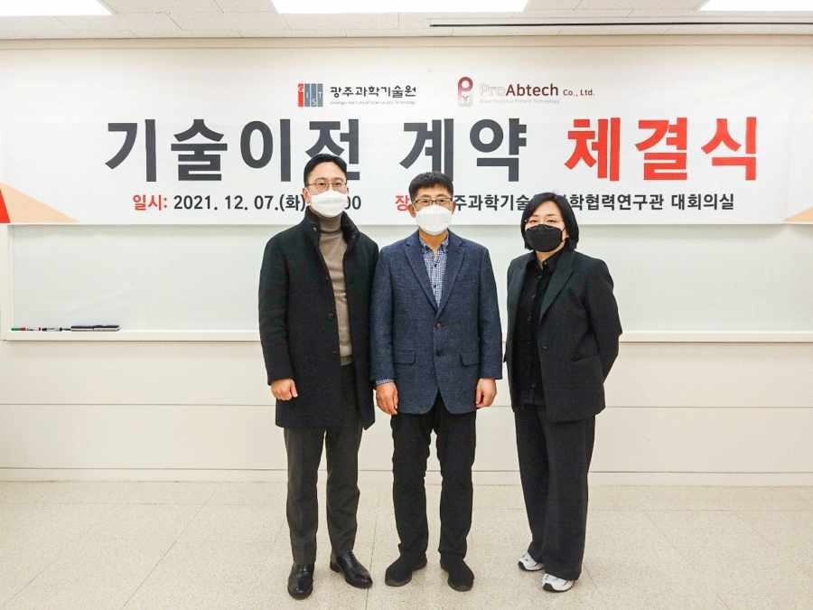
▲ From the left: ProApptech CEO Jung-haeng Cho, GIST Professor Inchan Kwon,
and ProApptech Research Institute Director Kyung-hee Lee

GIST (Gwangju Institute of Science and Technology, President Kiseon Kim) School of Materials Science and Engineering Professor Inchan Kwon has transferred technology to ProApptech, a company that develops long-acting biopharmaceuticals by developing a biobetter platform for anticancer drugs.

The technology transfer agreement ceremony was held at GIST on December 7th (Tuesday) with the participation of major officials, including GIST Professor Inchan Kwon, ProApptech CEO Jung-haeng Cho, and ProApptech Research Institute Director Kyung-hee Lee.

Metabolic cancer drugs are mechanisms that block energy metabolism in cancer by suppressing substances that play a key role in the cancer cell energy generation path.As it does not affect normal cells, it is attracting attention as a next-generation anticancer drug that overcomes the side effects of existing anticancer drugs and while increasing cure rate.

Arginine decarboxylase (ADC) is an enzyme that degrades arginine, which is an amino acid that is essential for cancer cell metabolism, but it has a short half-life in the body. To improve this, attempts have been made to increase the half-life through PEGylation* technology, but, so far, studies have been reported that the drug loses its efficacy when combined with an immune response problem.

* PEGylation: a drug delivery system design technology made by conjugating a polyethylene glycol (PEG) derivative to a new protein drug obtained by recombining a high molecular material to make the drug last longer

GIST Professor Inchan Kwon said, "The developed technology significantly increased the half-life and biological activity in the body by selectively binding albumin, a protein abundant in blood, to a specific site of arginine decarboxylase. This should greatly contribute to extending the duration of the anticancer drug's efficacy and maximizing its efficacy."

ProApptech CEO Jung-haeng Cho said, "Through this technology transfer, ProApptech is expected to expand its technology platform to include anticancer drugs, along with our treatments for gout and obesity, which is currently being developed, to broaden the spectrum of existing technologies and further strengthen competitiveness."

GIST Professor Inchan Kwon developed biotherapeutic drugs and related technologies and has applied for and registered more than 40 domestic and foreign patents. In particular, recently, five biobetter platform technologies were transferred to biopharmaceutical companies for a total of 2 billion won or more.

In addition, in recognition of Professor Kwon's contributions to the commercialization of biotherapeutic technology by actively participating in technology development as the CTO of ProApptech Co., Ltd., he received a commendation from the Minister of Trade, Industry and Energy at the ceremony for the 2021 Intellectual Property Day.

The technology developed this time was supported by the National Research Foundation's Individual Basic Research Project, C1 Gas Refinery Project, and Group Research Support Project.



