GIST and Korea Institute of Energy Technology signs
an MoU for future education innovation

- Expected to promote educational innovation and international joint research
through the Future Innovation Committee (tentative name)

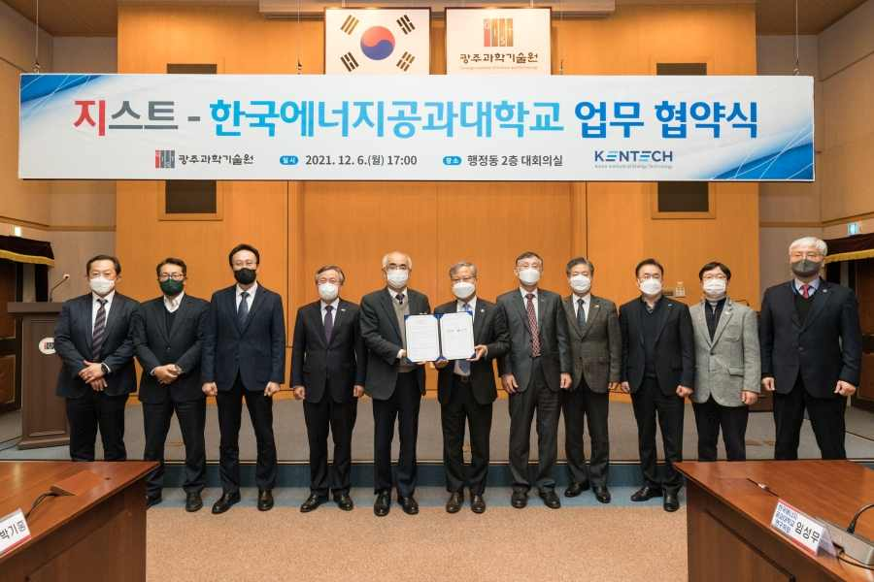
▲ From left: GIST Dean of Planning Zee-Yong Park, Acting Vice President of Research Kihong Park, Acting Vice President for Academic Affairs Chung-Hee Cho, Vice President for Public Affairs Young-jip Kim, President Kiseon Kim, KENTECH President Eui-jun Yoon, Vice President of Academics Seong-joo Park, Director of Planning Sang-cheol Han, Director of Research Seong-moo Lim, Dean of Academic Affairs Jun-seop Kwak, and Dean of Student Affairs Wan-gyu Park

GIST (Gwangju Institute of Science and Technology, President Kiseon Kim) has signed a business agreement (MoU) to establish a cooperative relationship in education and research with Korea Institute of Energy Technology (KENTECH, President Eui-jun Yoon).

This business agreement was signed on December 6th (Mon) with GIST President Kiseon Kim, Vice President for Public Affairs Young-jip Kim, Acting Vice President for Academic Affairs Chung-Hee Cho, Acting Vice President of Research Kihong Park, KENTECH President Eui-jun Yoon, Vice President of Academics Seong-joo Park, Director of Planning Sang-cheol Han, Director of Research Seong-moo Lim, Dean of Academic Affairs Jun-seop Kwak, and Dean of Student Affairs Wan-gyu Park.

The main parts of the agreement are ▲ operating the Future Innovation Committee (tentative name) ▲ education and human resource exchange ▲ R&D and technology exchange ▲ including international exchanges. In addition, GIST and KENTECH plans to cooperate on matters necessary for mutual development and friendship promotion.

In particular, the two organizations will operate the Future Innovation Committee (tentative name) to derive specific and substantial future cooperation plans. The committee plans to carry out comprehensive cooperation such as innovation in university education, a future research paradigm, and revitalization of international joint research.

GIST President Kiseon Kim said, "Through this agreement, a foothold has been laid for the establishment of an education and research cooperation system that enables the two universities to coexist and develop. We expect positive synergy effects through active cooperation with KENTECH."

KENTECH President Eui-jun Yoon said, "Humanity is facing the 4th Industrial Revolution due to the introduction of artificial intelligence and the energy industry revolution for carbon neutrality in 2050. At this momentous occasion, GIST, which leads artificial intelligence, and KENTECH, an energy-specialized university, will cooperate to bring about innovation that leads the region and the world."

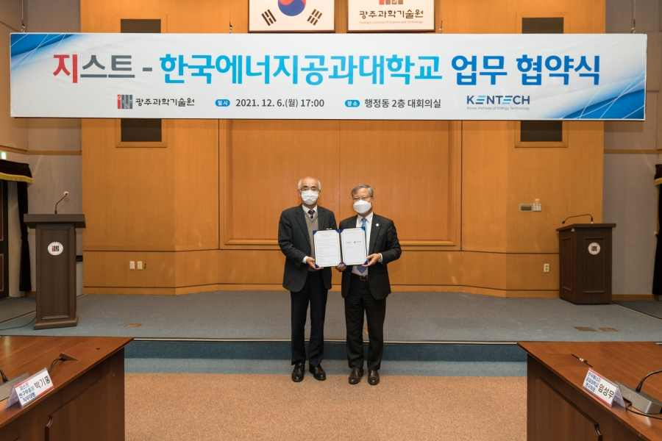
▲ From left: GIST President Kiseon Kim and KENTECH President Eui-jun Yoon



