GIST participates in '2021 Korea Software Competition' in the special field of preliminary start-up packages

- Exhibition seeks to strengthen the marketing and
investment capabilities of prospective entrepreneurs

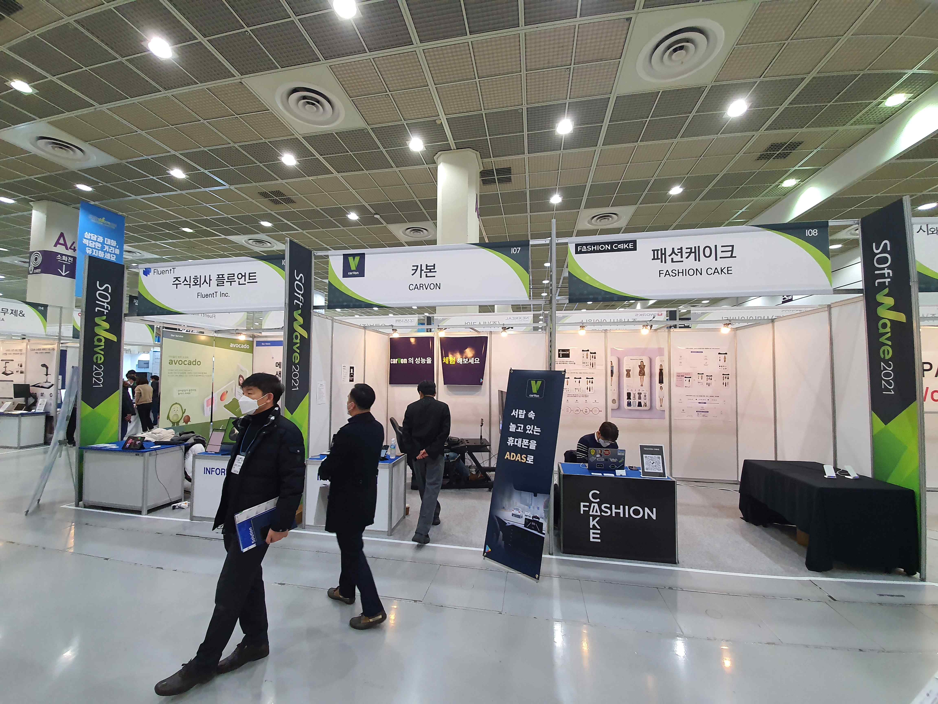
▲ GIST supports three start-up companies for the '2021 Korea Software Competition'

GIST (Gwangju Institute of Science and Technology, President Kiseon Kim) supported three start-up companies to compete in the '2021 Korea Software Competition' in the special field of preliminary start-up packages.

The start-up companies supported by GIST were 'Carbon (CEO Yoo-sung Lee),' 'Fluent Co., Ltd. (CEO Ye-chan Jeon),' and 'Fashion cake (CEO Kyung-jun Cho).' ▲ Carbon is a developer of a driving assistance application using the latest deep learning technology and computer vision system and is developing an application that improves a safe driving environment.

▲ Fluent Co., Ltd., is a company that develops 'TELL A TALE,' a real-time conversational facial motion synthesis solution for smooth communication in everyday life while wearing a mask. ▲ Fashion Cake is developing a user-customized fashion recommendation system application through a deep learning-based fashion recommendation algorithm.

GIST supports and manages the preliminary package specialized field (AI field) project in 2021 and evaluates the excellence and commercialization potential of business items with a focus on technology using artificial intelligence to achieve business start-up commercialization with material and human resources.

To strengthen the competencies of prospective entrepreneurs, various competency-building trainings such as labor, human resources, investment, and marketing are conducted, and various infrastructure and services are provided to help them succeed in starting a business by resolving difficulties in business execution through 1:1 mentor matching and supporting specialized programs.

GIST Business Incubator Director Byeong-kwan Cho said, "By participating in exhibitions such as the 2021 Korea Software Competition, we will actively support the participation of prospective start-ups in various programs so that they can promote their start-up ideas and have an opportunity to attract investment."

Meanwhile, 'Softwave 2021,' the largest software convergence exhibition in Korea, is hosted by the Software Organizing Committee and sponsored by seven government ministries including the Ministry of Science and ICT and the Seoul Metropolitan Government. It was held at COEX (Hall A) from December 1st (Wednesday) to 3rd (Friday).



